Contents

HOW TO SETUP LARAGON 1

1. Install Laragon. 1

2. Start Laragon. 2

HOW TO INSTALL VISUAL STUDIO CODE 4

DEFAULT WAY OF CREATING EMPTY LARAVEL PROJECT 6

CASE STUDY – E-LEARNING (MINI PROJECT) 14

Use Case Specification 14

HOW TO SETUP – ELEARNING (MINI PROJECT) 15

BRIEFING – E-LEARNING (MINI PROJECT) 20

Login Page 20

Register Page 21

Home Page 21

Course Module 22

Submodule – Create New Course 22

Show the Course Data Function 26

Creating the course Function 30

Edit the Course Function 35

Delete the course Function 38

Submodule – Add Resources to Course 40

Show the resources data Function 43

Add the Resources Function 46

Delete the Resources Function 52

IMPLEMENTING PROGRESSIVE WEB APPS (PWA) TO EXISTING PROJECT – ELEARNING (MINI PROJECT) 54

What is PWA? 54

Features of PWA? 54

Implementing PWA 54

HOW TO SETUP VIRTUAL REALITY (VR) SCENE? 56

Introduction 56

What is VR? 56

What is WebXR? 56

What is A-Frame? 56

Stage 1 – HTML & primitives 57

Installation of A-Frame using CDN 57

Basic A-Frame primitives 57

Transformation: position, rotation, scale 58

Extra: View the VR scene in Oculus Quest and mobile phone 59

Stage 2 – Building basic scene 60

Using external library: adding environment 60

Adding audio 61

Adding text 61

Import 3D model 62

Stage 3 – User interaction 63

Gaze-based cursor pointer 63

JavaScript interaction using A-Frame component registration 64

Stage 4 – Integration with Laravel project 66

Create a simple scene to display a 3D model 66

Upload the 3D model 66

Create function to display 3D model dynamically 68

View the 3D model 69

More user interaction using Oculus Touch Controller 70

HOW TO SETUP 360-DEGREE VIDEO? 74

Introduction 74

Stage 1 – Setup 360-degree video 74

Create 360-degree video scene using A-Frame 74

Stage 2 – Integration with Laravel Project 75

Create a new route 75

Create function to display 360-degree video based on the requested video ID 75

View 360-degree video 75

HOW TO SETUP AUGMENTED REALITY (AR) SCENE? 76

Introduction 76

What is AR? 76

What is AR.js? 76

Stage 1 – Marker tracking 76

Installation of AR.js and A-Frame using CDN 76

Adding AR.js entity in A-Frame 77

Stage 2 – Integration with Laravel project 78

Create a new route 78

Create function to display 3D model based on the requested model ID 78

View the 3D model in AR 79

Stage 3 – Create your own marker 79

Design and create own marker for elearning 79

Import to Laravel project 80

Using the new marker 80

Stage 3 – User interaction in AR scene 81

Create a custom button 81

# HOW TO SETUP LARAGON

Why Laragon? Laragon is a localhost program for Windows machine. Laragon provides a portable, isolated, fast and powerful development for **PHP, Node.JS, Phython, Java, Go, and Ruby** for Windows computers. You can use **Apache or Nginx** as a web server. You can add a domain name and customize as you wish. **MySQL, PostgreSQL, MongoDB and Redis** options are available for database. Laragon can be used **as a development environment**.

## Install Laragon.

Go to Laragon’s official website (<https://laragon.org/download>) and download the latest version of the appropriate installer for your version of Windows. For the purpose of this tutorial, we shall using the full edition.

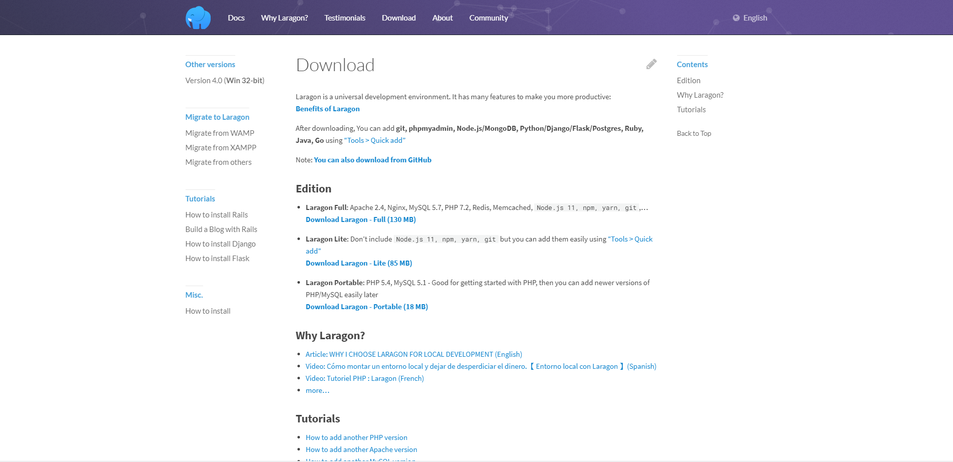

Figure 1: Laragon Website

After the download is complete, double-click on the Laragon Installer to initiate the installation process.

* On the ***“Select Setup Language”***, select your language of your choice. In this case, English then click on the OK button.
* On the ***“Select Destination Location”*** page, go with the default destination option which is C:\laragon and then click on the Next button. On the ***“Setup Options”*** page, it is my personal preference to uncheck these two checkboxes: ‘*Run Laragon when Windows starts*‘ and ‘*Add Notepad++ & Terminal to the Right-clik Menu*‘. Now, click Next.

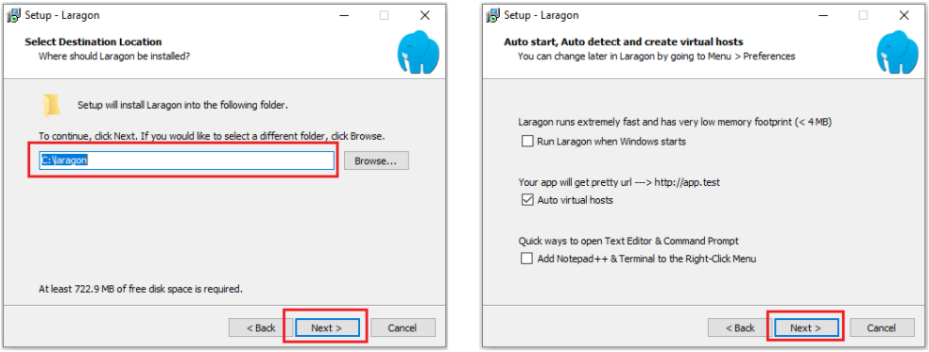

Figure 2: Setup Laragon

* On the “***Ready to Install***” page, click Install. When the installation is done, click on Finish so as to restart your machine.

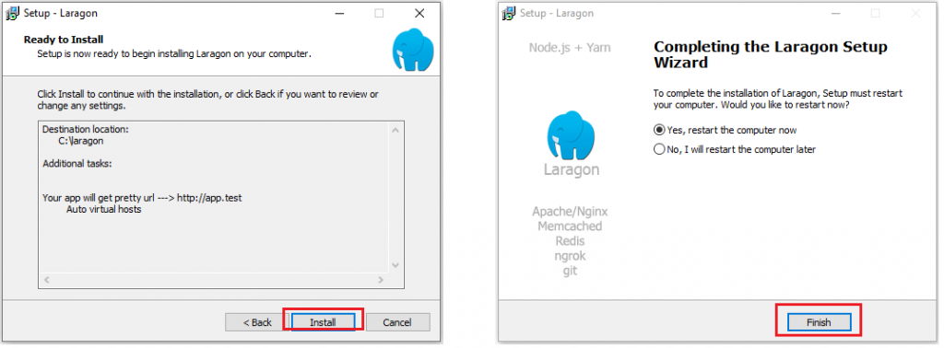

Figure 3: Setup Laragon

## Start Laragon.

After your PC is done rebooting, launch the Laragon app from the desktop or from the Start menu. When Laragon opens, you should see an interface that looks like the image on the left below. Click on the **Start All** button to start Apache and MySQL.

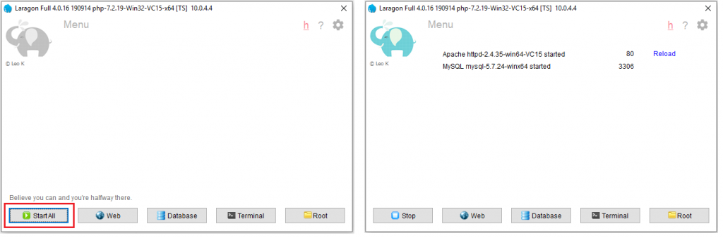

Figure 4: Laragon

In the event you get a firewall notice like the ones depicted in the image set below, you can choose to deny or allow access. But since I trust my private network, I normally click on checkbox for private networks and then the ‘Allow access’ button for both ***Apache HTTP Server*** and ***MySQL***so they can communicate on my private network.

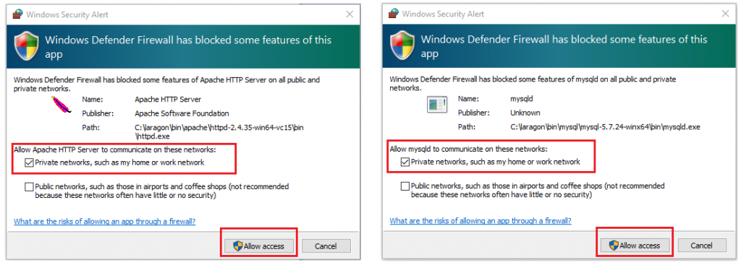

Figure 5: Windows Security Alert

# HOW TO INSTALL VISUAL STUDIO CODE

If you already have VS Code installed in your machine, you can skip this section. However, if you want it as one of the apps installed within the Laragon directory then you have to first uninstall VS Code from your PC before continuing with the tutorial in this section.

Download the VS Code installer for your version of Windows from **(https://code.visualstudio.com/download)**. When the download is complete, double-click on the installer to commence the installation process.

1. On the **“License Agreement”** page, choose ‘I accept the agreement‘ and click Next. On the **“Select Destination Location”** page, click on the ‘Browse‘ button and navigate to the laragon\bin directory and click OK. If you have done it correctly you should see C:\laragon\bin\Microsoft VS Code in the text-field; click Next.

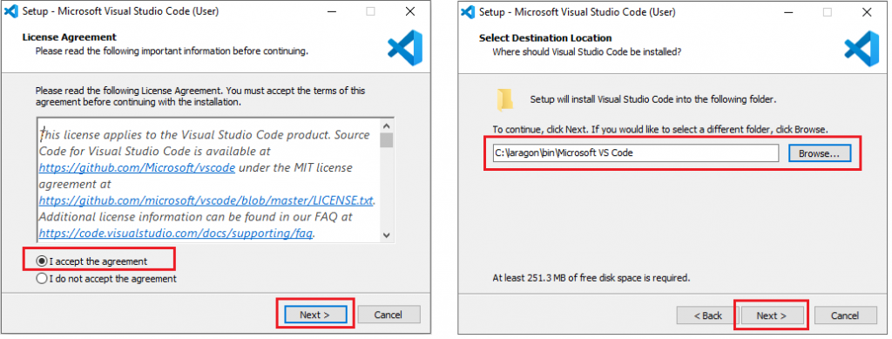

Figure 6: VS Code Setup

1. On the **“Select Start Menu Folder”** page, click Next. On the ***“Select Additional Tasks”*** page, ensure you check all the checkboxes, then click Next.

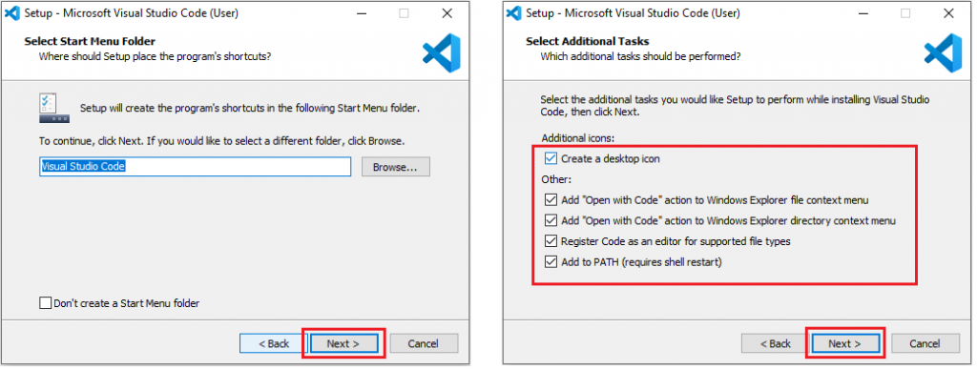

Figure 7: VS Code Setup

1. On the **“Ready to Install”** page, click Next. When the installation is complete, click Finish.

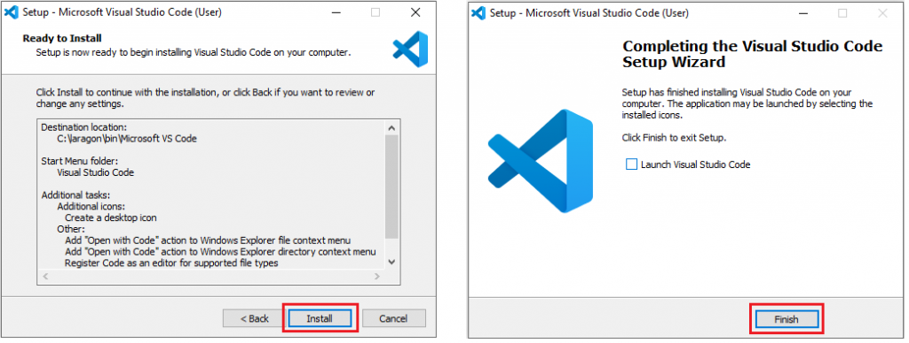

Figure 8: VS Code Setup

To start code, simply open visual studio code and click on the “File->Open Folder” and choose your Laravel project.

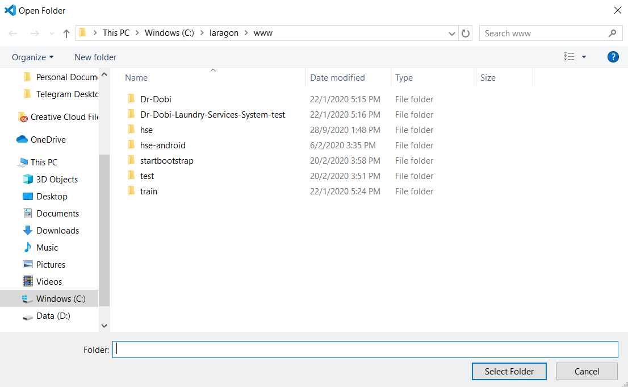

Figure 9: VS Code Open Folder

# DEFAULT WAY OF CREATING EMPTY LARAVEL PROJECT

Since Laragon version 4.0.16 only provide PHP 7.2, you need to install latest version of PHP to use Laravel 8.x. Go to ( <https://windows.php.net/download> ) and download the ZIP file under VC15 x64 Thread Safe for PHP 7.4 as shown below:

p/s: The version of php 7.4 may be higher than 7.4.11 during the time you follow this tutorial. Just ensure that it is php 7.4 and continue for the next step.

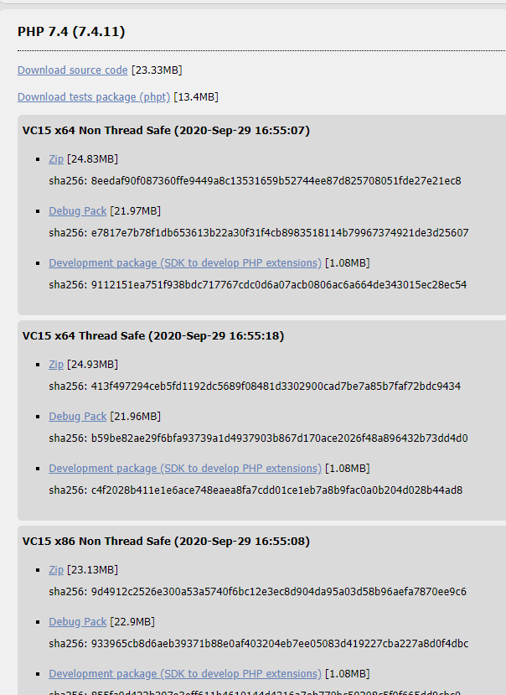

Figure 10:PHP website

After done downloading, extract the folder (use the **Extract to** option), copy and paste it to C->laragon->bin->php.

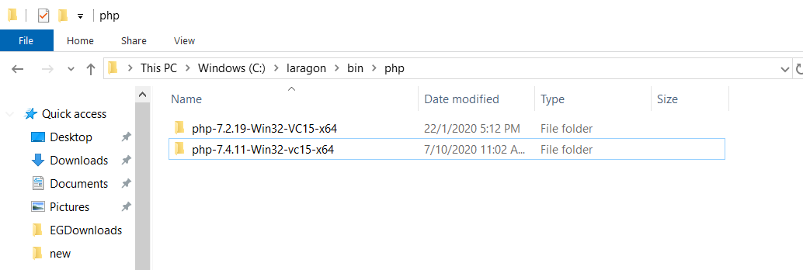

Figure 11: PHP Folder

Then, go to Laragon, right-click, go to PHP->version and choose PHP 7.4 as shown below:

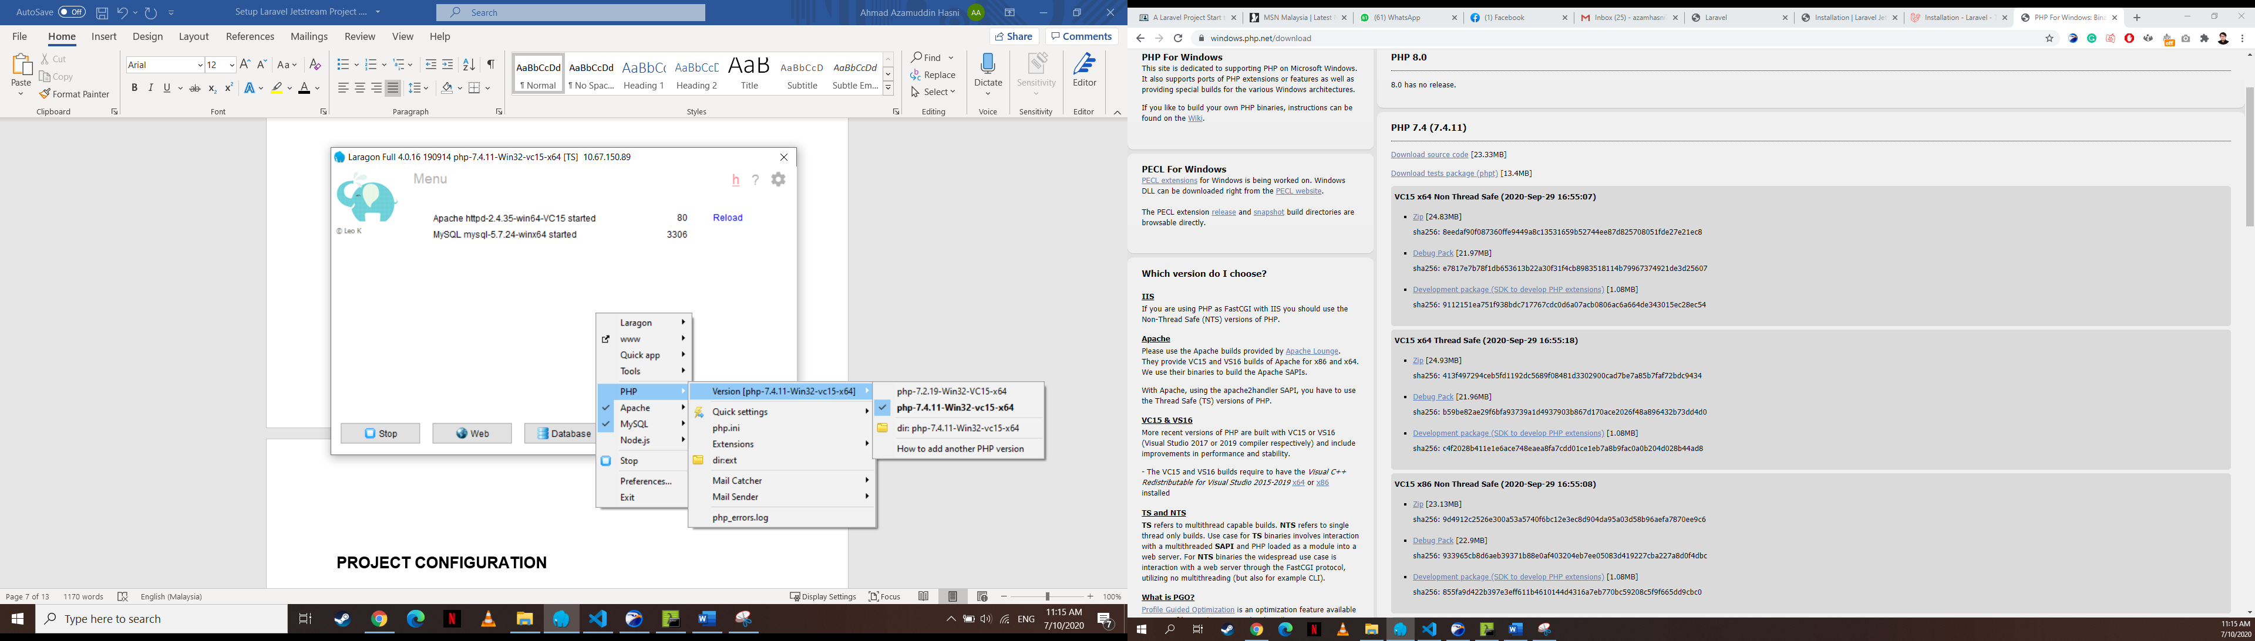

Figure 12:Change PHP version

Next restart your Laragon by click Stop and then Start All button. After that, Open Laragon “Terminal” and run these commands.

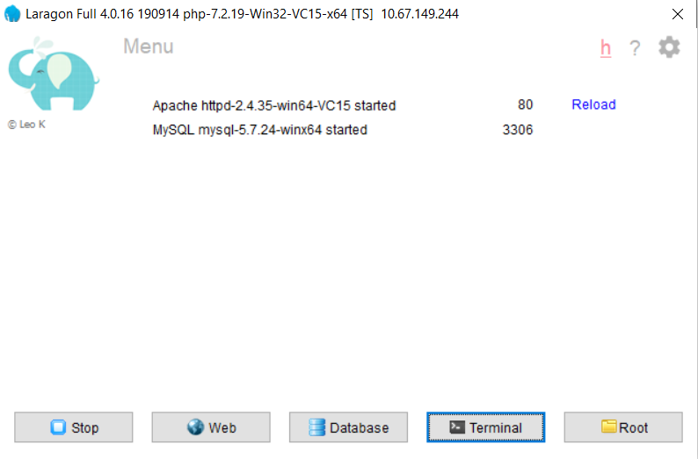

Figure 13:Laragon

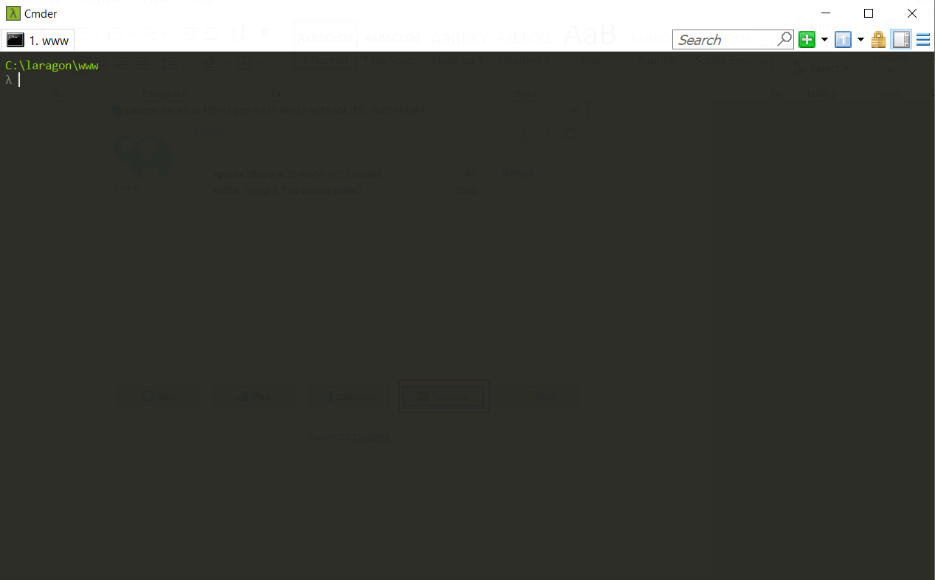

Figure 14:Terminal command prompt

Install Laravel

$ composer global require laravel/installer

Create new project as shown below

$ Laravel new example

*project-name is name of your project. For example in the figure above, example is the project name.

We use HeidiSQL as Database Tool for this project. Click on **“Database”** button in Laragon, the session manager will prompt as shown below



Figure 16:Laragon

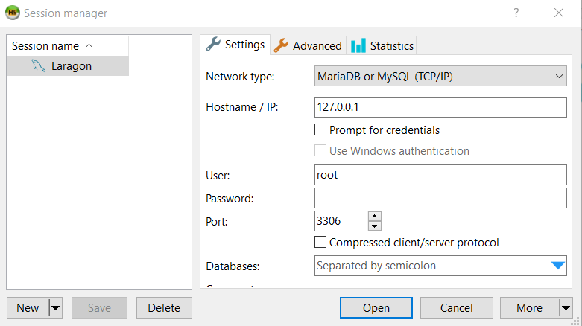

Figure 17: HeidiSQL

Click on the “New” on the left bottom and rename it to “Laragon” as shown above. Then, click “Open” to open HeidiSQL tool.

Right-click on the session name which is “Laragon”, then go to “Create new->Database” and name your database as shown below *(You can skip this if Laragon already automatically create database for you)*

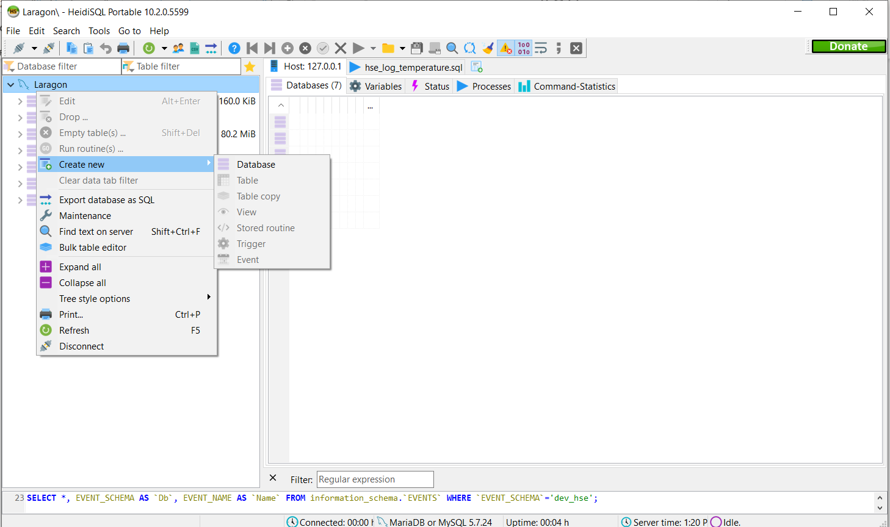

Figure 18: Create new database usin HeidiSQL

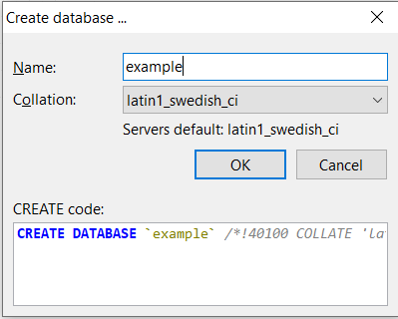

Figure 19: Name Database

Then, setup your database environment by open “.env” file in your Laravel project. Make sure “DB_DATABASE” is your database name in HeidiSQL

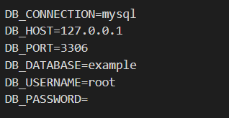

Figure 20: .env database setting

Then, Simply click “Terminal” button on Laragon and run the following command



Figure 21: Laragon

Direct the terminal to your project. Example on the figure below.

$ cd {your-project-name}

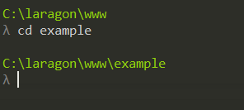

Figure 22: Direct terminal to project folder

Then, run the command below to migrate the tables that come with the project to test your connection is working as expected. Those migration files can be found in *“database/migrations/”.* Command:

And then migrate;

$ php artisan migrate

Installing php dependencies for the newly created Laravel project into your project by using composer;

Composer is a tool for dependency management in PHP. It allows you to declare the libraries your project depends on and it will manage (install/update) them for you. Command:

$ composer install

Storage link;

In modern web development, file uploads are one of the most commonly used features and Laravel Storage provides an intuitive way to handle the file storage. Command:

$ php artisan storage:link

Generate new application key;

Application key is used for encryption and session. After you run the command below, you can check your key named “**APP_KEY**” in **“.env”** file in your Laravel project. Command:

$ php artisan key:generate

To open the website, simply right-click laragon, navigate to “www” and to your project name

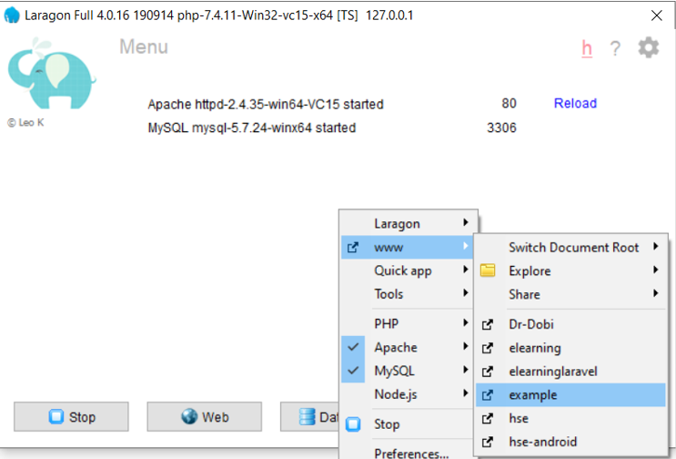

Figure 23: How to open the website through Laragon

The page should look like this and this is the starting page of Laravel application by default and you can start code your own user ineterfaces.

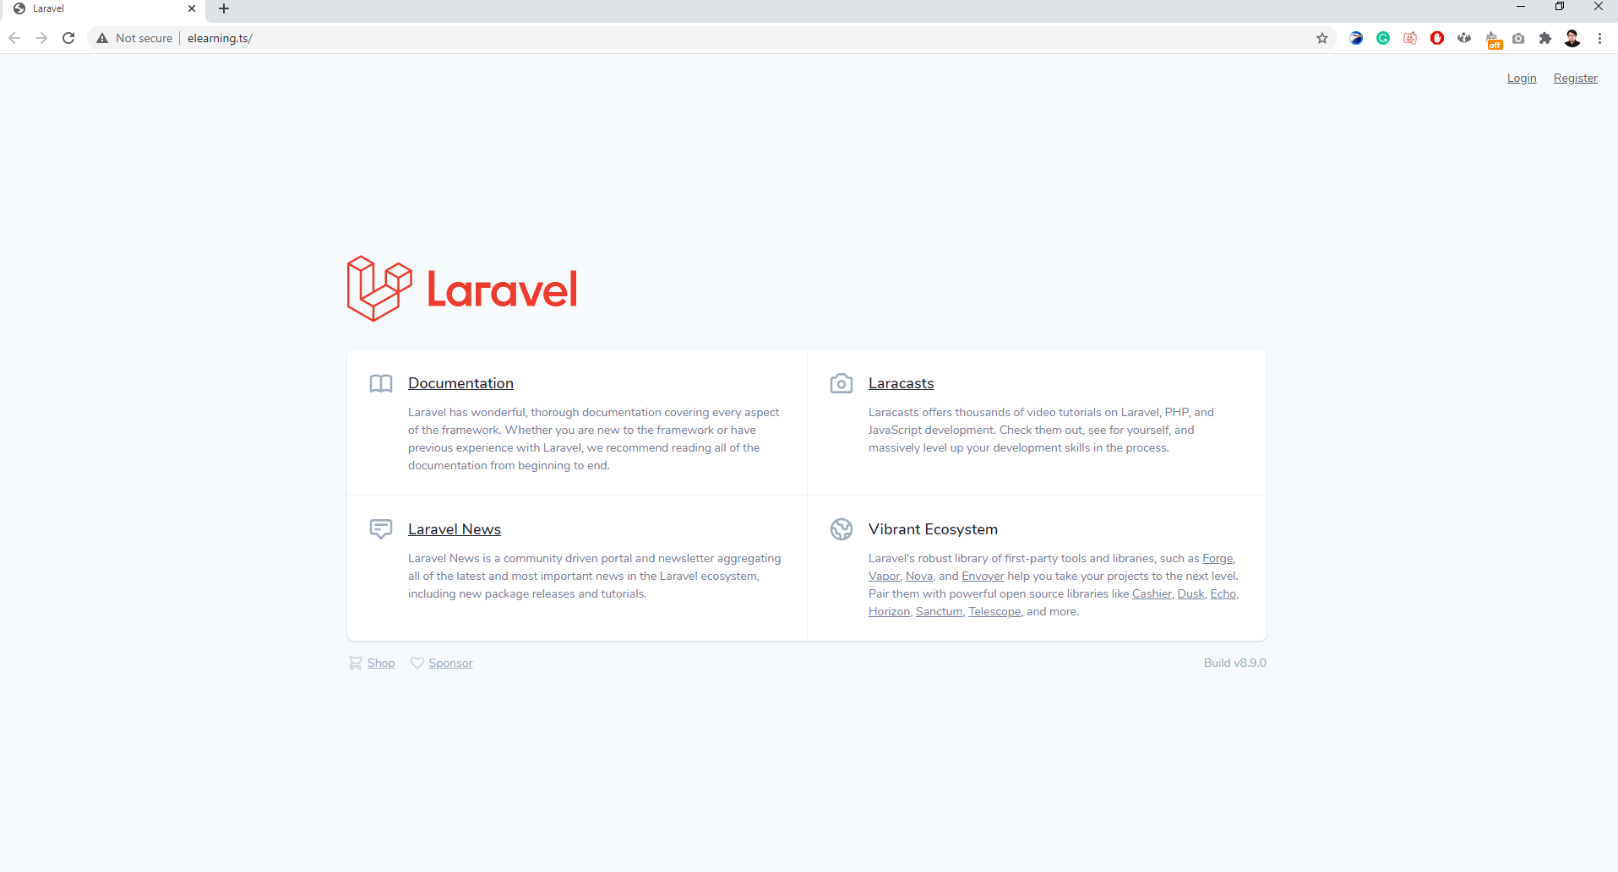

Figure 24: Laravel Website

# CASE STUDY – E-LEARNING (MINI PROJECT)

This mini project require you to built a simple e-learning website using Laravel framework. MVC architecture is used in Laravel project. Various functionality provided by Laravel like migration, seeding and request must be used in this project. The functionality for each users have been described in the use case below:

## Use Case Specification

* 1. UC001 – Registration

User can register themselves into the system

* 1. UC002 – Login

User can login into the system

* 1. UC005 – Manage Course

User can add course and manage resources inside the course.

# HOW TO SETUP – ELEARNING (MINI PROJECT)

1. From the provided resources, navigate to Code folder and extract the file named “**Laravel Short Course.rar**”. Inside the extracted folder, copy the folder “**elearning**” to your laragon local web server directory. Basically the default path is : “**C:\laragon\www**”.

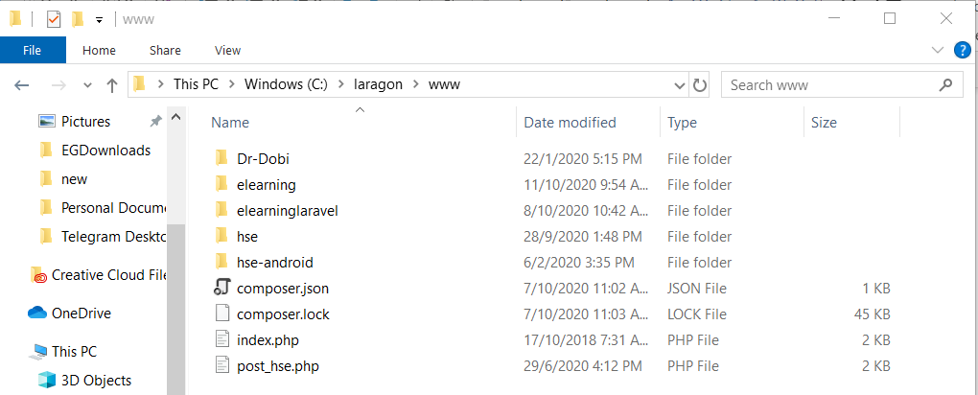

Figure 27: Laragon local web server directory

1. Open Laragon through the taskbar (if already running) and click “**Start All**”. Make sure to open only one Laragon at a time. To check, view your taskbar and confirm that only one Laragon is running.

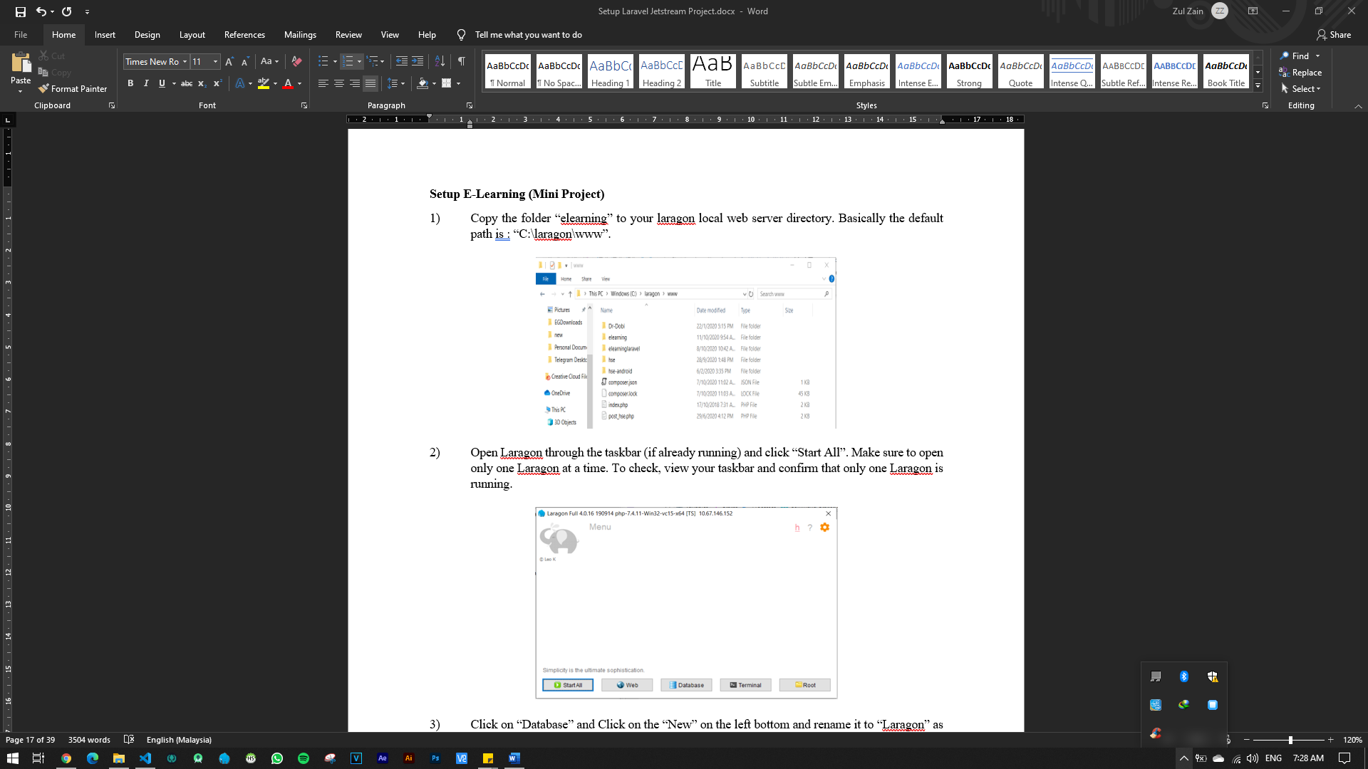 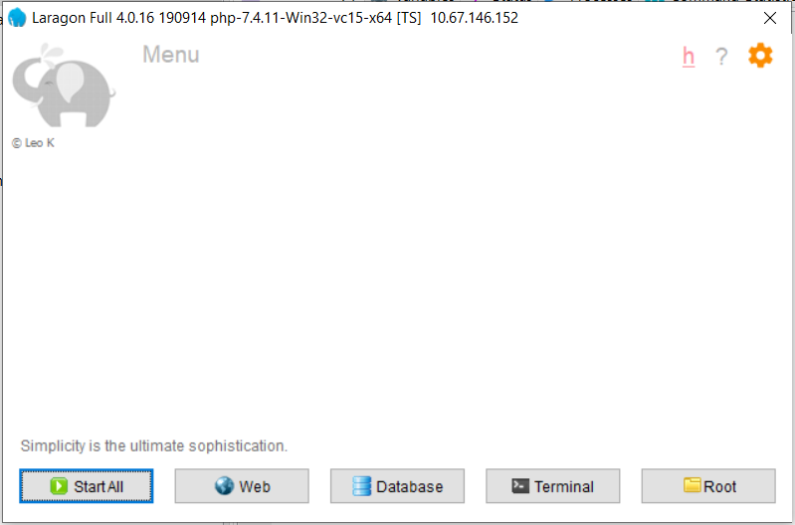

Figure 28: Laragon running at taskbar

1. Click on “**database**”.



Figure 29: Laragon interface

1. Click “**Open**” to open HeidiSQL (DB Manager) tool.



Figure 30: HeidiSQL Startup Interface

1. Right click on your server name and select “**Create New”** and choose “**database”**.

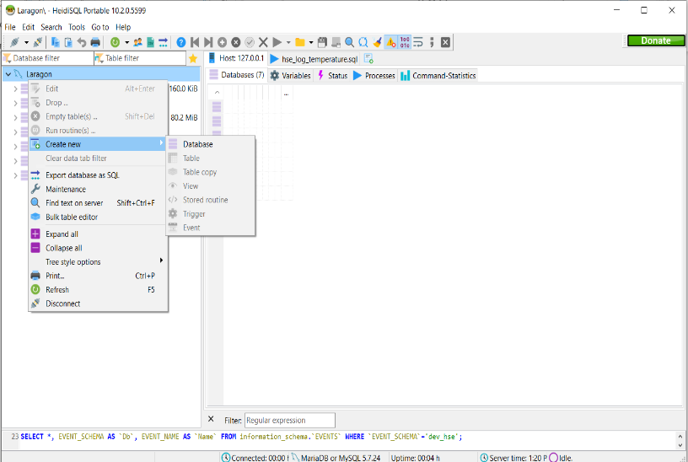

Figure 31: Create new database in HeidiSQL

1. Give your database name as “**elearning**”.

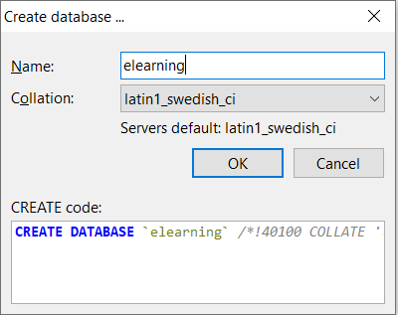

Figure 32: HeidiSQL new database name

1. To connect your project with database, we must configure database setting inside our project environment. Open your project code through Terminal provide by laragon.



Figure 33: Opening terminal using Laragon

1. Navigate to your project folder by inserting command “**cd elearning**” into the terminal and insert command **“code .”** . This will open your code editor (VS Code).

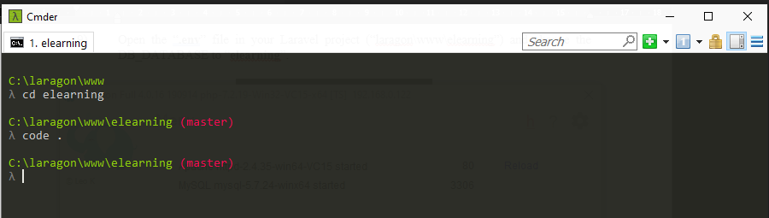

Figure 34: Navigate to project folder inside terminal

1. We need to modify some of our project environment through .env so our project can connect with database that we just created. Copy the “**.env.example**” file and rename it to “.**env**” file. Inside .**env** file rename the **DB_DATABASE** name to **elearning** which is the database name that you just create for this project.

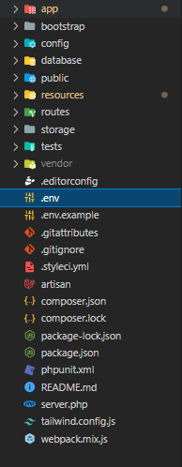 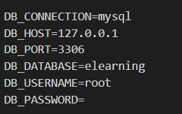

Figure 35: .env file inside root project directory

1. There are some command you need to run in the terminal before you can start running the system. Open back terminal and run the command below:
2. Install all laravel project dependencies : “**composer install**”
3. Database Migration : “**php artisan migrate**”
4. Laravel storage link : “**php artisan storage:link**”
5. Laravel application key : “**php artisan key:generate**”
6. Laravel includes the ability to seed your database with data so we already make some **data seeder** to insert a user into the database so you can use it to login into the system. Please run “**php artisan db:seed --class=UserSeeder**” inside the terminal. On successful, run your web project through laragon and login using below credential.

Username : [admin@mail.com](mailto:admin@mail.com)

Password : 123456

1. Open Visual Studio Code and you are ready to code!
2. Directory Structure :

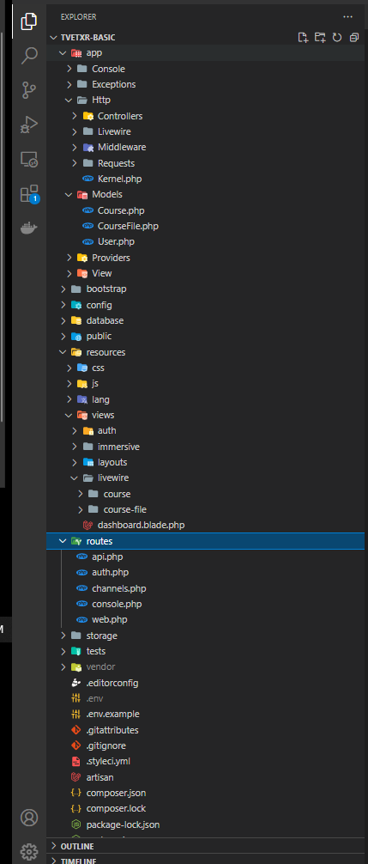

**Route**

All the route for our web will be place inside this folder.

**Model (M)**

All our models will be place into this folder.

**Controller (C)**

With Laravel Livewire, you will use the livewire folder as the **controller**. All the logical code will go into this folder.

**View (V)**

With Laravel Livewire, you will use the livewire folder as your View.

Figure 36: Project directory structure

# BRIEFING – E-LEARNING (MINI PROJECT)

The project was installed with Laravel Livewire which is one of Laravel Package that makes building dynamic interfaces simple, without leaving the comfort of Laravel. To know more about Livewire, you can visit the website at https://laravel-livewire.com/.

The project already comes with some pages which include login page, register page and home page which has been created for the purpose of this tutorial.

Below, we briefly explained on existed page that has been prebuilt by us to kickstart this project fast.

## Login Page

Model: User.php

View: login.blade.php

Controller: AuthenticatedSessionController.php

Route: /login

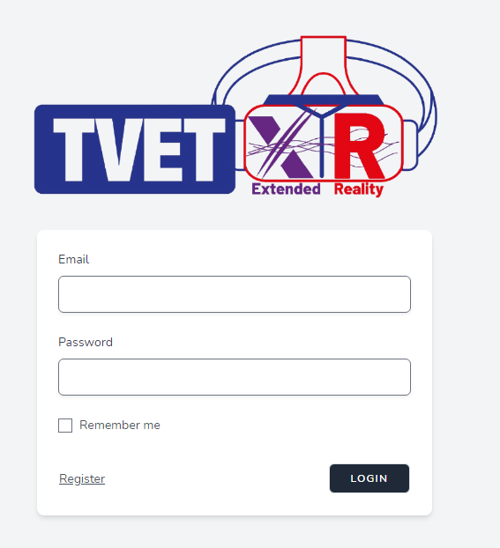

## Register Page

Model: User.php

View: register.blade.php

Controller: RegisteredUserController.php

Route: /register

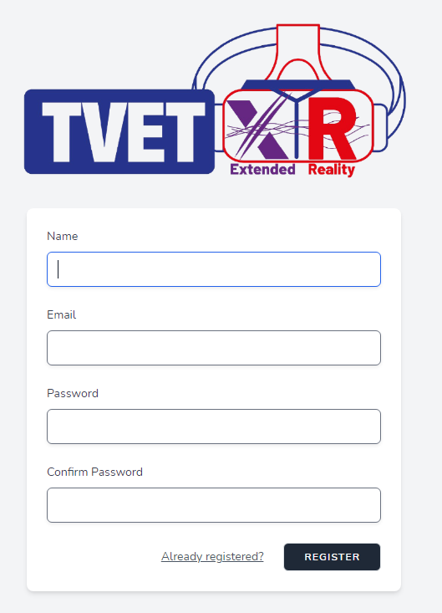

## Home Page

Model: Not used

View: [home.blade.php](http://home.blade.php)

Controller: Not used

Route: /home

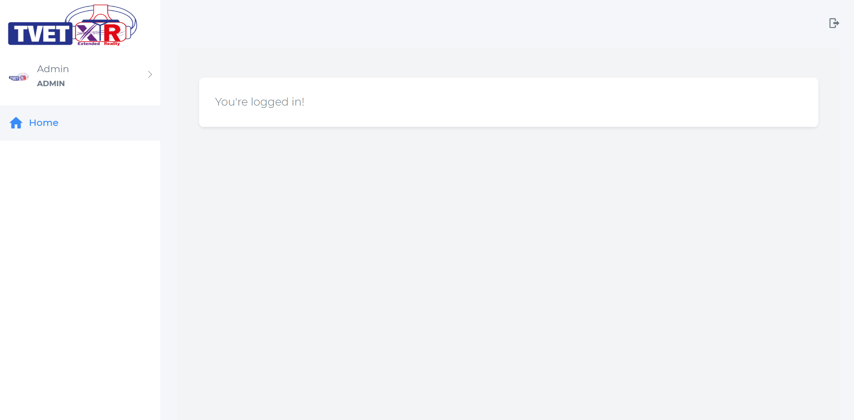

## Course Module

### Submodule – Create New Course

Submodule Outcome – At the end of this module, you can develop the Submodule Create New Course. This module will include below function:

|  |  |
| --- | --- |
| 1. Show the course data 2. Creating the course | 1. Edit the course 2. Delete the course. |
|  |  |

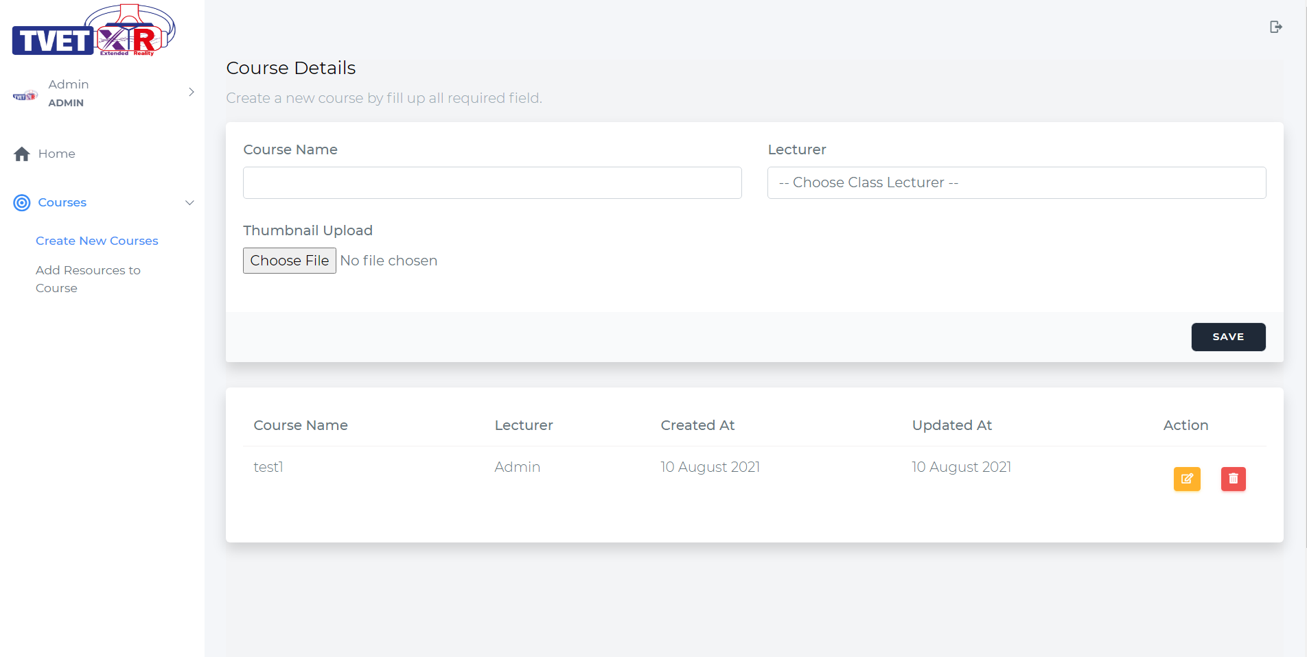

Figure 67: Course management page for admin

1. To have like above page. We must have the **Model-View-Controller (MVC)** component.
2. **For Model**, open the “**elearning-source**” folder and navigate to **Model** folder. Copy the **“Course.php”** file and paste it to “**www\elearning\app\Models\”** in your project folder. This will be the model for course.

**Explanation:** We already provide the Model file in the “**elearning-source**” folder to make things easier for you to develop. The default way of generating Course model is through Laravel artisan command in terminal which is “**php artisan make:model Course**”. This will create model file inside “**app\Models\Course.php**”.

1. **For Controller**, open the “**elearning-source**” folder and navigate to **Controller -> Course** folder. Copy the **“CourseWire.php”** file and paste it to “**app\Http\Livewire\Course**” (inside project folder)**.** This will be the logical code for this submodule.
2. **For View,** open back “**elearning-source**” folder and navigate to **View -> course** folder. Copy the **“course-wire.blade.php”** fileand paste it to “**resources\views\livewire\course**” (inside project folder). This will be the view for this submodule.

**Explanation:** We also provide the Controller and View file in the “**elearning-source**” folder to make things easier for you to develop. The default way of generating the component is through artisan console command in terminal. The artisan command to generate the component is ‘**php artisan make:livewire Course\\CourseWire**’. This will create the Controller file inside “**app\Http\Livewire\Course\CourseWire.php**” and View file inside “**resources\views\livewire\course\course-wire.php**”.

**Route**

1. Route defines the URL pattern that you want to generate. Route will point to a controller. From the controller you can develop process logic or return to a view (V) or redirect to other url. Now open back your project inside the VS Code and lets take a look at the route located at web.php. For quick search, use the hotkey “**Ctrl+P**” and key in “**web.php**”.

Uncomment below code. This is route we use to navigate to course page. The **url “/course”** will point to “**CourseWire.php**” class where the “**function render()**” inside “**CourseWire.php**” class will be run to return the user to the view (V)

<?php

use Illuminate\Support\Facades\Route;

use App\Http\Livewire\Course\CourseWire;

// use App\Http\Livewire\CourseFile\CourseFileWire;

Figure 68: Import class of CourseWire

And you need to import the class so the route can access to the right class that you have assigned.

//////////////////////////////////////////////////////////////////////////////

//Laravel Livewire Route

//////////////////////////////////////////////////////////////////////////////

Route::middleware('auth')->group(function () {

    Route::get('/home', function () {

        return view('home');

    })->name('home');

    Route::get('/course',   CourseWire::class);

    // Route::get('/coursefile',    CourseFileWire::class);

});

//////////////////////////////////////////////////////////////////////////////

Figure 69: Insert route to CourseWire class

1. Now open the system and try insert the **url “/course”** after your local domain.

Example: **elearning.test/course** This will bring you to the empty course page.

**Explanation:** The route pointing to the “**CourseWire.php**” class where inside the class the “**function render()**” is run and the function return a view “**course-wire.blade.php**”. Inside that view you will find the view code to generate below page.

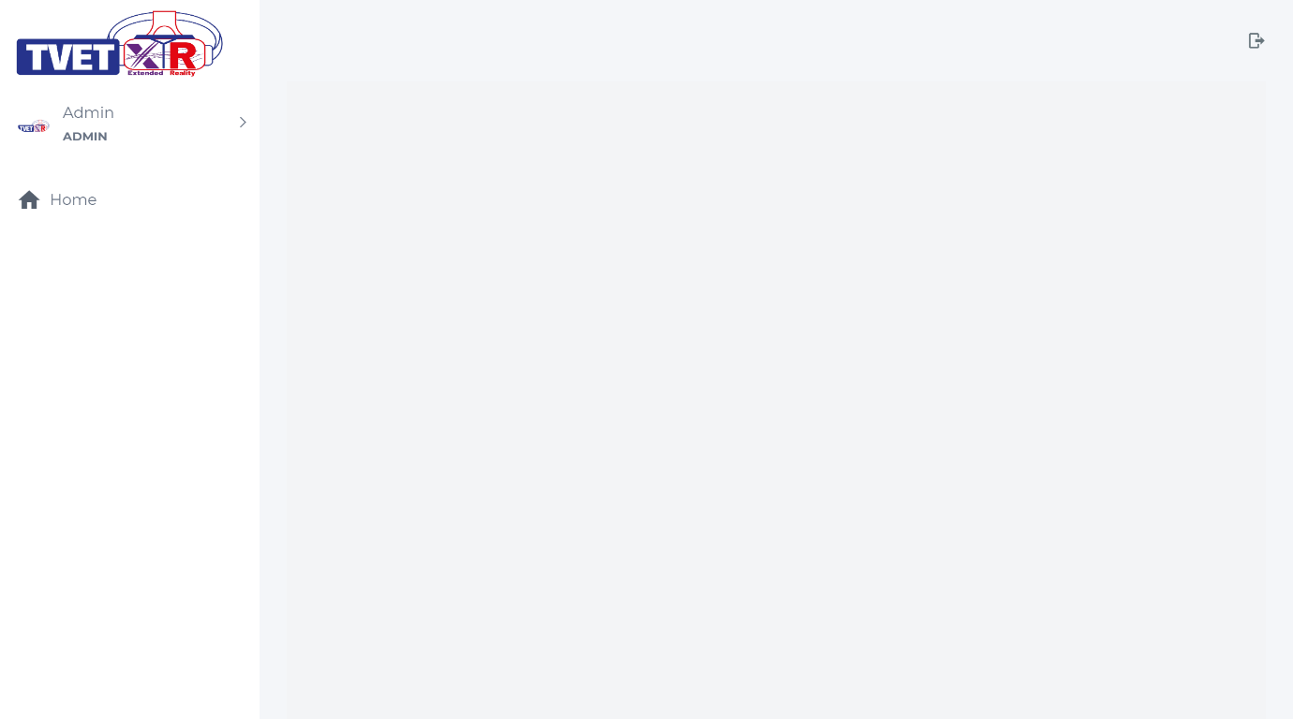

Figure 71: Empty course page

1. The sidebar and topbar of the system using layout file call “**app.blade.php**”. This layout will be use by all other pages so we don’t need to build the topbar and sidebar everytime we want to create a new page.
2. Inside project folder navigate to **resources/views/layouts** folder and open “**app.blade.php**” file. We need to have Course menu at the sidebar. To have those menus, uncomment the course menu under administration section. This will display the course menu at system sidebar. We use <a> tag as a link to the Create New Course page when user click on the Create New Course menu.

{{-------- START SECTION - ADMINISTRATION --------}}

@if (auth()->user()->role == 'admin')

    <li> <a class="has-arrow waves-effect waves-dark" href="#" aria-expanded="false"><i class="mdi mdi-bullseye"></i><span class="hide-menu">Courses </span></a>

        <ul aria-expanded="false" class="collapse">

            <li><a href="{{URL::to('course')}}">Create New Courses</a></li>

            <li><a href="{{URL::to('coursefile')}}">Add Resources to Course</a></li>

        </ul>

    </li>

@endif

{{-------- END SECTION - ADMINISTRATION --------}}

Figure 72: “app.blade.php” section administration source code

1. Now open back the system and you can see course menu has been display at the sidebar but with an empty content.

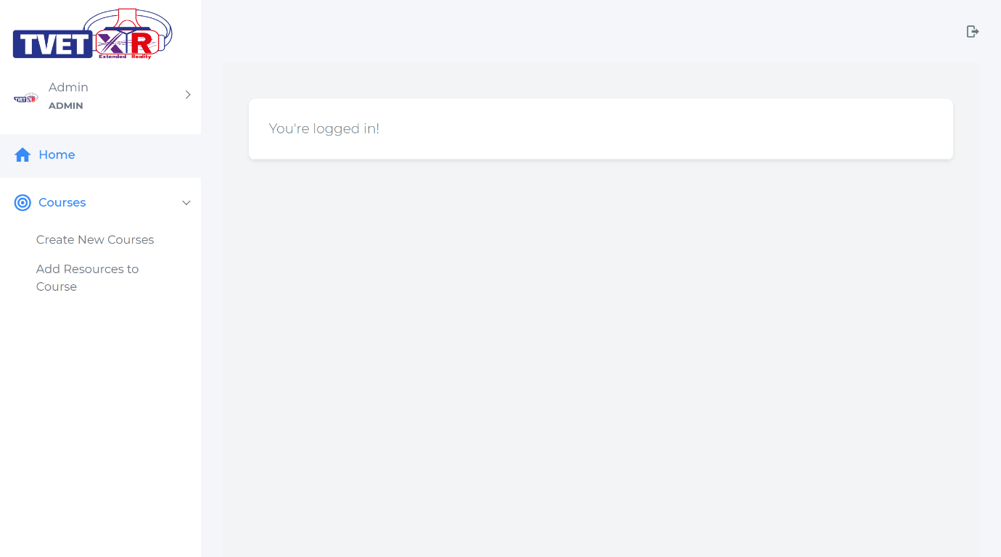

Figure 73: Empty course page with sidebar

#### Show the Course Data Function

1. Go to “**CourseWire.php**” inside **app/Http/Livewire/Course** folder and follow the code like below:

<?php

namespace App\Http\Livewire\Course;

use Livewire\Component;

Import course model so we can use it to fetch course data.

use App\Models\Course;

class CourseWire extends Component

{

    // public $course_id;

    // public $name;

    // public $action;

    // protected $listeners = [

    //     'refreshParent' => '$refresh',

    //     'delete'

    // ];

    // public function selectItem($modelid , $action)

    // {

    //     $this->course_id = $modelid;

    //     $this->action = $action;

    //     if($action == "update")

    //     {

    //         $this->emit('getModelId' , $this->course_id);

    //     }

    //     else if($action == "manageCourseResources")

    //     {

    //         $this->emit('getModelIdDeeper' , $this->course_id);

    //         $this->dispatchBrowserEvent('openModal_manageCourseResources');

    //     }

    // }

We use eloquent ORM provide by Laravel to fetch course data from database. Eloquent ORM is a beautiful, simple ActiveRecord implementation for working with your database.

The render method gets called on the initial page load & every subsequent component update.

    // public function delete()

    // {

    //     $course = Course::find($this->course_id);

    //     $course->delete();

    // }

    public function render()

    {

        $courses = Course::all();

        return view('livewire.course.course-wire')->with(compact('courses'));

Course data that have been fetch are return to the view using “with(compact())”

        // return view('livewire.course.course-wire');

    }

}

Figure 74: “CourseWire.php” source code

1. Go to “**course-wire.blade.php**” inside **resources/views/livewire/course** folder and uncomment the section “**DATATABLE COURSE**” like below. This is a table to show the list of course.

<div>

{{-- START SECTION - COURSE FORM  --}}

{{-- @livewire('course.course-form-wire') --}}

{{-- END SECTION - COURSE FORM  --}}

{{-- START SECTION - DATATABLE COURSE  --}}

<div class="row">

    <div class="col-md-12">

        <div class="card" style="box-shadow: 0 .5rem 1rem rgba(0,0,0,.15)!important;border-radius: 5px;">

            <div class="card-body" style="overflow:scroll">

                <table class="table table-hover" >

                    <thead>

                        <tr>

                            <th>Course Name</th>

                            <th>Lecturer</th>

                            <th>Created At</th>

                            <th>Updated At</th>

Course data send from controller is use to show all course exist in system.

                            <th style='width:40px'>Action</th>

                        </tr>

                    </thead>

                    @foreach ($courses as $course)

                        <tbody>

                            <tr>

                                <td>{{$course->name}}</td>

                                <td>{{$course->lecturer ? $course->lecturer->name : 'undefined'}}</td>

                                <td>{{date('j F Y', strtotime($course->created_at))}}</td>

                                <td>{{date('j F Y', strtotime($course->updated_at))}}</td>

                                <td>

                                    <table style="border:none">

                                        <tr>

                                            <td style="border:none">

                                                <button type="button" wire:click="selectItem({{$course->id}} , 'update' )" class="btn btn-sm waves-effect waves-light btn-warning"><i class="far fa-edit"></i></button>

                                            </td>

                                            <td style="border:none">

                                                <button type="button" wire:click="selectItem({{$course->id}} , 'delete' )" class="btn btn-sm waves-effect waves-light btn-danger data-delete" data-form="{{$course->id}}"><i class="fas fa-trash-alt"></i></button>

                                            </td>

                                        </tr>

                                    </table>

                                </td>

                            </tr>

                        </tbody>

                    @endforeach

                </table>

            </div>

        </div>

    </div>

</div>

{{-- END SECTION - DATATABLE COURSE  --}}

@push('scripts')

{{-- START SECTION - SCRIPT FOR DELETE BUTTON  --}}

{{-- <script>

  document.addEventListener('livewire:load', function () {

    $(document).on("click", ".data-delete", function (e)

        {

            e.preventDefault();

            swal({

            title: "Are you sure?",

            text: "Once deleted, you will not be able to recover!",

            icon: "warning",

            buttons: true,

            dangerMode: true,

            })

            .then((willDelete) => {

            if (willDelete) {

                e.preventDefault();

                Livewire.emit('delete')

            }

            });

        });

  })

</script> --}}

{{-- END SECTION - SCRIPT FOR DELETE BUTTON  --}}

@endpush

</div>

Figure 75: “course-wire.blade” source code

1. Now open the system and you will see table of course with empty data. We need to create a form to add course data.

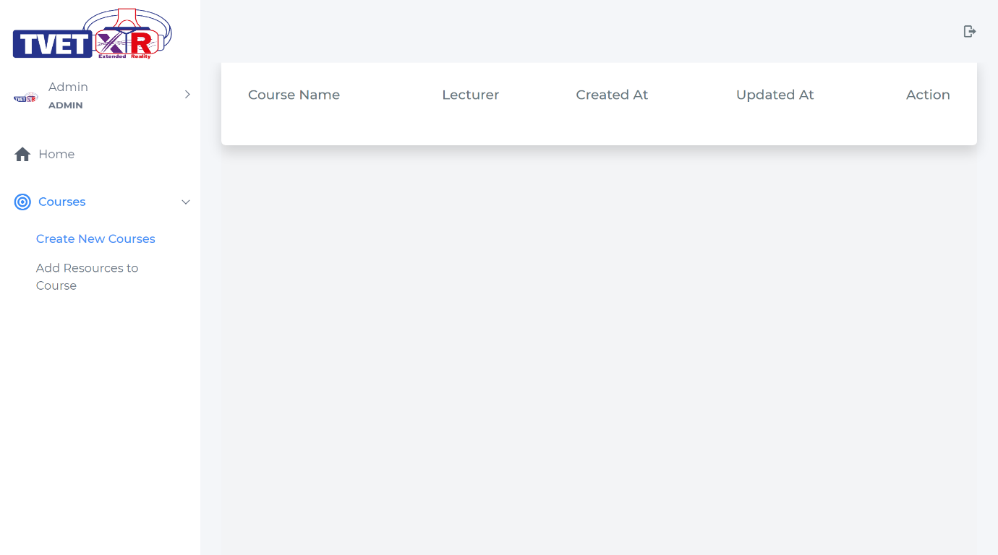

Figure 76: Create New Course page with table of course

#### Creating the course Function

1. Now, we already have view for table of course. To have a create function, go to “**CourseFormWire.php**” inside **app/Http/Livewire/Course** folder and uncomment the code like below:

<?php

namespace App\Http\Livewire\Course;

use Livewire\Component;

Import user and course model so we can use it to fetch the data.

use App\Models\User;

use App\Models\Course;

class CourseFormWire extends Component

Public properties in Livewire are automatically made available to the view. You need to declare all the properties needed in view(V) here.

{

    public $name;

    public $id_lecturer;

    // public $model_id;

    // protected $listeners = [

    //     'getModelId'

    // ];

    // public function getModelId($model_id)

    // {

    //     $course = Course::find($model_id);

    //     $this->model_id = $course->id;

    //     $this->name = $course->name;

    //     $this->id_lecturer = $course->id_lecturer;

    // }

    public function store()

    {

    //     if($this->model_id)

    //     {

    //         $this->validate([

    //             'name' => 'required|string|max:255',

    //         ]);

    //         $update = Course::find($this->model_id);

    //         $update->name = $this->name;

    //         $update->id_lecturer = $this->id_lecturer;

    //         $update->save();

    //         session()->flash('message', 'Course successfully updated');

    //     }

    //     else

    //     {

            $this->validate([

Store function for creating new course. We must first validate the input from view(V) . If validation is fail, error message is return to view.

                'name' => 'required|string|max:255',

                'id_lecturer' => 'required',

            ]);

            $add = New Course;

If validation is successful. We use the eloquent ORM to store course data into database.

            $add->name = $this->name;

            $add->id_lecturer = $this->id_lecturer;

            $add->save();

Send message to view on successful store course into database.

            session()->flash('message', 'New course

successfully added');

    //     }

        // $this->emit('refreshParent');

We use eloquent ORM provide by Laravel to fetch user data with role == lecturer. By using the where method.

    }

    public function render()

    {

        $lecturers = User::where('role' , 'lecturer')->get();

        return view('livewire.course.course-form-wire')->with(compact('lecturers'));

        // return view('livewire.course.course-form-wire');

    }

}

Figure 77: “CourseFormWire.php”

1. Now go to “**course-form-wire.blade.php**” inside **resources/views/livewire/course** folder and uncomment the section “**COURSE FORM**”.

<div>

    {{-- START SECTION - COURSE FORM  --}}

    <div class="row">

        <div class="col-lg-4">

            <h3 style="color:black">Course Details</h3>

Laravel livewire use wire:submit.prevent = ”function in controller” to submit form.

            <p class="text-muted">Create a new course by fill up all required field.</p>

        </div>

        <div class="col-lg-12">

            <form wire:submit.prevent="store">

            <div class="card" style="box-shadow: 0 .5rem 1rem rgba(0,0,0,.15)!important;border-radius: 5px;">

                <div class="card-body" >

                    <div class="row">

                        <div class="col-md-6">

                            <div class="form-group">

                                <label class="control-label" style="font-weight:500">Course Name</label>

                                <input wire:model="name" type="text" id="name" name="name" class="form-control" >

Laravel livewire use wire:model to synchronize value of form input and public properties in the controller.

                                @error('name') <span class="error">{{ $message }}</span> @enderror

                            </div>

                        </div>

                        <div class="col-md-6">

                            <div class="form-group">

                                <label class="control-label" style="font-weight:500">Lecturer</label>

                                   @if (auth()->user()->role == 'admin')

                                   <select wire:model="id_lecturer" name="id_lecturer" id="id_lecturer" class="form-control custom-select" data-placeholder="Choose Class Owner" tabindex="1">

                                        <option value="">-- Choose Class Lecturer --</option>

                                        @foreach ($lecturers as $lecturer)

                                            <option value="{{$lecturer->id}}">{{$lecturer->name}}</option>

                                        @endforeach

                                    </select>

                                   @else

                                   <select wire:model="id_lecturer" name="id_lecturer" id="id_lecturer" class="form-control custom-select" data-placeholder="Choose Class Owner" tabindex="1">

                                    <option value="">-- Choose Class Lecturer --</option>

                                    <option value="{{auth()->user()->id}}">{{auth()->user()->name}}</option>

                                   </select>

                                   @endif

                                @error('id_lecturer') <span class="error">{{ $message }}</span> @enderror

If validation is fail at controller. It will return the error message to view and the message will show up here.

                            </div>

                        </div>

                    </div>

                </div>

                <div class="card-footer" style="background-color: #f9fafb !important;border-top: none;">

                    <div class="row">

                        <div class="col-md-12 text-right">

                            @if (session()->has('message'))

                                {{ session('message') }}

                            @endif

                            <button type="submit" class="inline-flex items-center px-4 py-2 bg-gray-800 border border-transparent rounded-md font-semibold text-xs text-white uppercase tracking-widest hover:bg-gray-700 active:bg-gray-900 focus:outline-none focus:border-gray-900 focus:shadow-outline-gray disabled:opacity-25 transition ease-in-out duration-150">

                                Save

                            </button>

                        </div>

                    </div>

                </div>

            </div>

        </form>

        </div>

    </div>

    {{-- END SECTION - COURSE FORM  --}}

</div>

Figure 78: “course-form-wire.blade.php” source code

1. To include “**course-form-wire.blade**” component inside “**course-wire.blade**”. Go to “**course-wire.blade**” inside **resources/views/livewire/course** folder and uncomment the section “**COURSE FORM**”.

{{-- START SECTION - COURSE FORM  --}}

@livewire('course.course-form-wire')

{{-- END SECTION - COURSE FORM  --}}

Figure 79: “course-wire.blade” Course Form section

1. Now go back to system and you will see the create form for course , you can create new course after fill in all the required field and click the save button. Go on and try. On successful , you will got a message notified that course successfully created but if you notice, the course table does not update and show the latest course that you just create in real-time, this mean you need to refresh the page to see the change.

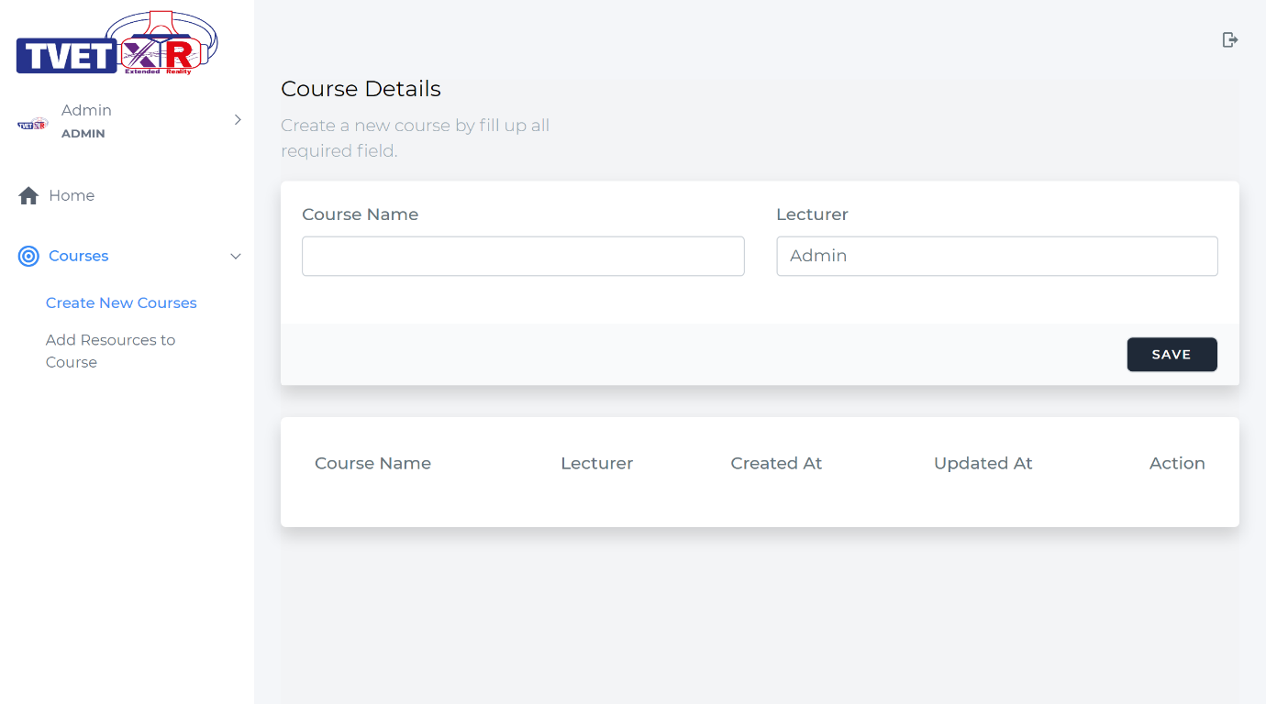

Figure 80: Create New Course page with table of course & create new course component

1. To have a real-time update on the course table go back to “**CourseWire.php**” inside **app/Http/Livewire/Course** folder and uncomment some code like below. This is the listener to listen on succesful store event of course.

protected $listeners = [

        'refreshParent' => '$refresh',

        // 'delete'

    ];

Figure 81: “CourseWire.php” listener

1. After that go to “**CourseFormWire.php**” inside **app/Http/Livewire/Course** folder and uncomment below code. This code is use to triggered the listener after all the logic above it successfully executed without error.

   $this->emit('refreshParent');

Figure 82: “CourseFormWire.php” emitting to listener

1. We use listener on store function in “**CourseFormWire.php**” to detect if course have been successfully created. First, we **define the listener** in “**CourseWire.php**” just like in the code above. Then we call the listener by using **emit(‘refreshParent’)**. When the listener is triggered, the **magic keyword** provide by Laravel livewire which is **“$refresh”** will refresh the “**CourseWire.php**” component automatically which is the course table so we will have the latest data that we just created. Go on and try to insert back new course.

#### Edit the Course Function

1. If you noticed we already uncomment some code inside “**course-wire.blade**”. The code will fire when user click on the button. The **wire:click** event will run the **selectItem** function inside “**CourseWire.php**” to set all the public properties to a specific course that we have choose.

<td style="border:none">

    <button type="button" wire:click="selectItem({{$course->id}} , 'update' )" class="btn btn-sm waves-effect waves-light btn-warning"><i class="far fa-edit"></i></button>

</td>

1. Go to “**CourseWire.php**” inside **app/Http/Livewire/Course** folder and uncomment below code. The “**selectItem**” function will run on “**wire:click**” that we define at “**course-wire.blade.php**”. We write the logic ‘**if($action == “update”)**’ if the parameter “**$action**” pass an “**update**” value, thus it will emit listener name “**getModelId**” with parameter of **course id**.

public function selectItem($modelid , $action)

    {

        $this->course_id = $modelid;

        $this->action = $action;

        if($action == "update")

        {

            $this->emit('getModelId' , $this->course_id);

        }

        else if($action == "manageCourseResources")

        {

            $this->emit('getModelIdDeeper' , $this->course_id);

            $this->dispatchBrowserEvent('openModal_manageCourseResources');

        }

    }

Figure 83: “CourseWire.php” selectItem function

1. After that, go to “**CourseFormWire.php**” inside **app/Http/Livewire/Course** folder and uncomment below code. This code is to listen to an event call “**getModelID**” from the “**CourseWire.php**”. The listener will run the function **getModelId** and set all the data of course. This data will synchronise automatically with the view where we define **wire:model** at “**course-wire-form.blade.php**”..

<?php

namespace App\Http\Livewire\Course;

use Livewire\Component;

use App\Models\User;

use App\Models\Course;

class CourseFormWire extends Component

{

    public $name;

    public $id_lecturer;

    public $model_id;

    protected $listeners = [

        'getModelId'

    ];

    public function getModelId($model_id)

    {

        $course = Course::find($model_id);

        $this->model_id = $course->id;

        $this->name = $course->name;

        $this->id_lecturer = $course->id_lecturer;

    }

Figure 84: “CourseFormWire.php”

1. Now go on to system and click at the edit button and you will see the data that you want to edit will automatically fill in the course form component.

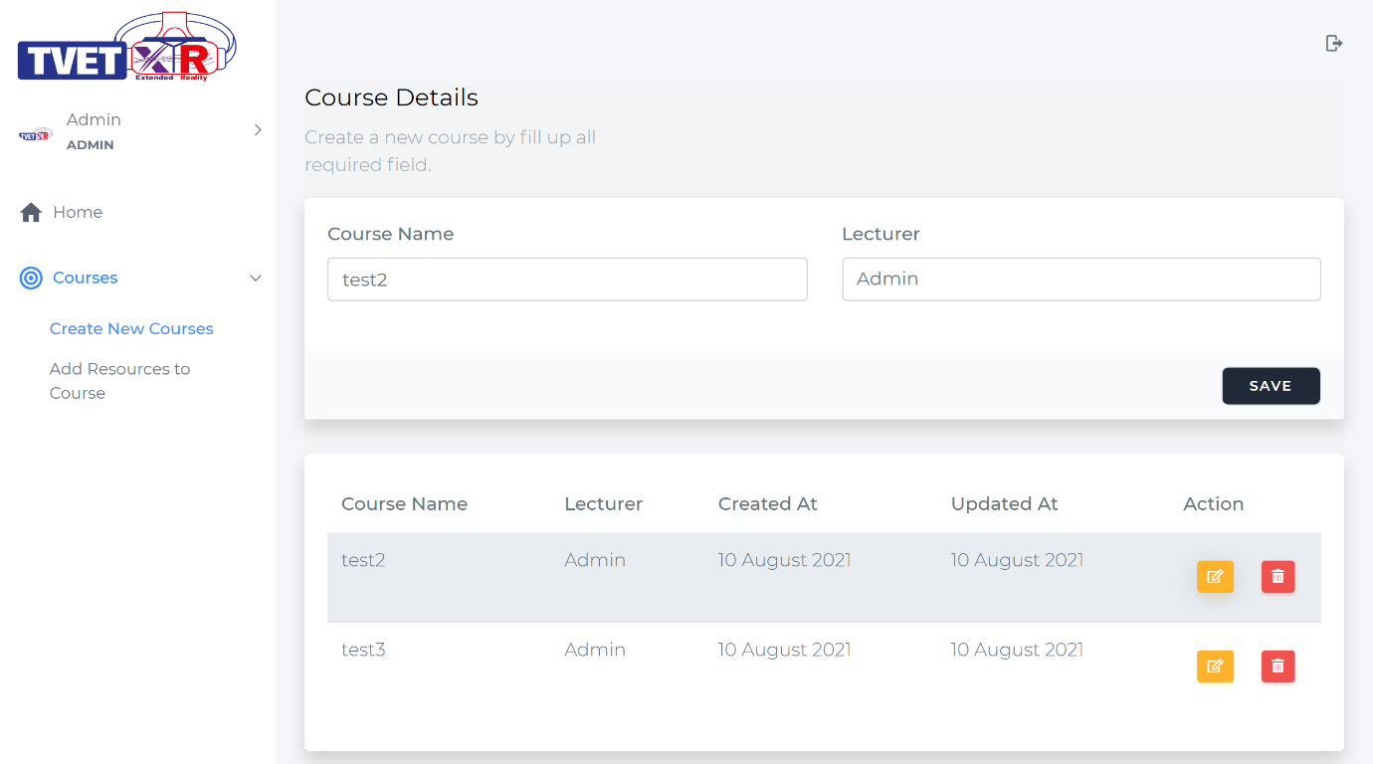

Figure 85: Create New Course page with applied real-time update

1. But If you click on the save button, the data will create a new course. To enable the edit function lets do some logic on the store function. Go back to “**CourseFormWire.php**” inside **app/Http/Livewire/Course** folder and uncomment all the code located in the store function.

 public function store()

    {

If this function detect “model_id” has a value, then it will do an update to the existed course data.

        if($this->model_id)

{

            $this->validate([

                'name' => 'required|string|max:255',

            ]);

            $update = Course::find($this->model_id);

            $update->name = $this->name;

            $update->id_lecturer = $this->id_lecturer;

            $update->save();

            session()->flash('message', 'Course successfully updated');

        }

        else

        {

            $this->validate([

                'name' => 'required|string|max:255',

                'id_lecturer' => 'required',

            ]);

            $add = New Course;

            $add->name = $this->name;

            $add->id_lecturer = $this->id_lecturer;

            $add->save();

            session()->flash('message', 'New course successfully added');

        }

        $this->emit('refreshParent');

    }

Figure 86: “CourseFormWire.php” source code

1. Lets jump back to the system and edit some course. The edit function will be successful.

#### Delete the course Function

1. If you noticed we already uncomment some code inside “**course-wire.blade**”. The code will fire when user click on the button. The **wire:click** event will run the **selectItem** function inside “**CourseWire.php**” to set all the public properties to a specific user that we have choose.

<td style="border:none">

     <button type="button" wire:click="selectItem({{$course->id}} , 'delete' )" class="btn btn-sm waves-effect waves-light btn-danger data-delete" data-form="{{$course->id}}"><i class="fas fa-trash-alt"></i></button>

</td>

1. Beside using wire:click event, to include delete function, go to “**course-wire.blade.php**” inside **resources/views/livewire/course** folder and uncomment on section “**Script for Delete Button**” like below. This is the script to popup a message of confirmation on deletion of course.

{{-- START SECTION - SCRIPT FOR DELETE BUTTON  --}}

<script>

  document.addEventListener('livewire:load', function () {

This script will run on user click on tag that has a “data-delete” class. If you see at step 26, we define a “data-delete” class at the delete button.

    $(document).on("click", ".data-delete", function (e)

        {

            e.preventDefault();

            swal({

            title: "Are you sure?",

            text: "Once deleted, you will not be able to recover!",

            icon: "warning",

            buttons: true,

            dangerMode: true,

            })

This emit function of delete will sent a message to the listener located at “CourseWire.php” and call the function delete.

            .then((willDelete) => {

            if (willDelete) {

                e.preventDefault();

                Livewire.emit('delete')

            }

            });

        });

  })

</script>

{{-- END SECTION - SCRIPT FOR DELETE BUTTON  --}}

Figure 87: “course-wire.blade.php” Script for Delete Button section

1. After that navigate to “**CourseWire.php**” inside **app/Http/Livewire/Course** folder and uncomment below code inside the file.

  public $course_id;

    public $name;

    public $action;

    protected $listeners = [

Because we already set the public properties on wire:click event at step 27. We can use the value to search for the course and delete it.

        'refreshParent' => '$refresh',

        'delete'

    ];

 public function delete()

    {

        $course = Course::find($this->course_id);

        $course->delete();

    }

Figure 88: “CourseWire.php”

1. Now lets navigate back to system and try the delete function by clicking the delete button as below.

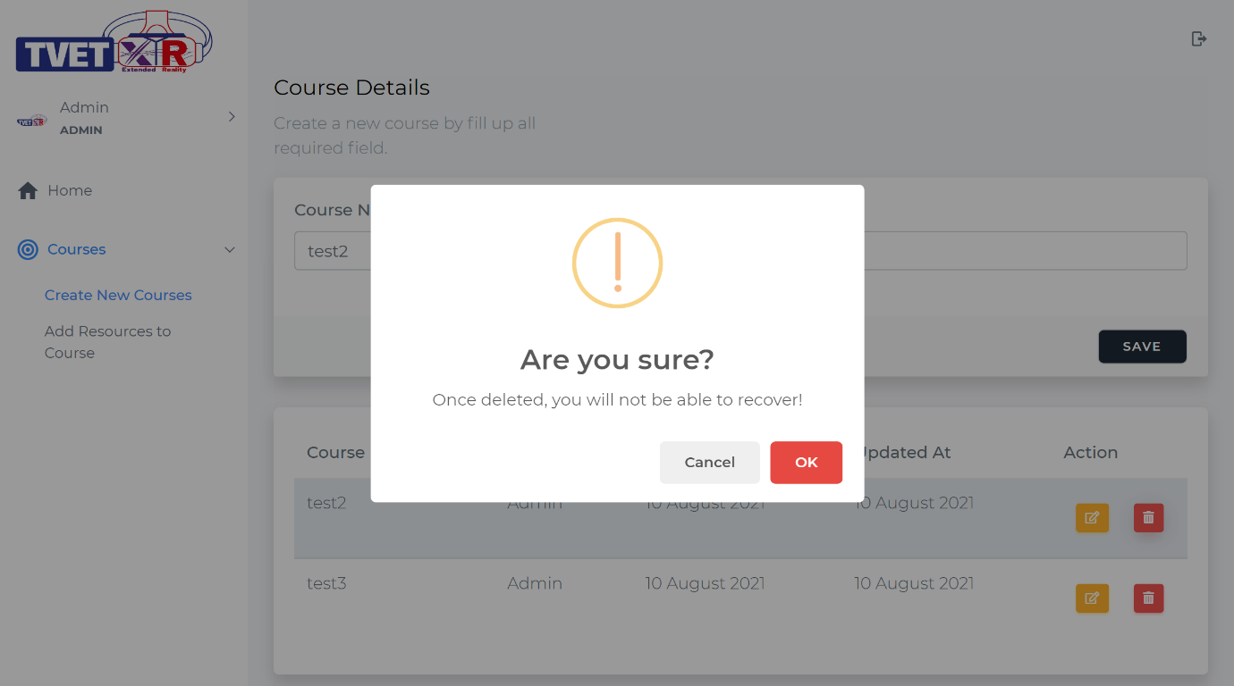

Figure 89: Course Page with delete function

### Submodule – Add Resources to Course

Submodule Outcome – At the end of this module, you can develop the Submodule Add Resources to Course for administration use. This module will include below function:

|  |  |
| --- | --- |
| 1. Show the resources data 2. Add the resources | 1. Delete the resources |

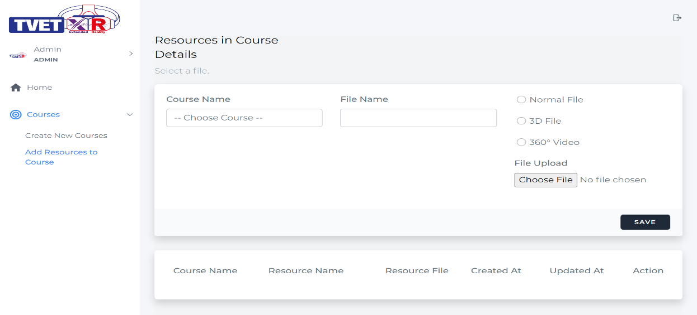

Figure 90: Course File management page for admin

1. To have like above page. We must have the **Model-View-Controller (MVC)** component.
2. **For Model**, open the “**elearning-source**” folder and navigate to **Model** folder. Copy the **“CourseFile.php”** file and paste it to “**app\Models\”** in your project folder. This will be the model for course file.

**Explanation:** We already provide the Model file in the “**elearning-source**” folder to make things easier for you to develop. The original way of generating Course File model is through Laravel artisan command in terminal which is “**php artisan make:model CourseFile**”. This will create model file inside “**app\Models\CourseFile.php**”.

1. **For Controller**, open the “**elearning-source**” folder and navigate to **Controller/CourseFile** folder. Copy the **“CourseFileWire.php”** folder and paste it to “**app\Http\Livewire\CourseFile**” (inside project folder)**.** This will be the logical code for this submodule.
2. **For View,** open back “**elearning-source**” folder and navigate to **View/course-file** folder. Copy the **“course-file-wire.blade.php”** folderand paste it to “**resources\views\livewire\course-file\**” (inside project folder). This will be the view for this submodule.

**Explanation:** We also provide the Controller and View file in the “**elearning-source**” folder to make things easier for you to develop. The original way of generating the component is through artisan console command in terminal. The artisan command to generate the component is ‘**php artisan make:livewire CourseFile\\CourseFileWire**’. This will create the Controller file inside “**app\Http\Livewire\CourseFile\ CourseFileWire.php**” and View file inside “**resources\views\livewire\course-file\course-file-wire.php**”.

**Route**

1. Route defines the URL pattern that you want to generate. Route will point to a controller. From the controller you can develop process logic or return to a view (V) or redirect to other url. Now open back your project inside the VS Code and lets take a look at the route located at web.php. For quick search, use the hotkey “**Ctrl+P**” and key in “**web.php**”.

Uncomment below code. This is route we use to navigate to Add Resource to Course page. The **url “/coursefile”** will point to **“CourseFileWire.php”** class where the “**function render()**” inside “**CourseFileWire.php**” class will be run to return the user to the view (V).

//////////////////////////////////////////////////////////////////////////////

//Laravel Livewire Route

/////////////////////////////////////////////////////////////////////////////////////////////////////////////////////////////

Route::middleware('auth')->group(function () {

    Route::get('/home', function () {

        return view('home');

    })->name('home');

    Route::get('/course',   CourseWire::class);

    Route::get('/coursefile',   CourseFileWire::class);

});

//////////////////////////////////////////////////////////////////////////////

Figure 91: Insert route to CourseFileWire class

And you need to import the class so the route can access to the right class that you have assigned.

<?php

use Illuminate\Support\Facades\Route;

use App\Http\Livewire\Course\CourseWire;

use App\Http\Livewire\CourseFile\CourseFileWire;

Figure 92: Import class of CourseFileWire

1. Now open the system and try insert the **url “/coursefile”** after your local domain.

Example: **elearning.test/coursefile.** This will bring you to the empty add resources to course page.

**Explanation:** The route pointing to the “**CourseFileWire.php**” class where inside the class the “**function render()**” is run and the function return a view “**course-file-wire.blade.php**”. Inside that view you will find the view code to generate below page.

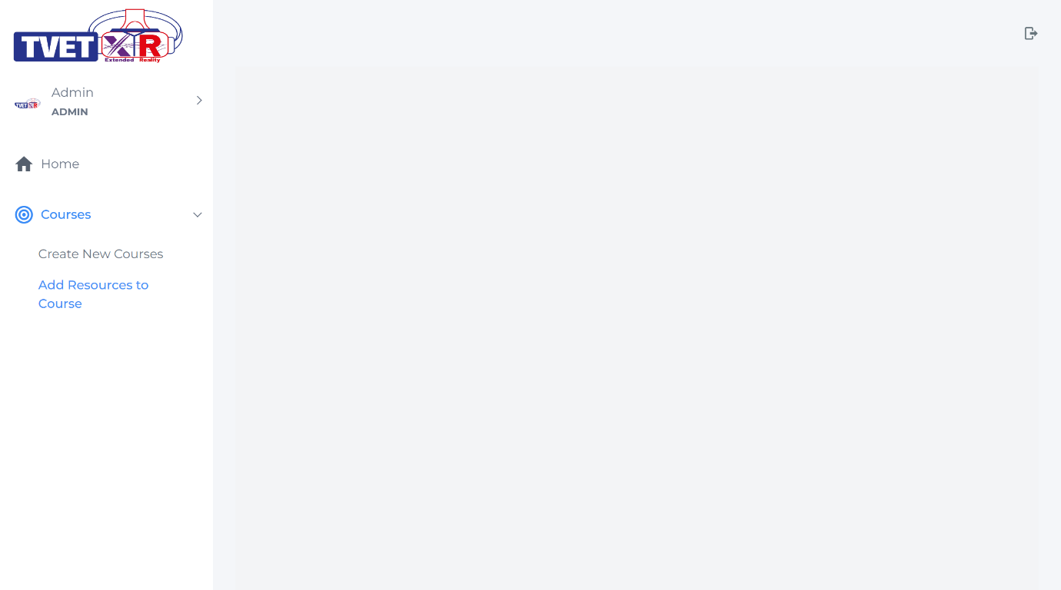

Figure 94: Empty add resources to course page

#### Show the resources data Function

1. Go to “**CourseFileWire.php**” inside **app/Http/Livewire/CourseFile** folder and uncomment the code like below:

<?php

namespace App\Http\Livewire\CourseFile;

use Livewire\Component;

Import course file model so we can use it to fetch course file data.

use App\Models\CourseFile;

class CourseFileWire extends Component

{

    // public $id_coursefile;

    // public $action;

    // protected $listeners = [

    //     'refreshParent' => '$refresh',

    //     'delete'

    // ];

    // public function selectItem($modelid , $action)

    // {

    //     $this->id_coursefile = $modelid;

    //     $this->action = $action;

    // }

    // public function delete()

We use eloquent ORM provide by Laravel to fetch course file data from database. Eloquent ORM is a beautiful, simple ActiveRecord implementation for working with your database.

The render method gets called on the initial page load & every subsequent component update.

    // {

    //     $coursefile = CourseFile::find($this->id_coursefile);

    //     $coursefile->delete();

    // }

    public function render()

    {

        $coursefiles = CourseFile::all();

        return view('livewire.course-file.course-file-wire')->with(compact('coursefiles'));

        // return view('livewire.course-file.course-file-wire');

Course file data that have been fetch are return to the view using “with(compact())”

    }

}

Figure 95: “CourseFileWire.php” source code

1. Go to “**course-file-wire.blade.php**” inside **resources/views/livewire/course-file** folder and uncomment the section “**DATATABLE COURSE FILE**” like below. This is a table to show the list of course file.

{{-- START SECTION - DATATABLE COURSE FILE  --}}

    <div class="row">

        <div class="col-md-12">

            <div class="card" style="box-shadow: 0 .5rem 1rem rgba(0,0,0,.15)!important;border-radius: 5px;">

                <div class="card-body" style="overflow:scroll">

                    <table class="table table-hover" >

                        <thead>

                            <tr>

                                <th>Course Name</th>

                                <th>Resource Name</th>

                                <th class="text-center">Resource File</th>

                                <th>Created At</th>

                                <th>Updated At</th>

                                <th style='width:40px'>Action</th>

Course file data send from controller is use to show all course file exist in system.

                            </tr>

                        </thead>

                            @foreach ($coursefiles as $coursefile)

                            <tbody>

                                <tr>

                                    <td>{{$coursefile->course ? $coursefile->course->name : ''}}</td>

                                    <td>{{$coursefile->name}}</td>

                                    <td class="text-center">

                                        <a href="{{URL::to(''.$coursefile->file_path.'')}}" target="_blank" class="btn btn-success">Download</a>

                                        <br>

                                        <small>{{$coursefile->file_name}}</small>

                                    </td>

                                    <td>{{date('j F Y', strtotime($coursefile->created_at))}}</td>

                                    <td>{{date('j F Y', strtotime($coursefile->updated_at))}}</td>

                                    <td>

                                        <table style="border:none">

                                            <tr>

                                                <td style="border:none">

                                                    <button type="button" wire:click="selectItem({{$coursefile->id}} , 'delete' )" class="btn btn-sm waves-effect waves-light btn-danger data-delete" data-form="{{$coursefile->id}}"><i class="fas fa-trash-alt"></i></button>

                                                </td>

                                            </tr>

                                        </table>

                                    </td>

                                </tr>

                            </tbody>

                            @endforeach

                    </table>

                </div>

            </div>

        </div>

    </div>

      {{-- END SECTION - DATATABLE COURSE FILE  --}}

Figure 96: “course-file-wire.blade” source code

1. Now open the system, refresh and you will see table of course file with empty data.

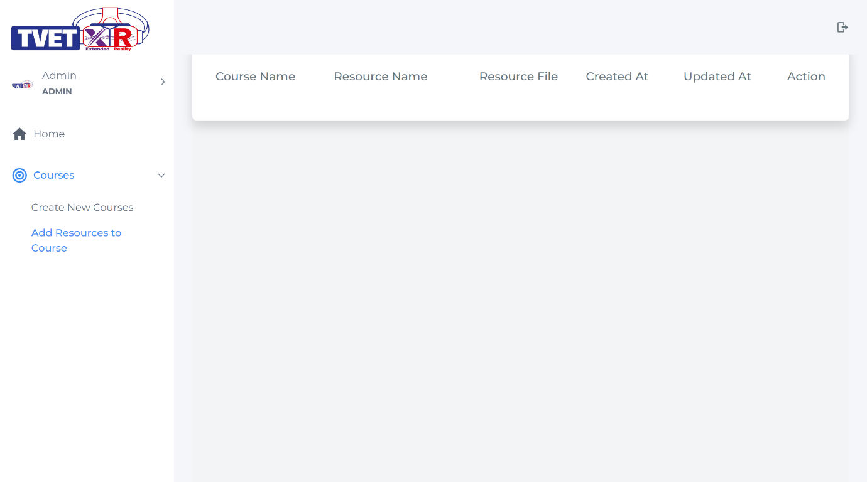

Figure 97: Add Resource to Course page with table of course file

#### Add the Resources Function

1. Now, we already have view for table of course file. To have a create function, go to “**CourseFileFormWire.php**” inside **app/Http/Livewire/CourseFile** folderand follow the code like below:

<?php

namespace App\Http\Livewire\CourseFile;

Import course and course file model so we can use it to fetch the data.

Add livewire package “WithFileUploads” if you have file to upload to the server.

use Livewire\Component;

use App\Models\Course;

use App\Models\CourseFile;

use Livewire\WithFileUploads;

class CourseFileFormWire extends Component

{

To make file upload available when using livewire, add the “use WithFileUploads”.

    use WithFileUploads;

    public $id_coursefile;

    public $name;

Public properties in Livewire are automatically made available to the view. You need to declare all the properties needed in view(V) here.

    public $file_path;

    public $file_name;

    public $id_course;

public $file_type;

    public function store()

    {

            $this->validate([

                'file_name' => 'required',

            ]);

Handle the file upload from view. The function will check if the file is exist then below code will be executed where it will save the file into the server.

            $add = New CourseFile;

            $add->name = $this->file_name;

            $add->id_course = $this->id_course;

            // Handle File Upload

            if ($this->file_path) {

                // Get filename with the extension

                $filenameWithExt = $this->file_path->getClientOriginalName();

                // Get just filename

                $filename = pathinfo($filenameWithExt, PATHINFO_FILENAME);

 // Get just ext

                if($this->file_type == "3dfile") {

                    $extension = "glb";

                } else {

                    $extension = $this->file_path->getClientOriginalExtension();

                }

                // Filename to store

                $fileNameToStore = $filename . '_' . time() . '.' . $extension;

                // Upload Image

                $this->file_path->storeAs('public' . DIRECTORY_SEPARATOR . 'coursefile', $fileNameToStore);

            }

else {

                $fileNameToStore = 'nofile_' . $this->id_course . '_' . time() . '.png';

                $img_path = public_path() . '' . DIRECTORY_SEPARATOR . 'storage' . DIRECTORY_SEPARATOR . 'coursefile' . DIRECTORY_SEPARATOR . 'nofile_' . $this->id_course->id . '_' . time() . '.png';

                copy(public_path() . '' . DIRECTORY_SEPARATOR . 'img' . DIRECTORY_SEPARATOR . 'noimage.png', $img_path);

            }

            //path

            $path = '' . DIRECTORY_SEPARATOR . 'storage' . DIRECTORY_SEPARATOR . 'coursefile' . DIRECTORY_SEPARATOR . '' . $fileNameToStore;

$add->file_type = $this->file_type;

            $add->file_name = $fileNameToStore;

            $add->file_path = $path;

            $add->save();

            session()->flash('message', 'New resources successfully added into course');

Send message to view on successful store course file into database.

        // $this->emit('refreshParent');

    }

    public function render()

    {

$courses = Course::all();

        return view('livewire.course-file.course-file-form-wire')->with(compact('courses'));

        // return view('livewire.course-file.course-file-form-wire');

  }

}

Figure 98: “CourseFileFormWire.php”

1. Now go to “**course-file-form-wire.blade.php**” inside **resources/views/livewire/course-file** folder and uncomment the section “**COURSE FILE FORM**”.

<div>

    {{-- START SECTION - COURSE FILE FORM  --}}

    <div class="row">

        <div class="col-lg-4">

            <h3 style="color:black">Resources in Course Details</h3>

Laravel livewire use wire:submit.prevent = ”function in controller” to submit form.

            <p class="text-muted">Select a file.</p>

        </div>

        <div class="col-lg-12">

            <form wire:submit.prevent="store" enctype="multipart/form-data">

            <div class="card" style="box-shadow: 0 .5rem 1rem rgba(0,0,0,.15)!important;border-radius: 5px;">

                <div class="card-body" >

Laravel livewire use wire:model to synchronize value of form input and public properties in the controller.

                    <div class="row">

                        <div class="col-md-4">

                            <div class="form-group">

                                <label class="control-label" style="font-weight:500">Course Name</label>

                                <select wire:model="id_course" name="id_course" id="id_course" class="form-control custom-select" data-placeholder="Choose Class Course" tabindex="1">

                                    <option value="">-- Choose Course --</option>

                                    @foreach ($courses as $course)

                                        <option value="{{$course->id}}">{{$course->name}}</option>

                                    @endforeach

                                </select>

                                @error('id_course') <span class="error">{{ $message }}</span> @enderror

                            </div>

                        </div>

                        <div class="col-md-4">

                            <div class="form-group">

                                <label class="control-label" style="font-weight:500">File Name</label>

                                <input wire:model="file_name" type="text" id="file_name" name="file_name" class="form-control" >

                                @error('file_name') <span class="error">{{ $message }}</span> @enderror

If validation is fail at controller. It will return the error message to view and the message will show up here.

                            </div>

                        </div>

                        <div class="col-md-4">

                            <div class="demo-radio-button">

                                <input name="group1" type="radio" id="radio_1" wire:model="file_type" value="normalfile" />

                                <label for="radio_1">Normal File</label>

                                <input name="group1" type="radio" id="radio_2" wire:model="file_type" value="3dfile"/>

                                <label for="radio_2">3D File</label>

                                <input name="group1" type="radio" id="radio_3" wire:model="file_type" value="360file"/>

                                <label for="radio_3">360° Video</label>

                            </div>

                        </div>

                    </div>

                    <div class="row">

                        <div class="col-md-4">

                        </div>

                        <div class="col-md-4">

                        </div>

                        <div class="col-md-4" id="fileupload">

                            <div class="form-group">

                                <label class="control-label" style="font-weight:500">File Upload</label>

                                <div

                                    x-data="{ isUploading: false, progress: 0 }"

                                    x-on:livewire-upload-start="isUploading = true"

                                    x-on:livewire-upload-finish="isUploading = false"

                                    x-on:livewire-upload-error="isUploading = false"

                                    x-on:livewire-upload-progress="progress = $event.detail.progress">

                                <div wire:loading wire:target="file_path"><i class="mdi mdi-loading mdi-spin mdi-24px"></i></div>

                                    <input type="file" wire:model="file_path" id="file_path" name="file_path" class="dropify" />

                                    @error('file_path') <span class="error">{{ $message }}</span> @enderror

                                    <div x-show="isUploading">

                                        <progress max="100" x-bind:value="progress"></progress>

                                    </div>

                                </div>

                            </div>

                        </div>

                    </div>

                </div>

                <div class="card-footer" style="background-color: #f9fafb !important;border-top: none;">

                    <div class="row">

                        <div class="col-md-12 text-right">

                            @if (session()->has('message'))

                                {{ session('message') }}

                            @endif

                            <button type="submit" class="inline-flex items-center px-4 py-2 bg-gray-800 border border-transparent rounded-md font-semibold text-xs text-white uppercase tracking-widest hover:bg-gray-700 active:bg-gray-900 focus:outline-none focus:border-gray-900 focus:shadow-outline-gray disabled:opacity-25 transition ease-in-out duration-150">

                                Save

                            </button>

                        </div>

                    </div>

                </div>

            </div>

        </form>

        </div>

    </div>

    {{-- END SECTION - COURSE FILE FORM  --}}

</div>

Figure 99: “course-file-form-wire.blade.php” source code

1. To include “**course-file-form-wire.blade**” component inside “**course-file-wire.blade**”. Go to “**course-file-wire.blade**” inside **resources/views/livewire/course-file** folder and uncomment the section “**COURSE FILE FORM**”.

    {{-- START SECTION - COURSE FILE FORM  --}}

    @livewire('course-file.course-file-form-wire')

    {{-- END SECTION - COURSE FILE FORM  --}}

Figure 100: “course-file-wire.blade” Course File Form section

1. Now go back to system and you will see the create form for add resource to course, you can add resource to course after fill in all the required field and click the save button. Go on and try. On successful , you will got a message notified that resource successfully added to the course but if you notice, the resource table does not update and show the latest resource that you just create in real-time, this mean you need to refresh the page to see the change.

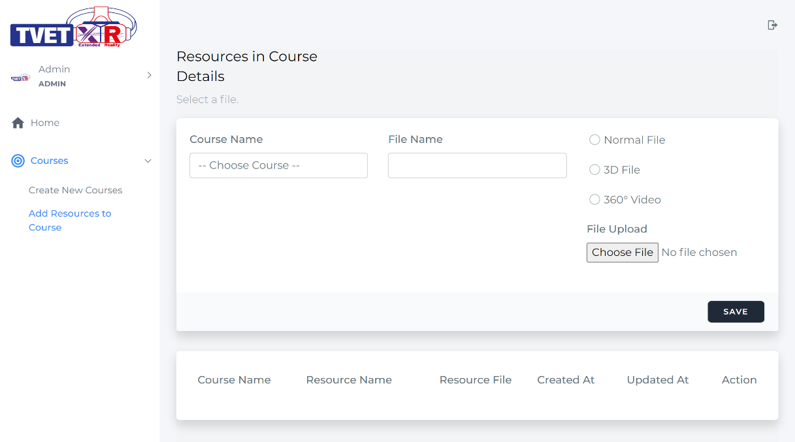

Figure 101: Add Resource to Course page with table of resource & add resource to course component

1. To have a real-time update on the resource table go back to “**CourseFileWire.php**” inside **app/Http/Livewire/CourseFile** folder and uncomment some code like below. This is the listener to listen on succesful store event of course.

protected $listeners = [

        'refreshParent' => '$refresh',

        // 'delete'

    ];

Figure 102: “CourseFileWire.php” listener

1. After that go to “**CourseFileFormWire.php**” inside **app/Http/Livewire/CourseFile** folder and uncomment below code. This code is use to triggered the listener.

   $this->emit('refreshParent');

Figure 103: “CourseFileFormWire.php” emitting to listener

1. We use listener on store function in “**CourseFileFormWire.php**” to detect if resource have been successfully added into course. First, we define the listener in “**CourseFileWire.php**” just like in the code above. Then we call the listener by using **emit(‘refreshParent’).** When the listener is triggered, the **magic keyword** provide by Laravel livewire which is “**$refresh**” will refresh the “**CourseFileWire.php**” component which is the course table so we will have the latest data that we just created. Go on and try to add back new resource to course.

#### Delete the Resources Function

1. If you noticed we already uncomment some code inside “**course-file-wire.blade**”. The code will fire when user click on the button. The **wire:click** event will run the **selectItem** function inside “**CourseFileWire.php**” to set all the public properties to a specific user that we have choose.

<td style="border:none">

          <button type="button" wire:click="selectItem({{$coursefile->id}} , 'delete' )" class="btn btn-sm waves-effect waves-light btn-danger data-delete" data-form="{{$coursefile->id}}"><i class="fas fa-trash-alt"></i></button>

</td>

1. Beside using wire:click event, to include delete function, go to “**course-file-wire.blade.php**” inside **resources/views/livewire/course-file** folder and uncomment on section “**Script for Delete Button**” like below. This is the script to popup a message of confirmation on deletion of course.

{{-- START SECTION - SCRIPT FOR DELETE BUTTON  --}}

<script>

  document.addEventListener('livewire:load', function () {

This script will run on user click on tag that has a “data-delete” class. If you see at step 17, we define a “data-delete” class at the delete button.

    $(document).on("click", ".data-delete", function (e)

        {

            e.preventDefault();

            swal({

            title: "Are you sure?",

            text: "Once deleted, you will not be able to recover!",

            icon: "warning",

            buttons: true,

            dangerMode: true,

            })

This emit function of delete will sent a message to the listener located at “CourseFileWire.php” and call the function delete.

            .then((willDelete) => {

            if (willDelete) {

                e.preventDefault();

                Livewire.emit('delete')

            }

            });

        });

  })

</script>

{{-- END SECTION - SCRIPT FOR DELETE BUTTON  --}}

Figure 104: “user-file-wire.blade.php” Script for Delete Button section

1. After that navigate to “**CourseFileWire.php**” inside **app/Http/Livewire/CourseFile** folder and uncomment below code inside the file.

public $id_coursefile;

public $action;

protected $listeners = [

When user click at the delete button. This function will run and set the public properties.

        'refreshParent' => '$refresh',

        'delete'

    ];

 public function selectItem($modelid , $action)

    {

        $this->id_coursefile = $modelid;

        $this->action = $action;

Once user confirm the deletion. An emit event is send from the view and the listener ‘delete’ will trigger and run the function delete.

    }

    public function delete()

    {

        $coursefile = CourseFile::find($this->id_coursefile);

        $coursefile->delete();

    }

Figure 105: “CourseFileWire.php”

1. Now lets navigate back to system, refresh and try the delete function by clicking the delete button as below.

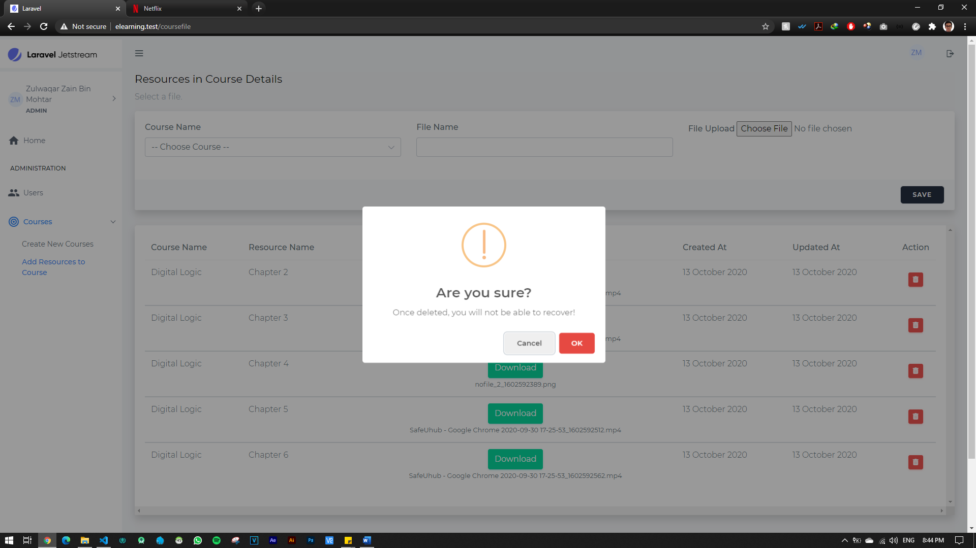

Figure 106: Add Resource to Course Page with delete function

# IMPLEMENTING PROGRESSIVE WEB APPS (PWA) TO EXISTING PROJECT – ELEARNING (MINI PROJECT)

### What is PWA?

A progressive web app (PWA) is the set of mobile web application development techniques that entails building apps that feel and look like native ones. Using a web stack (JS, HTML, and CSS), progressive web apps combine a rich functionality and smooth user experience associated with native apps. Simply put, PWA is the web app with the native-app flavour. After the installation, a user clicks on its icon on a device home screen and gets straight to the website just like any other application on the mobile device.

### Features of PWA?

1) Installable

You can install a PWA to your desktop or mobile device. The PWA will appear in your Start menu, desktop or applications, with a minimum of fuss and without much change to the code.

2) Offline Mode

Unlike normal web browser, PWA can work even if you are offline just like any other native apps.

3) Push Notification

Just like native apps, PWA can send push notifications which normal web browser doesn’t support.

4) Background Synchronization

Background synchronization means delays actions until stable connectivity is back. For example, like messaging apps such WhatsApp, telegram, etc, the message sent right before the connection fails will be marked as sent and then will be delivered as soon as service is restored. So, servers can send periodic updates to the app allowing it to update itself when the connection is restored.

### Implementing PWA

Two core components needed to make PWA available on your device are to include 2 files in your public folder inside your project folder.

a) Web App manifest

Inside **elearning-source** folder, you will find PWA folder. Copy **_manifest.json** file into public folder of your project folder.

b) Service Worker

Inside **elearning-source** folder, you will find PWA folder. Copy **_service-worker.js** file into public folder of your project folder.

Open your web browser and refresh the page, you will see installable icon on your URL bar if you are in chrome browser.

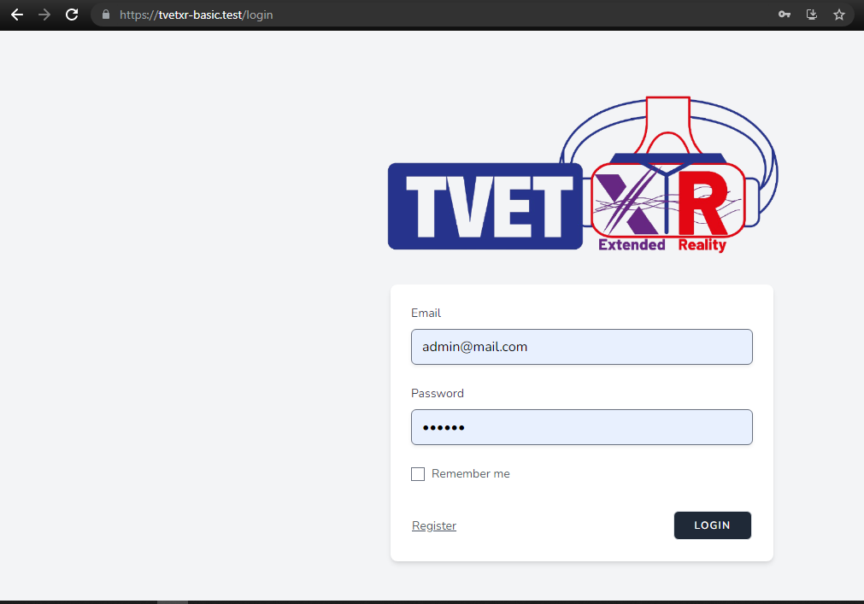

In android chrome, you may visit first the website then click on the setting button and you will find install app option. Click that and install the app to your device.

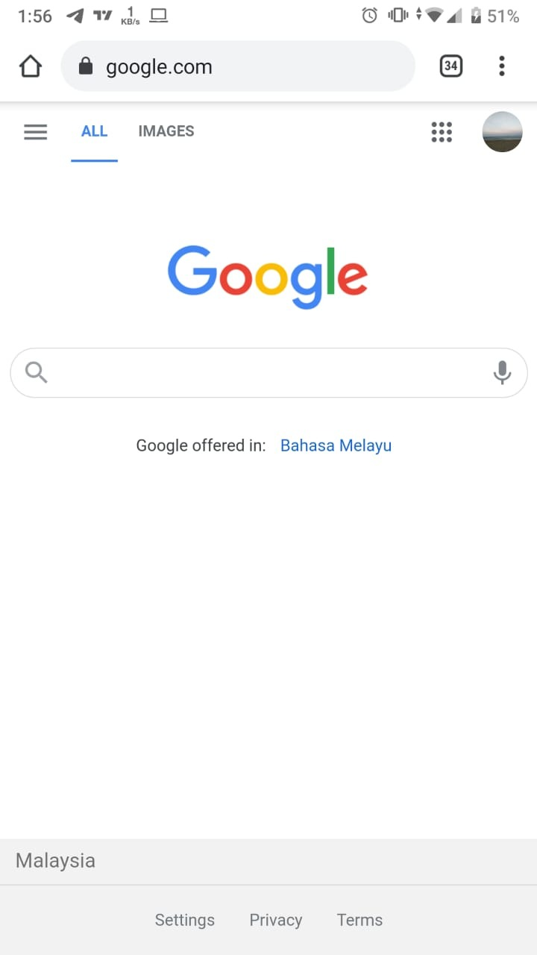 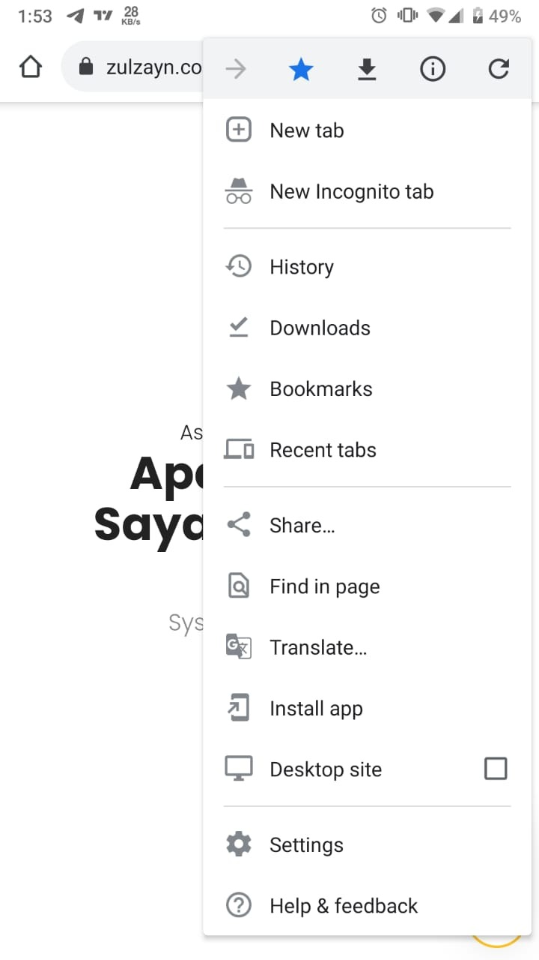

# HOW TO SETUP VIRTUAL REALITY (VR) SCENE?

## Introduction

### What is VR?

Virtual reality (VR) is a technology that uses head-mounted headsets with displays to generate the realistic images, sounds, and other sensations to put users into an immersive virtual environment. VR allows us to create unbounded worlds that people can walk around and interact with using their hands, to feel as if they were transported to another place.



### What is WebXR?

WebXR is a JavaScript API for creating immersive 3D, VR experiences, and augmented reality (AR) in your browser. Or simply put, allows VR and AR in the browser over the Web. The XR stands for “Extended Reality”.

### What is A-Frame?

A-Frame is an easy and powerful web framework for building VR experiences. A-Frame is based on top of HTML, making it simple to get started. But A-Frame is not just a 3D scene graph or a markup language; the core is a powerful entity-component framework that provides a declarative, extensible, and composable structure to [three.js](https://threejs.org/).

A-Frame supports most mobile phones and VR headsets such as Vive, Rift, Windows Mixed Reality, Daydream, GearVR, Cardboard, Oculus Go, and can even be used for AR. Although A-Frame supports the whole spectrum, A-Frame aims to define fully immersive interactive VR experiences that go beyond basic 360° content, making full use of positional tracking and controllers.

## Stage 1 – HTML & primitives

### Installation of A-Frame using CDN

To include A-Frame in an HTML file in the local server, you can drop a <script> tag pointing to the CDN build:

<head>

...

<script src="https://aframe.io/releases/1.0.4/aframe.min.js"></script>

</head>

And that is it!

### Basic A-Frame primitives

1. Let us start by building a basic A-Frame scene. This is a HTML starter structure:

<html>

    <head>

        <script src="https://aframe.io/releases/1.0.4/aframe.min.js"></script>

    </head>

    <body>

        <a-scene>

        </a-scene>

    </body>

</html>

1. The <a-scene> will contain every entity in our scene, such as camera, lights, 3D models, etc.
2. Within the <a-scene>, we attach 3D entities using one of A-Frame’s standard primitives <a-box>. We can use <a-box> just like a normal HTML element, defining the tag and using HTML attributes to customize it. Some other examples of primitives that come with A-Frame include <a-cylinder>, <a-plane>, or <a-sphere>.

<a-scene>

<a-box color="red"></a-box>

</a-scene>

1. Besides that, primitives are A-Frame’s easy-to-use HTML elements that wrap the underlying entity-component assembly. They can be convenient, but underneath <a-box> is <a-entity> with the geometry and material components:

<a-entity id="box" geometry="primitive: box" material="color: red"></a-entity>

=

<a-entity geometry="primitive: box">

<a-box>

### Transformation: position, rotation, scale

1. The transformation tools help us to move the entities, rotate them and change their size. The 3D space is illustrated as follows:

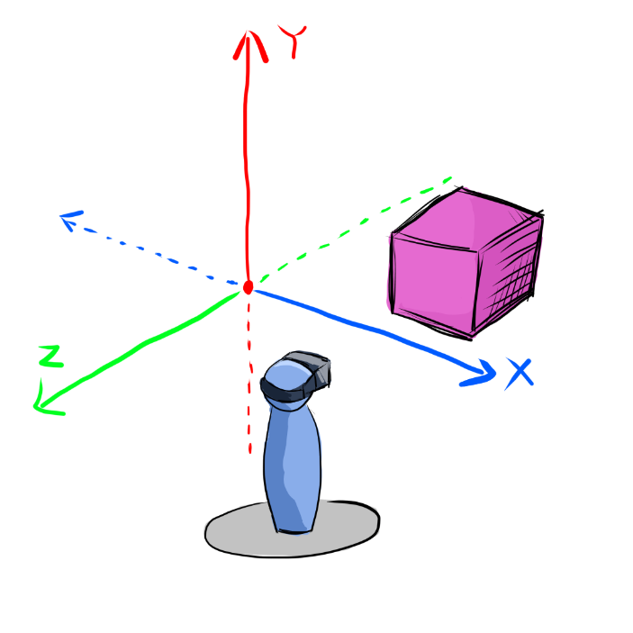

Note: The position of the object in 3D scene is defined in the XYZ-axes.

1. We can move the box back *5 meters* on the negative Z-axis with the position component. We also move it up *2 meters* on the positive Y-axis. Next, the box is rotate at an angle and double its size:

<a-entity id="box" geometry="primitive: box" material="color: red" position="0 2 -5" rotation="0 45 45" scale="2 2 2"></a-entity>

Note: position component moves the entity; rotation component rotates the entities; scale component changes the size of the entities.

1. To run this HTML file, make sure you are accessing the site over HTTPS to enable enter VR mode and grant access to the device sensors. These are the steps to enable HTTPS by using Laragon.

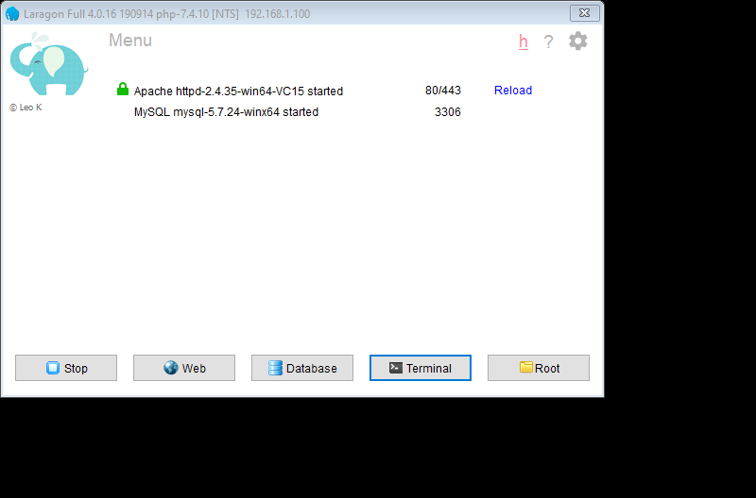 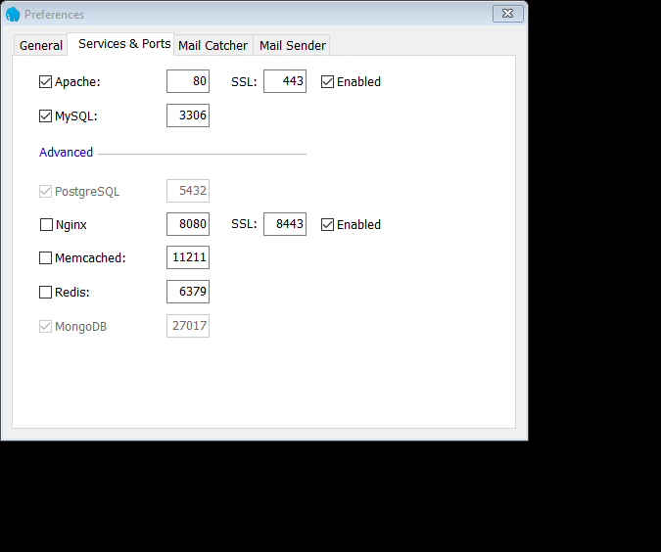

Enable the checkboxes

1. Type in the address bar in your browser: “**https://<your-project-name>.test**”. Now we can see the box!

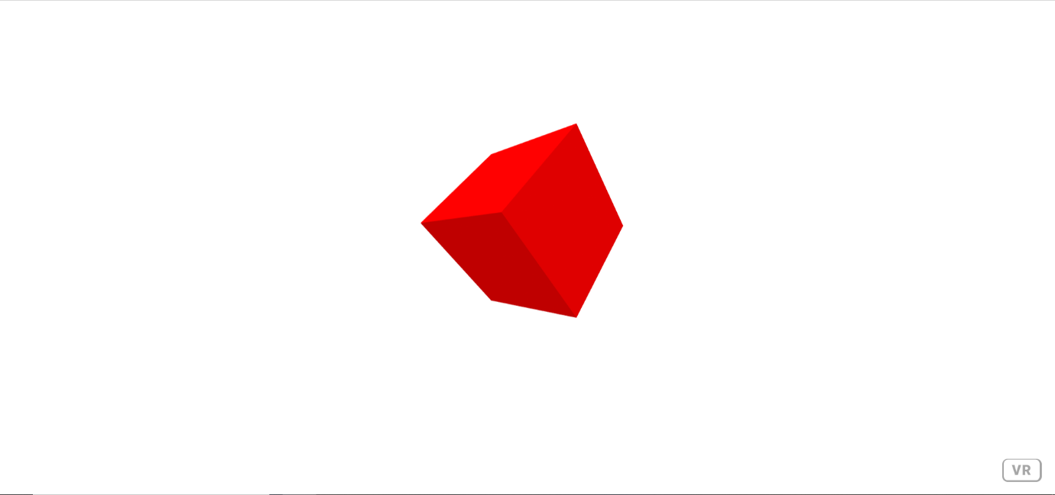

You may drag around the screen to move the camera view.

### Extra: View the VR scene in Oculus Quest and mobile phone

1. To open the website in localhost by using Oculus Quest or mobile phone, the laptop (localhost) and Oculus Quest need to connect to the same network.
2. Then, type in “cmd” in your Windows search bar and open the command prompt:

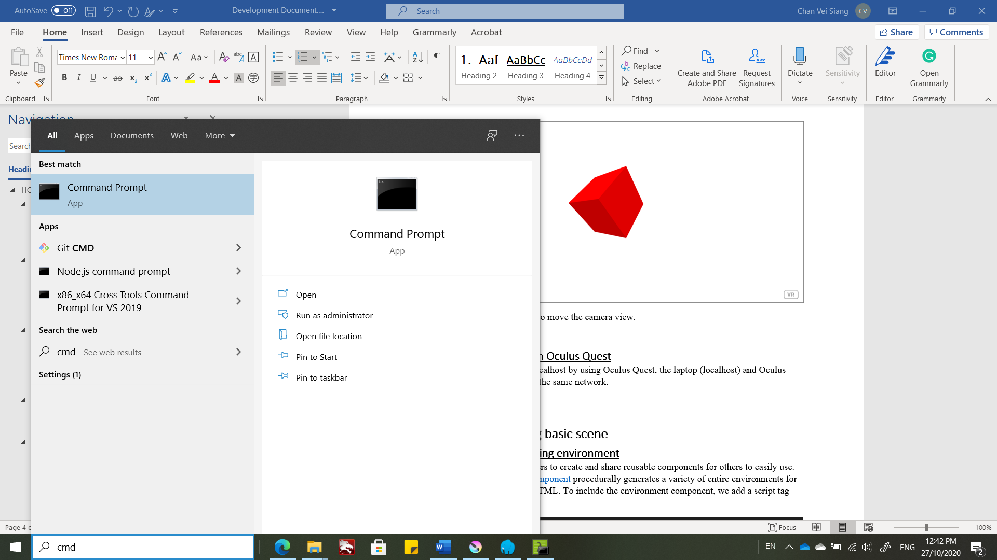

1. Type in the command prompt:

ipconfig

1. Next, we need to add our path into Laragon’s settings. Open Laragon at the bottom menu bar by right click and select the second option (the name will change depend on your root folder). Then, select “Switch Document Root” and click “Select another” to open a file explorer.

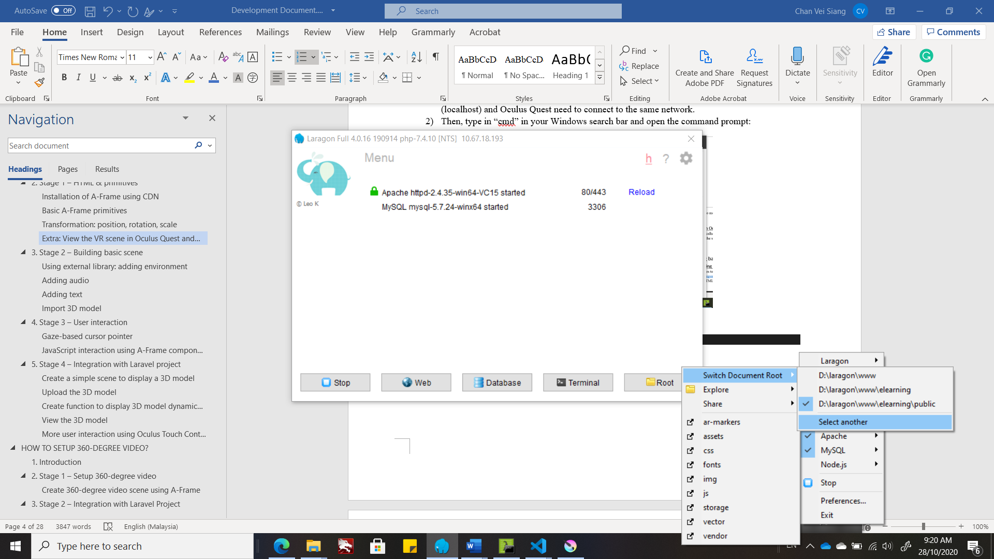

1. Using the file explorer, search for the “elearning” > “public” folder.
2. Search for the “IPv4 Address”. Then, open the browser in Oculus Quest and type in the address: **https://<IPv4 Address>/**

## Stage 2 – Building basic scene

### Using external library: adding environment

1. A-Frame allows developers to create and share reusable components for others to easily use. [@feiss](https://github.com/feiss/)‘s [environment component](https://github.com/feiss/aframe-environment-component/) procedurally generates a variety of entire environments for us with a single line of HTML. To include the environment component, we add a script tag after A-Frame:

<head>

    <script src="https://aframe.io/releases/1.0.4/aframe.min.js"></script>

    <script src="https://unpkg.com/aframe-environment-component/dist/aframe-environment-component.min.js"></script>

</head>

1. Then within the scene, add an entity with the environment component attached. We can specify a preset (e.g., forest) with along many other parameters (e.g., 200 trees):

<a-scene>

<a-entity id="box" geometry="primitive: box" material="color: red" position="0 2 -5" rotation="0 45 45" scale="2 2 2"></a-entity>

    <a-entity environment="preset: forest; dressingAmount: 500"></a-entity>

</a-scene>

You can try with these preset values: none, default, contact, egypt, checkerboard, forest, goaland, yavapai, goldmine, threetowers, poison, arches, tron, japan, dream, volcano, starry, osiris

1. The result:

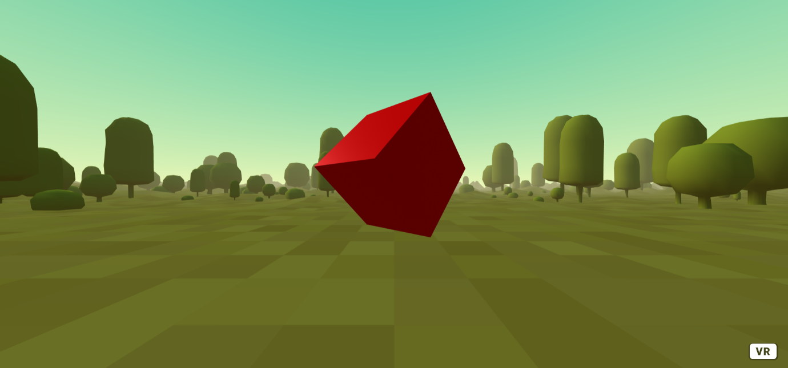

### Adding audio

1. Now, we would like to add a sound effect to the scene.
2. A-Frame provides a nice [asset management system](https://aframe.io/docs/1.0.0/core/asset-management-system.html) for performance. The asset management system makes it easier for the browser to cache assets (e.g., images, videos, models) and A-Frame will make sure all the assets are fetched before rendering.
3. To use the asset management system for an audio:

<a-scene>

<a-assets>

     <audio id="backgroundnoise" src=<https://cdn.aframe.io/basic-guide/audio/backgroundnoise.wav> autoplay preload></audio>

</a-assets>

<!-- ... -->

<a-sound src="#backgroundnoise"></a-sound>

</a-scene>

Note: Do not copy and paste the whole code. Just copy and paste the new lines in your text editor. The <!-- ... --> represents the other codes that you written before.

### Adding text

1. A-Frame also comes with a text component:

<a-scene>

<!-- ... -->

<a-entity text="value: Hello, A-Frame!; color: #BBB" position="-0.9 0.2 -3" scale="1.5 1.5 1.5"></a-entity>

</a-scene>

1. The result:

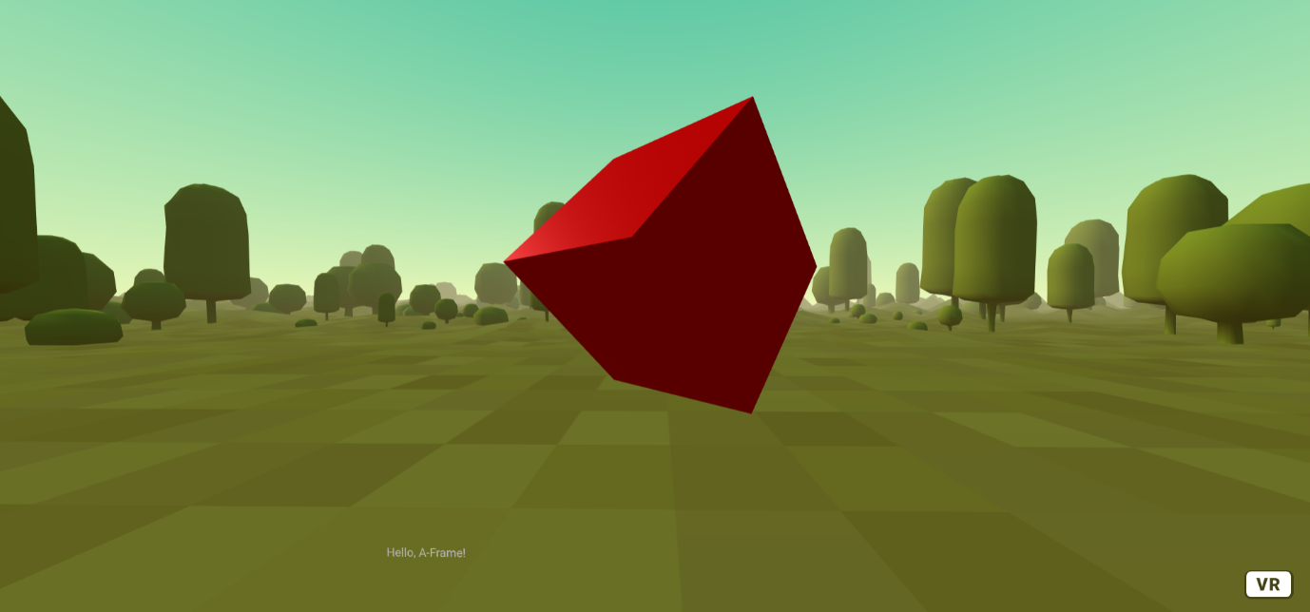

### Import 3D model

1. A-Frame provides components for loading 3D models. We recommend using gltf or glb if possible as glb and glTF gain adoption as the standard for transmitting 3D models over the Web.
2. In this example, we will import a city model into the scene with animation.
3. Create a new folder named “assets” in your root folder. Then, create another folder “3d_models” inside the “assets” folder.
4. Next, copy the “VC.glb” 3D model into “3d_models” folder.
5. Use the asset management system to import the 3D model:

<a-scene>

<a-assets>

<!-- ... -->

<a-asset-item id="cityModel" src="assets/3d_models/VC.glb"></a-asset-item>

</a-assets>

<!-- ... -->

    <a-entity id="gltfModel" gltf-model="#cityModel" position="0 0.1 0"></a-entity>

</a-scene>

Use the gltf-model component to link to the id of the 3D model asset.

1. Some author provides the animation of the 3D model. The [animation-mixer component](https://github.com/n5ro/aframe-extras/tree/master/src/loaders#animation), part of [aframe-extras](https://github.com/n5ro/aframe-extras) by Don McCurdy, provides controls for playing animations in three.js (.json) and gltf models.
2. To use the animation-mixer component, we need to add the script tag in <head> first:

<head>

<!-- ... -->

    <script src="https://unpkg.com/aframe-extras.animation-mixer@3.4.0/dist/aframe-extras.animation-mixer.js"></script>

</head>

1. Then, just add animation-mixer in your 3D model entity:

<a-scene>

<!-- ... -->

    <a-entity id="gltfModel" gltf-model="#cityModel" position="0 0.1 0" animation-mixer></a-entity>

</a-scene>

1. Result (3D model with animation):

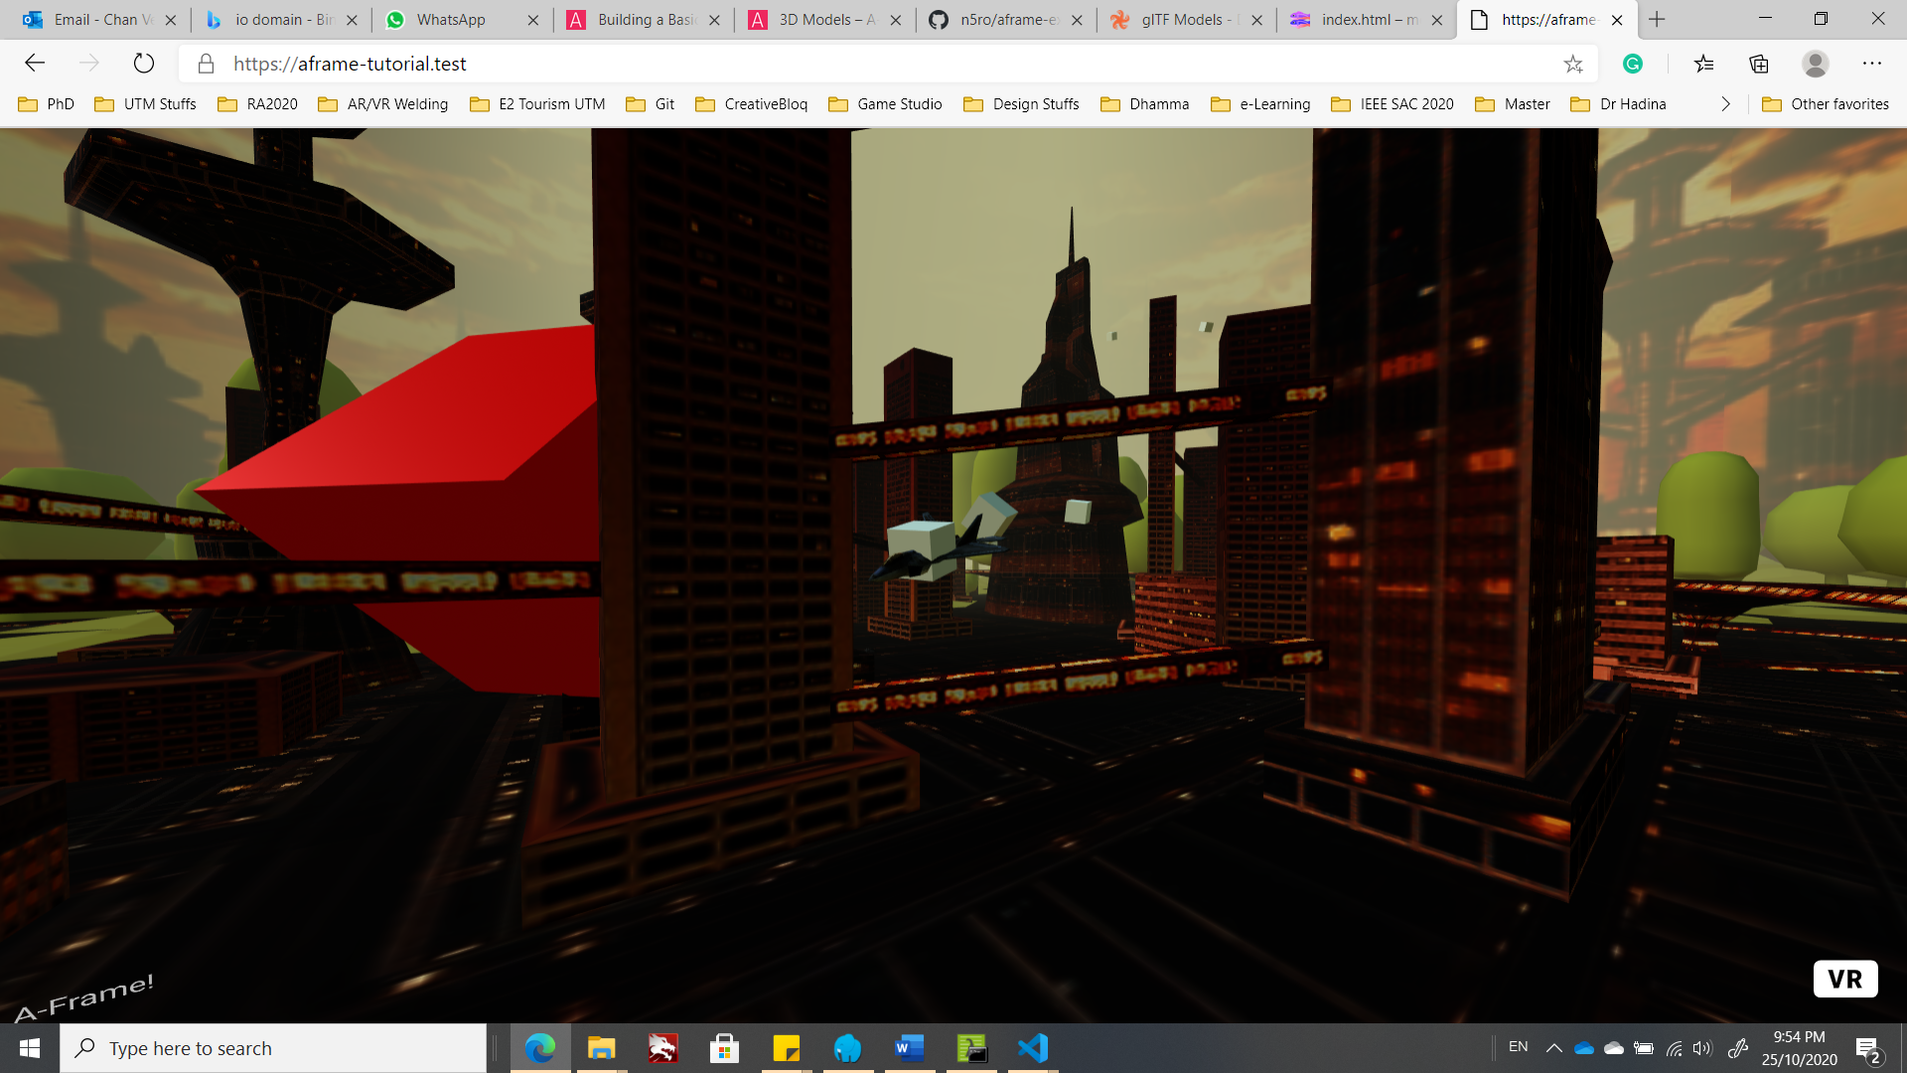

## Stage 3 – User interaction

### Gaze-based cursor pointer

1. Let’s add interaction with the box: when we look at the box, we’ll increase the size of the box.
2. Firstly, we will focus this section on using basic **mobile** and **desktop** inputs with the built-in [cursor component](https://aframe.io/docs/1.0.0/components/cursor.html). The cursor component by default provides the ability to “click” on entities by staring or gazing at them on mobile, or on desktop, looking at an entity and click the mouse.
3. To have a visible cursor fixed to the camera, we place the cursor as a child of the camera. Child entities inherit transformations (i.e., position, rotation, and scale) from their parent. Let’s define <a-camera> that contain <a-cursor>:

<a-camera id="head" camera wasd-controls look-controls>

<a-cursor id="cursor"></a-cursor>

</a-camera>

Note: By default, A-Frame automatically included an <a-camera> for us if we didn’t specifically define a camera in the scene.

Note: The wasd-controls component allows the user to move around the scene using WASD keys; the look-controls component allows the user to look around the scene by dragging using the mouse (desktop) or move user’s head (mobile VR and HMD).

1. We can also stylize our cursor. To add visual feedback to the cursor to show when the cursor is clicking or fusing, we can use the [animation component](https://aframe.io/docs/1.0.0/components/animation.html). When the mouse is clicked, it will emit an event on the <a-cursor>:

<a-camera id="head" camera wasd-controls look-controls>

<a-cursor id="cursor"

     animation__click="property: scale; startEvents: click; from: 0.1 0.1 0.1; to: 1 1 1; dur: 150"

        animation__fusing="property: fusing; startEvents: fusing; from: 1 1 1; to: 0.1 0.1 0.1; dur: 1500"

        material="color: crimson; shader: flat"></a-cursor>

</a-camera>

We also change our cursor color into crimson by using material component.

1. The result:

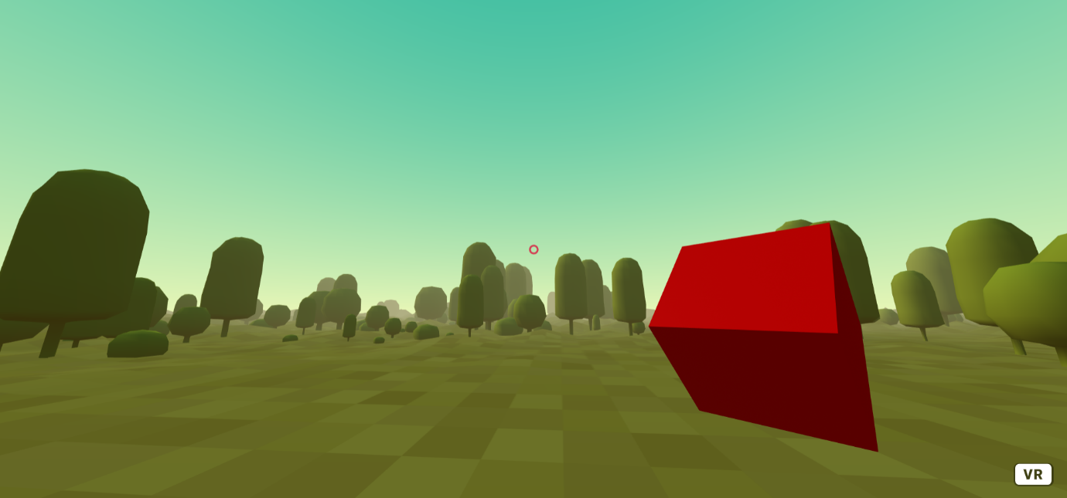

### JavaScript interaction using A-Frame component registration

1. We can use the A-Frame component registration by using JavaScript to handle the cursor events, such as click. Now, we want to scale the box when the cursor hovered over it. Use the following code to register new scale-on-mouseenter component to the box entity when mouseenter event (cursor hover to the target box) is detected:

<head>

<!-- ... -->

    <script>

        AFRAME.registerComponent('scale-on-mouseenter', {

            schema: {

                to: {default: '3 3 3', type: 'vec3'}

            },

            init: function () {

                var data = this.data;

                var el = this.el;

                this.el.addEventListener('mouseenter', function () {

                    el.object3D.scale.copy(data.to);

                });

            }

        });

    </script>

</head>

<body>

    <a-scene>

<!-- ... -->

        <a-entity id="box" geometry="primitive: box" material="color: red" position="3 2 -5" rotation="0 45 45" scale="2 2 2" scale-on-mouseenter></a-entity>

    <!-- ... -->

    </a-scene>

</body>

Note: The scale-on-mouseenter component is attached to the box entity.

1. Play the scene and hover your cursor to the box, notice that the box will be scaled up.

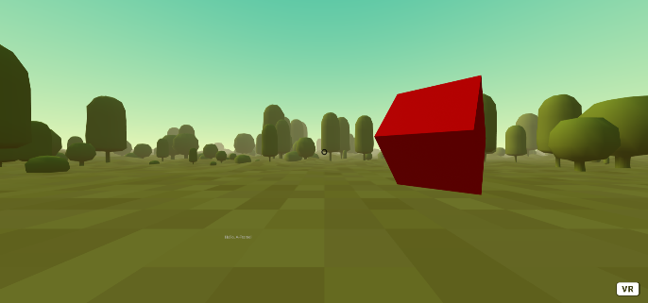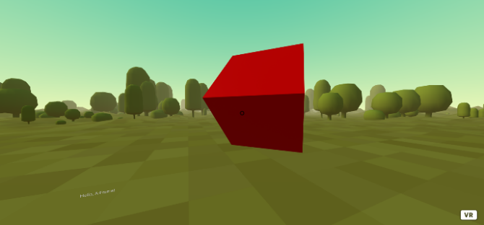

1. To change the size of box back to its origin when the cursor left the box, let’s add a mouseleave event to the scale-on-mouseenter component registration:

<script>

        AFRAME.registerComponent('scale-on-mouseenter', {

            schema: {

                to: {default: '3 3 3', type: 'vec3'},

                origin: {default: '2 2 2', type: 'vec3'}

            },

            init: function () {

/* ... */

                this.el.addEventListener('mouseleave', function() {

                    el.object3D.scale.copy(data.origin);

                })

            }

        });

    </script>

1. There are many [cursor events](https://aframe.io/docs/1.0.0/components/cursor.html#events) we can explore and utilize to make our VR application more interactive.

## Stage 4 – Integration with Laravel project

### Create a simple scene to display a 3D model

1. We can integrate the VR application with our elearning Laravel project. Create a new folder named “3d_model_view” in your “resources” > “views” folder. Then, copy and paste your “index.html” into “3d_model_view” folder. Rename “index.html” into “index.blade.php”.
2. Create a new route in “web.php” in “routes” folder:

Route::get('/3d_model_view', function() {

        return view('3d_model_view.index');

})->name('3d_model_view');

1. Type in the address bar in your browser: “**https://<your-project-name>.test /3d_model_view**”.

### Upload the 3D model

1. Firstly, we need to make sure that we have the correct 3D model format. The elearning only accepts glb file format. These are the websites that can convert your 3D model files into glb:

* Aspose.3D conversion: <https://products.aspose.app/3d/conversion/gltf-to-glb>

1. Go to “Add Resources to Courses” page.

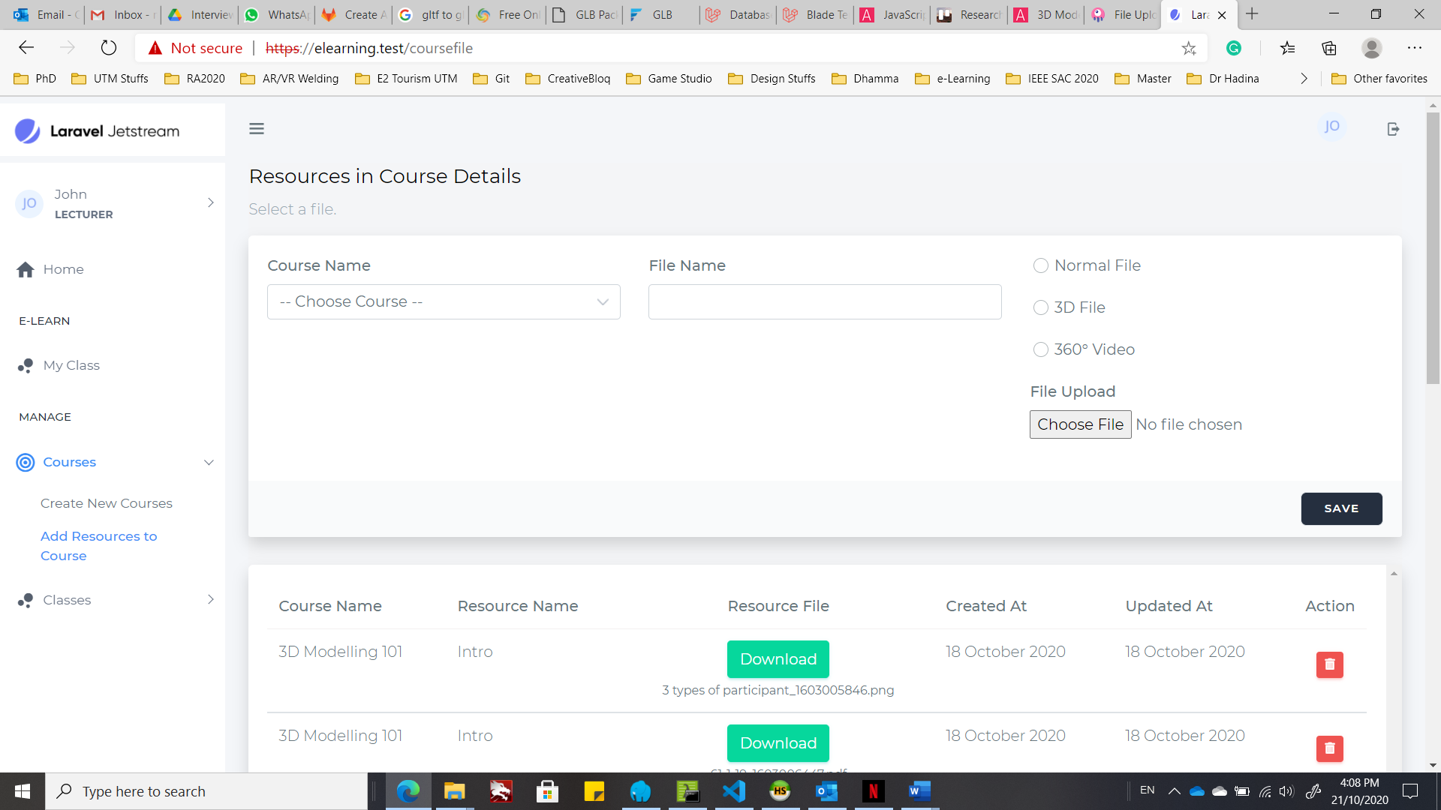

1. To assign the 3D model to a course, you need select a course, enter file name, choose the file type (3D file) and click on the “Choose File” button to search for the 3D model.

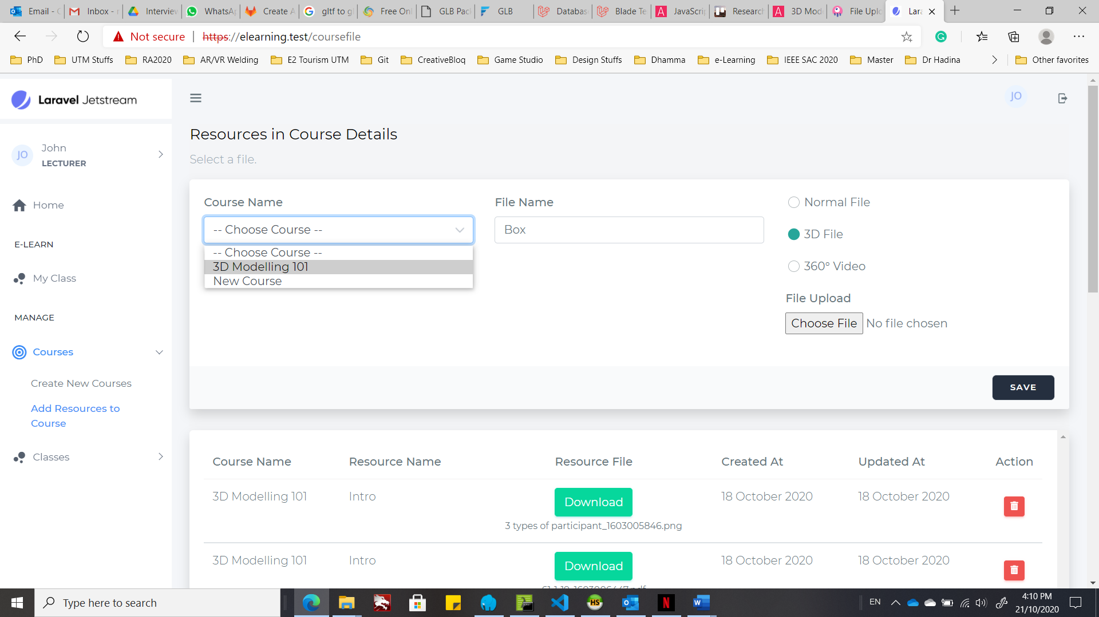

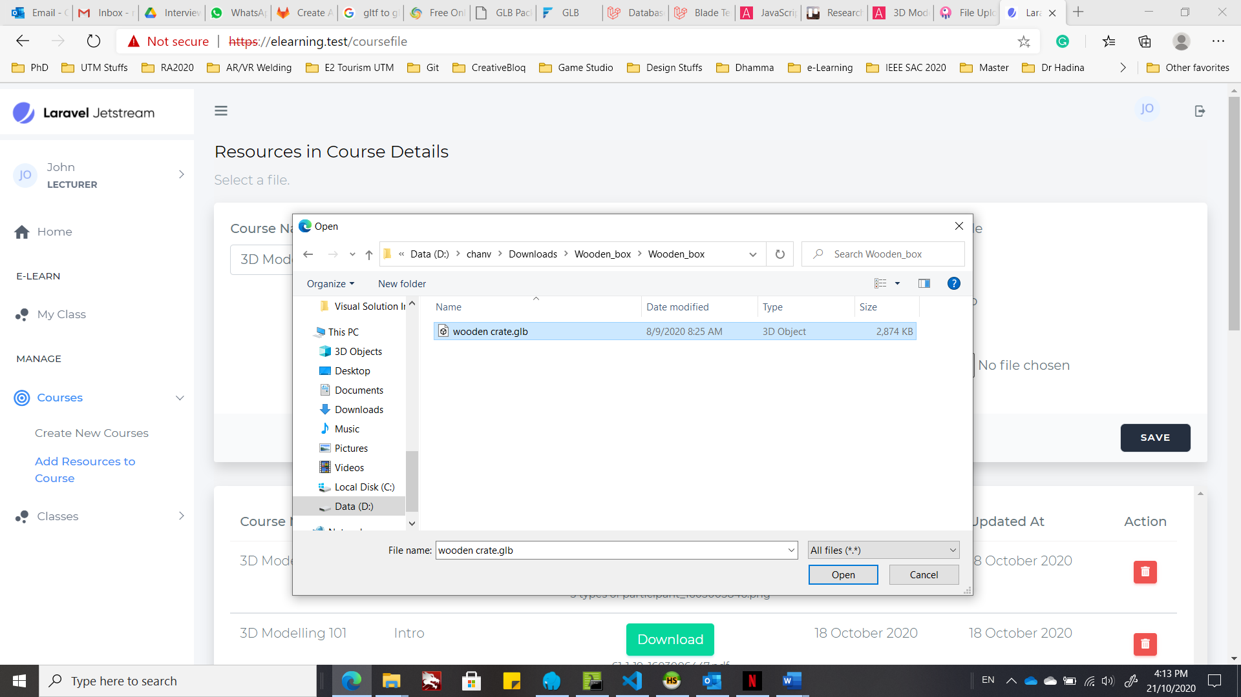

1. Wait for the upload to complete and click “SAVE” button to continue. You may scroll to find your uploaded 3D model.

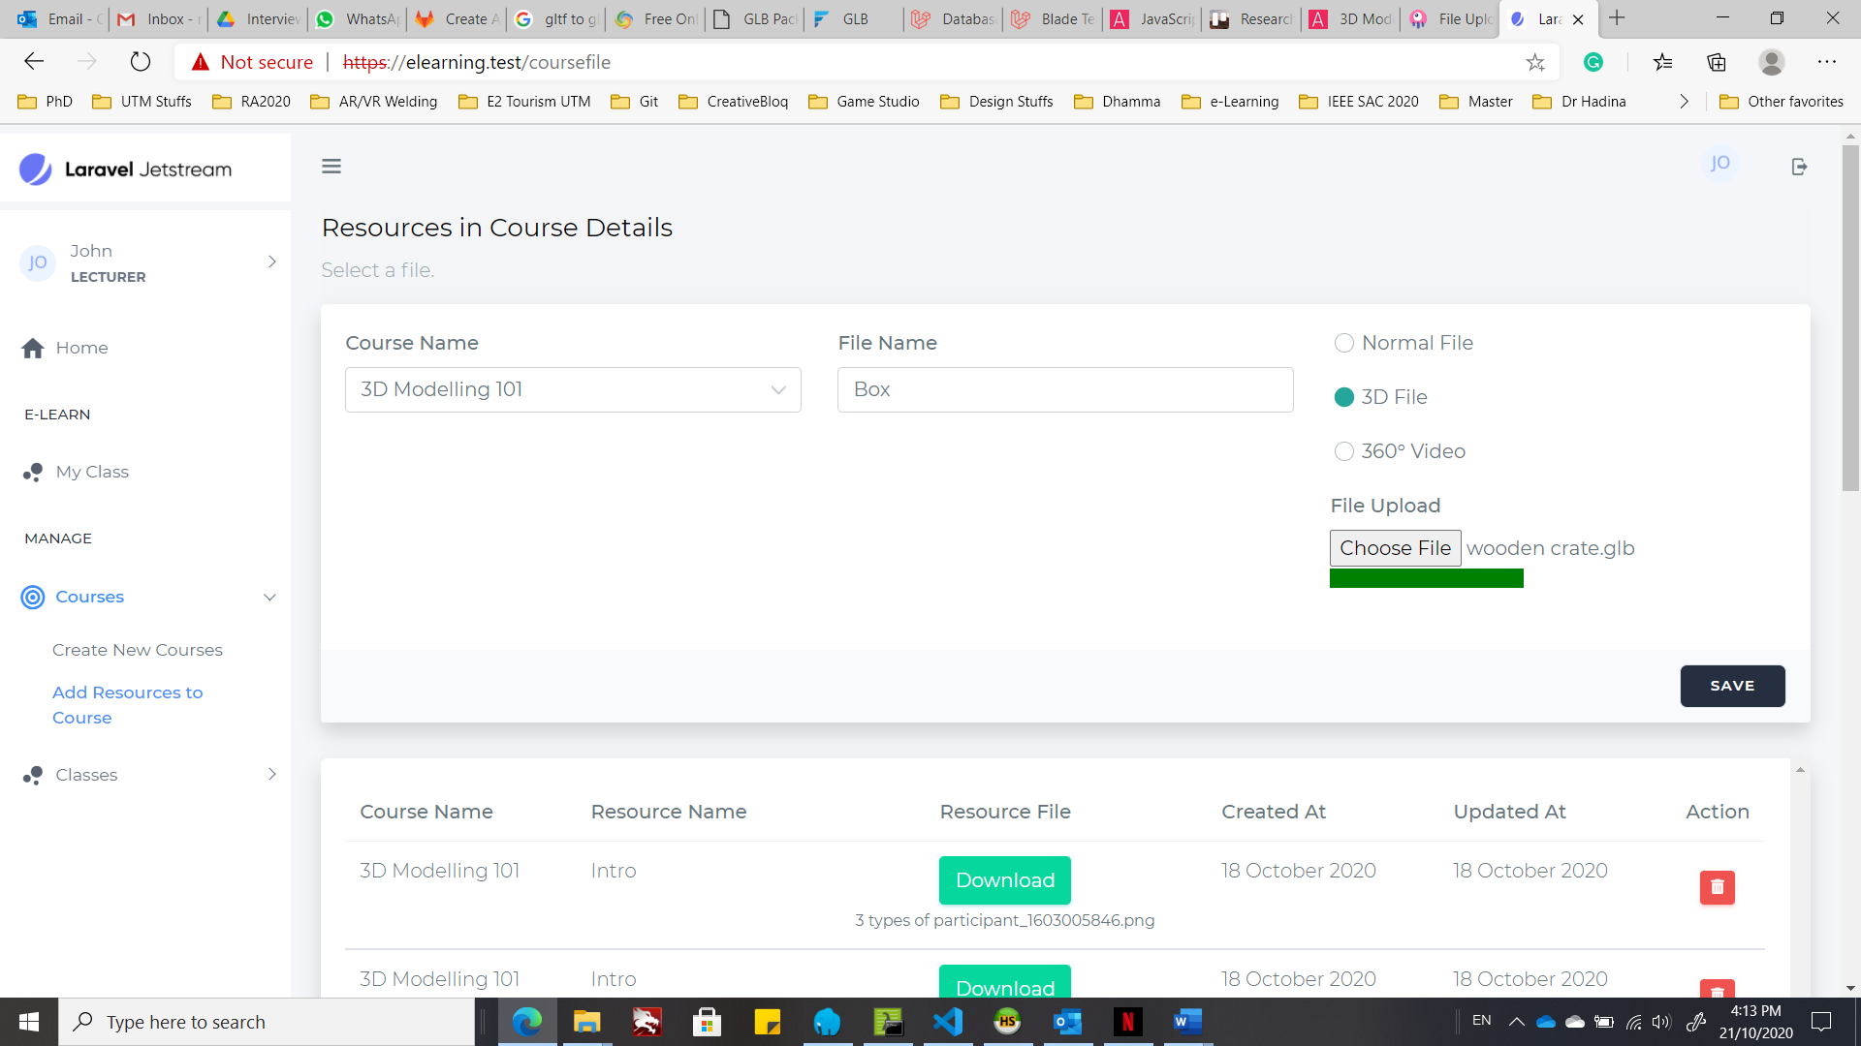

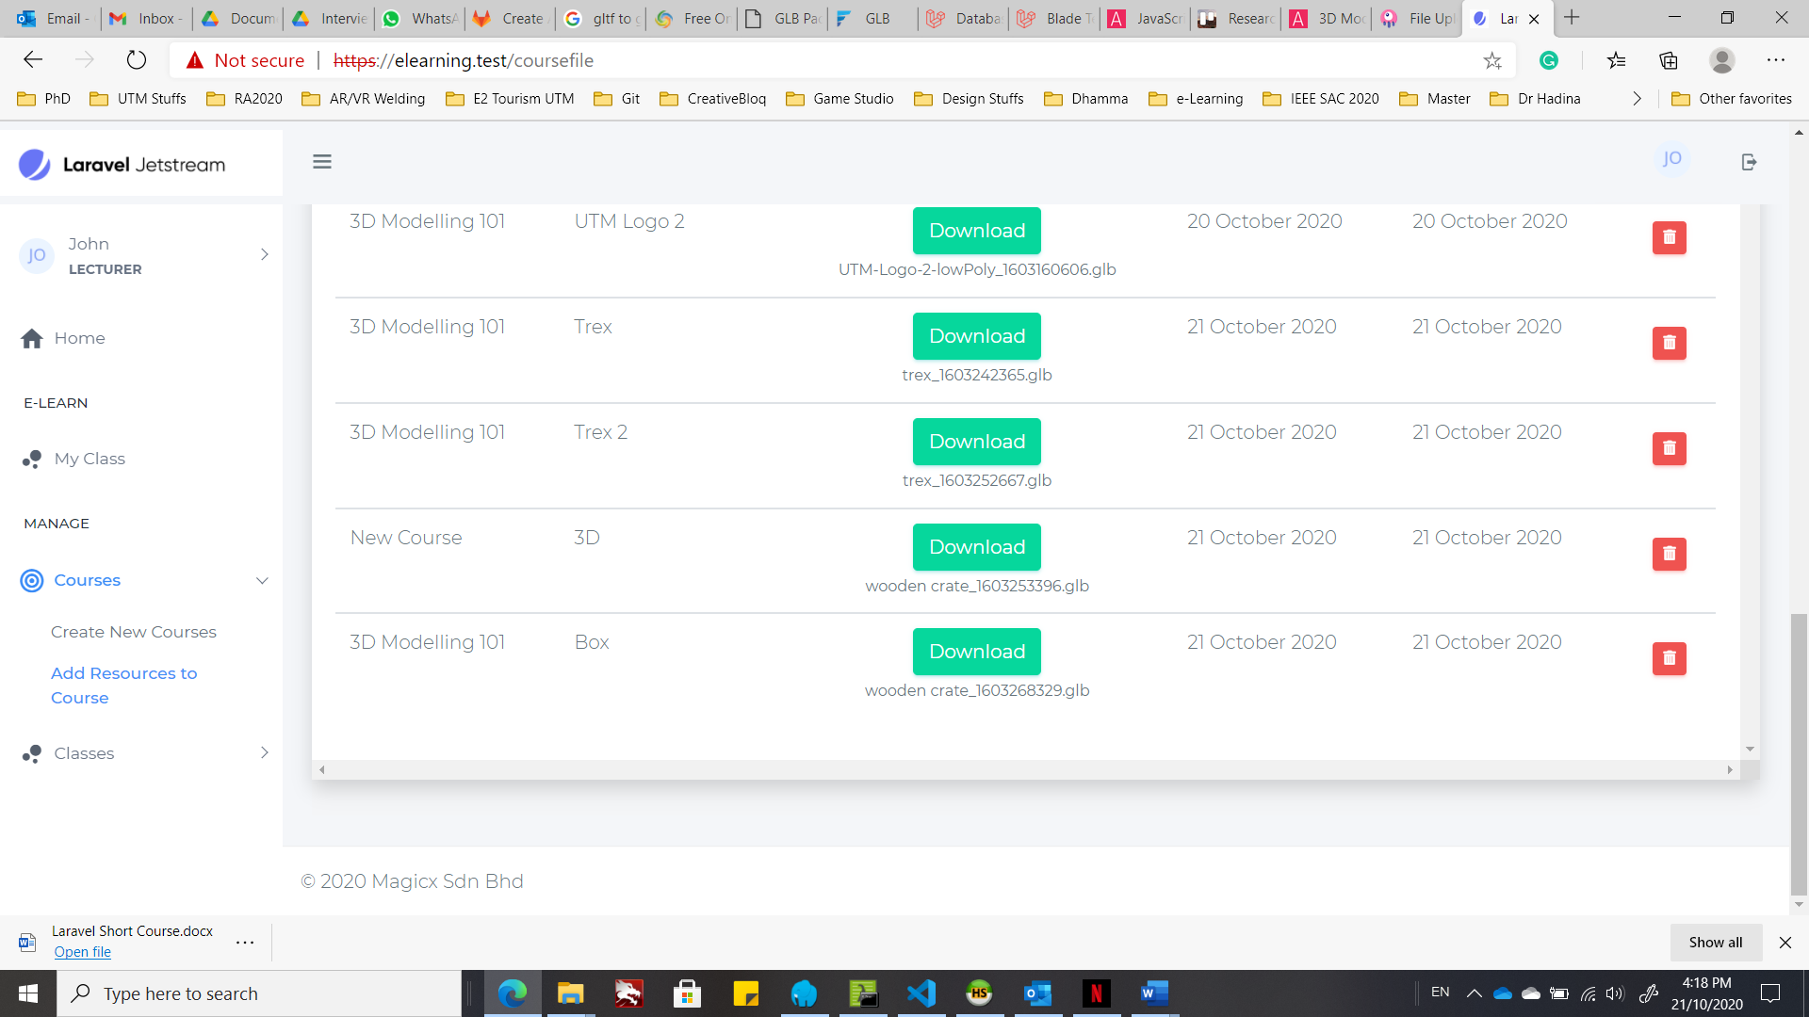

### Create function to display 3D model dynamically

1. Since our elearning project consists of the 3D model upload function, we can view the 3D model VR view in the elearning based on the model ID dynamically.
2. Update the “web.php” to accept the model ID and get the 3D model based on the ID:

Route::get('/3d_model_view/{modelId}', function($modelId) {

        $model = App\Models\CourseFile::find($modelId);

        return view('3d_model_view.index', [

            'modelSrc' => $model

        ]);

})->name('3d_model_view');

1. Update the asset source in the “index.blade.php” to link the 3D model to the chosen 3D model directory.

<a-assets>

<a-asset-item id="cityModel"

src="{{URL::to(''.$modelSrc->file_path.'')}}"></a-asset-item>

</a-assets>

So, whenever the model ID changed, the scene updates the 3D model according to the ID.

1. Go to the class webpage and open the 3D model scene.

### View the 3D model

1. Choose a class by clicking your username icon at the top right corner.

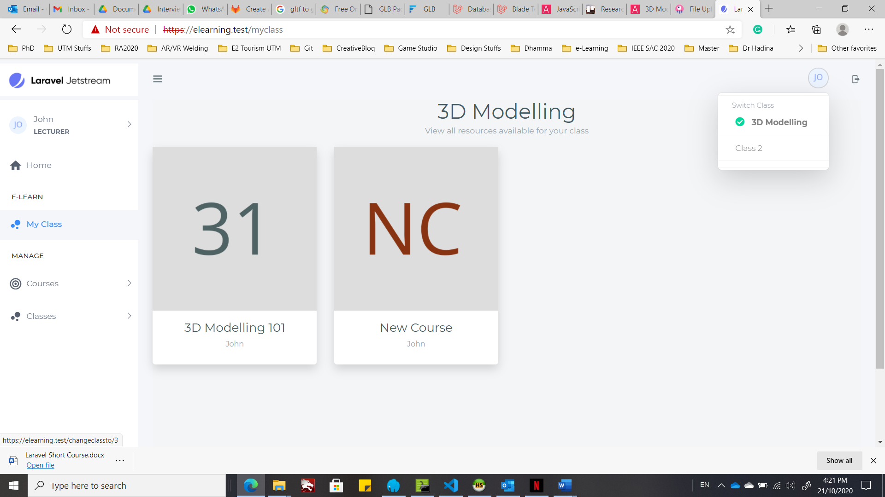

Choose a class.

1. In the “My Class” page, choose a course you want to view, which will open a modal dialog box.

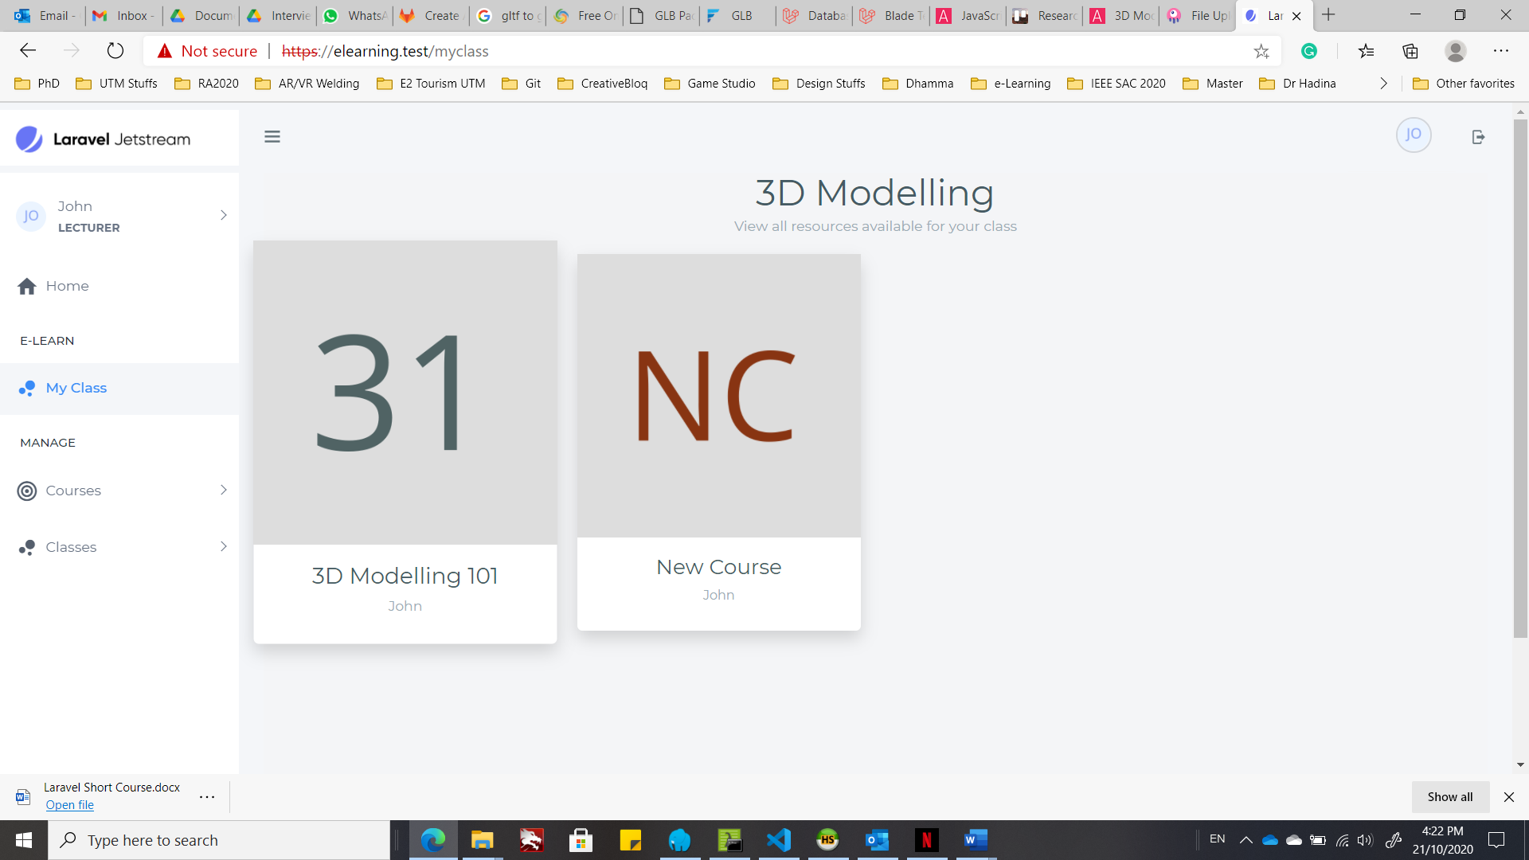

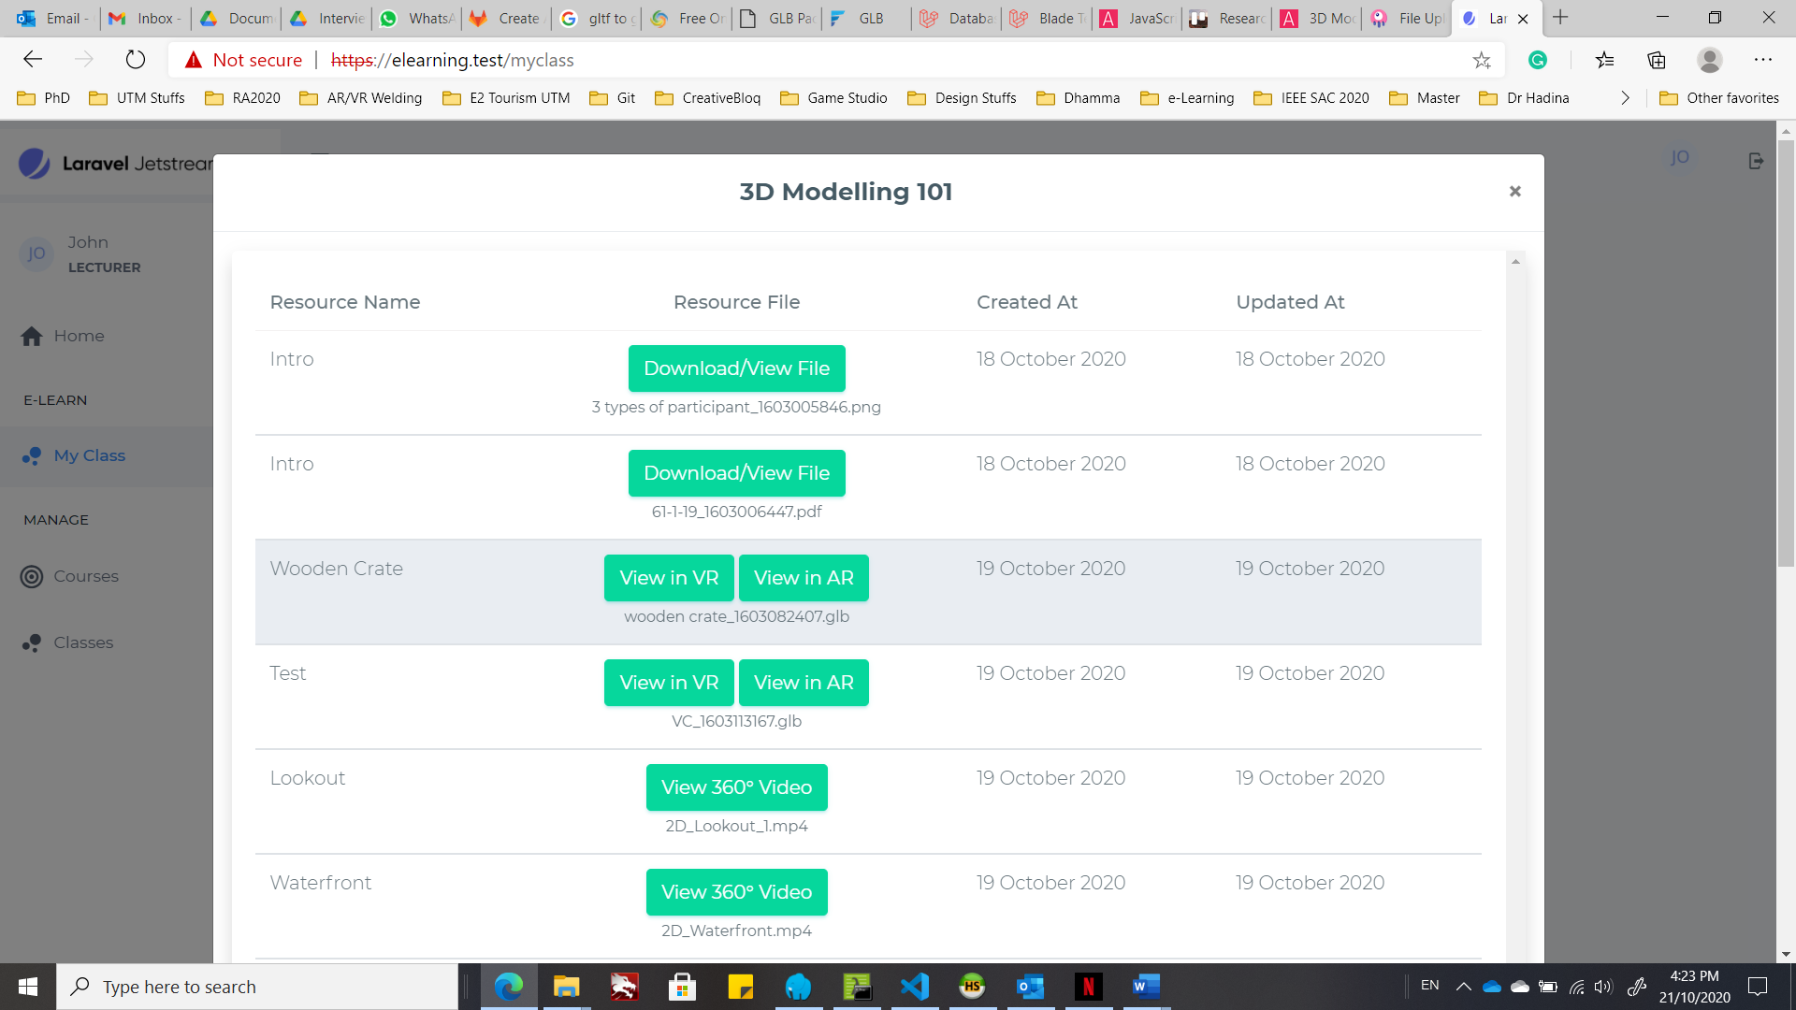

1. Search for the 3D model you want to view. You may notice that only 3D model asset has 2 buttons: “**View in VR**” button and “**View in AR**” button. Click on the “**View in VR**” button to open the VR scene.

### More user interaction using Oculus Touch Controller

1. In this section, we want to add 3D buttons into the scene to let the user change the size of the 3D model.
2. We can extend the current web application into HMD VR application by adding tracked controller for a more immersive interaction. Adding HTC Vive or Oculus Touch tracked controller is easy:

<!-- Vive. -->

<a-entity vive-controls="hand: left"></a-entity>

<a-entity vive-controls="hand: right"></a-entity>

<!-- Or Rift. -->

<a-entity oculus-touch-controls="hand: left"></a-entity>

<a-entity oculus-touch-controls="hand: right"></a-entity>

1. To add the tracked controller input, we can place it as the child of the camera entity. When moving or rotating the camera relative to the scene, use a camera rig. By doing so, the camera’s height offset can be updated by room-scale devices, while still allowing the tracked area to be moved independently around the scene, which is applicable to the HMD devices such as HTC Vive and Oculus Quest. Therefore, change your <a-camera> entity into:

<a-entity id="cameraRig" position="0 0.6 0">

<a-camera id="head" camera wasd-controls look-controls>

     <a-cursor id="cursor"></a-cursor>

    </a-camera>

</a-entity>

1. Next, we add a tracked controller into the scene with a laser pointer.

<a-entity id="cameraRig" position="0 0.6 0">

<!-- ... -->

    <a-entity id="rightHand" oculus-touch-controls="hand: right" laser-controls></a-entity>

</a-entity>

1. Then, we use the box entity for button and text entity for the button’s text. Button ID btn-minus is to reduce the size of the 3D model, while button btn-plus is to increase the size of the 3D model.

<a-scene>

<!-- ... -->

<a-entity position="-2 4 0" rotation="0 15 0">

        <a-entity id="btn-minus"

          class="link"

          geometry="primitive: box"

          material="color: blue"

          scale="2 1 0.5"

          addValue="-0.05"

          cursor-listener></a-entity>

        <a-entity text="value: - Reduce size; width: 3; color: white;"

          position="1 0 0.25"></a-entity>

      </a-entity>

      <a-entity position="2 4 0" rotation="0 -15 0">

        <a-entity id="btn-plus"

          class="link"

          geometry="primitive: box"

          material="color: green"

          scale="2 1 0.5"

          addValue="0.05"

          cursor-listener>

        </a-entity>

        <a-entity text="value: + Add size; width: 3; color: black;"

          position="1 0 0.25"></a-entity>

      </a-entity>

</a-scene>

1. Add an object (with class named link) to the raycaster component to the cursor entity so that the cursor can be clicked on the link button classes.

<a-scene>

<a-entity id="cameraRig" position="0 .6 4">

        <a-camera id="head" camera wasd-controls look-controls>

          <a-cursor id="cursor" raycaster="objects: .link"></a-cursor>

        </a-camera>

        <!-- ... -->

      </a-entity>

</a-scene>

1. Let’s add the cursor-listener component registration to increase or reduce the size of the model when the plus button or minus button is clicked:

<script>

<!-- ... -->

      AFRAME.registerComponent('cursor-listener', {

        init: function () {

          this.el.addEventListener('click', function (evt) {

            var btnEl = evt.target;

            var addValue = parseFloat(btnEl.getAttribute('addValue'));

            var targetModel = document.querySelector('#gltfModel');

            var scale = targetModel.getAttribute('scale');

            targetModel.setAttribute('scale', {

              x: scale.x + addValue,

              y: scale.y + addValue,

              z: scale.z + addValue

            });

          });

        }

      });

</script>

1. Play the scene. Direct the cursor to the minus button and use mouse click to see the change of 3D model’s size, while the plus button increases the 3D model’s size. If you are using Oculus Quest VR, you can enter the VR scene and use the controller to click on the buttons to see the effect. You can enter the Laravel project by following the step in Extra: View the VR scene in Oculus Quest and type in the address: **https://<IPv4 Address>/**

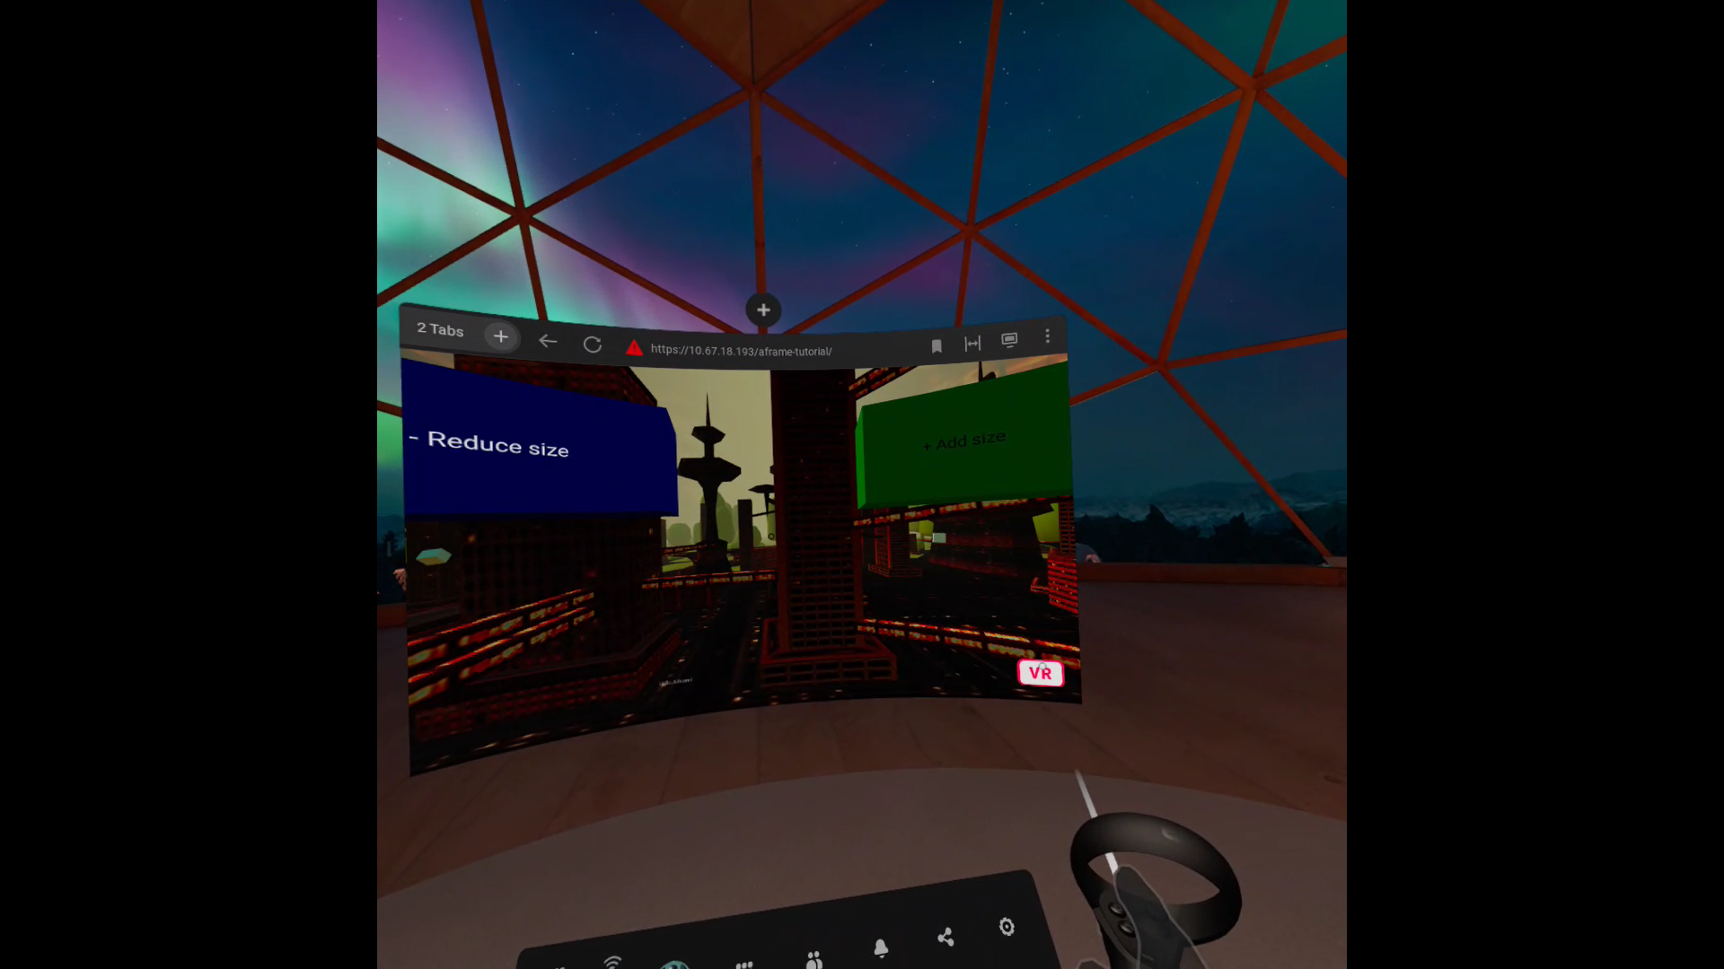

Click the VR button to enter full VR in Oculus Browser.

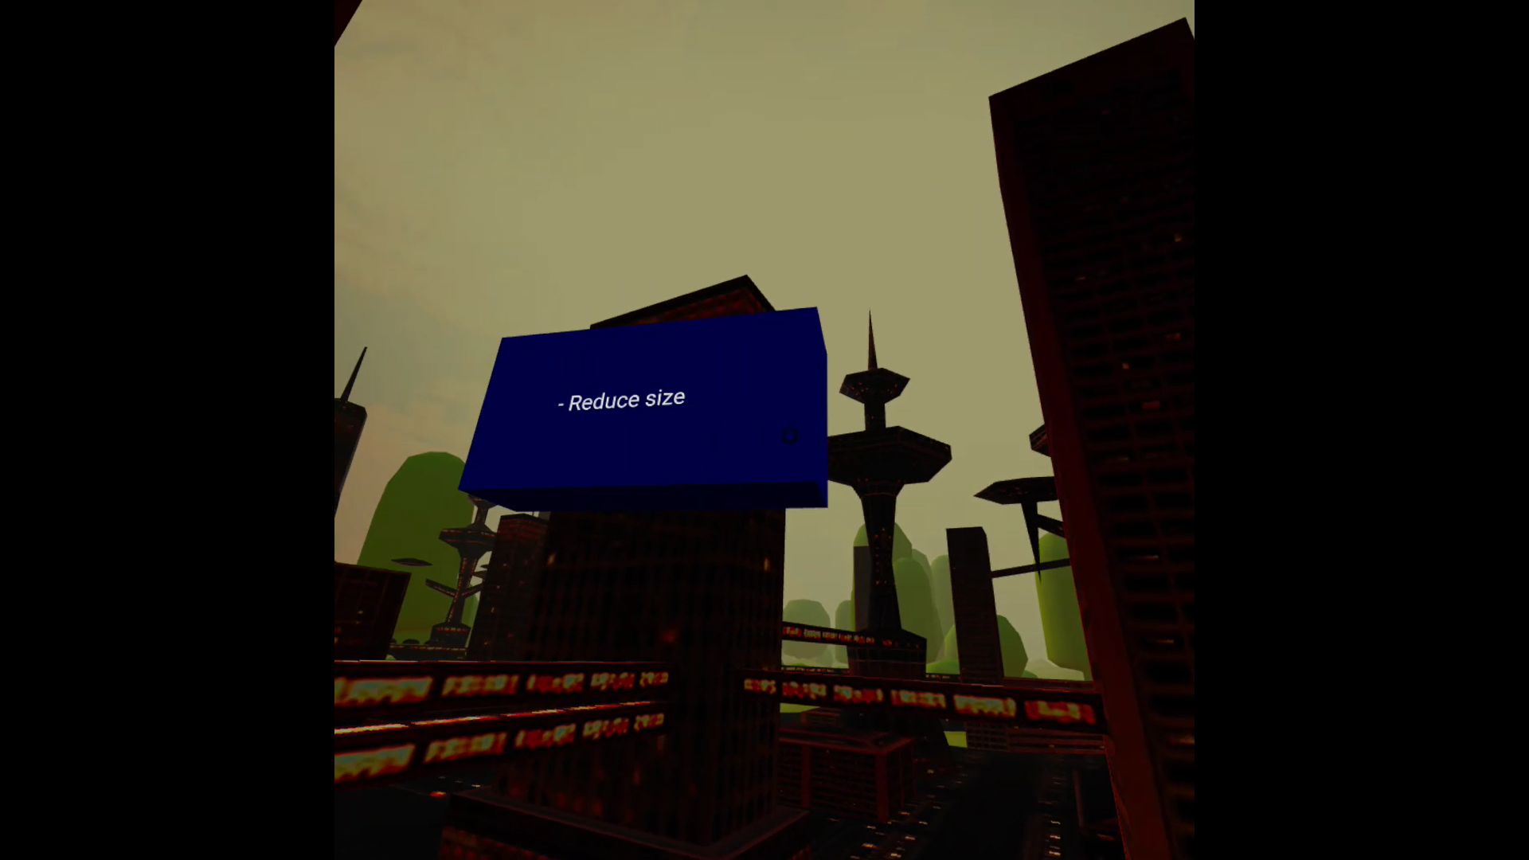

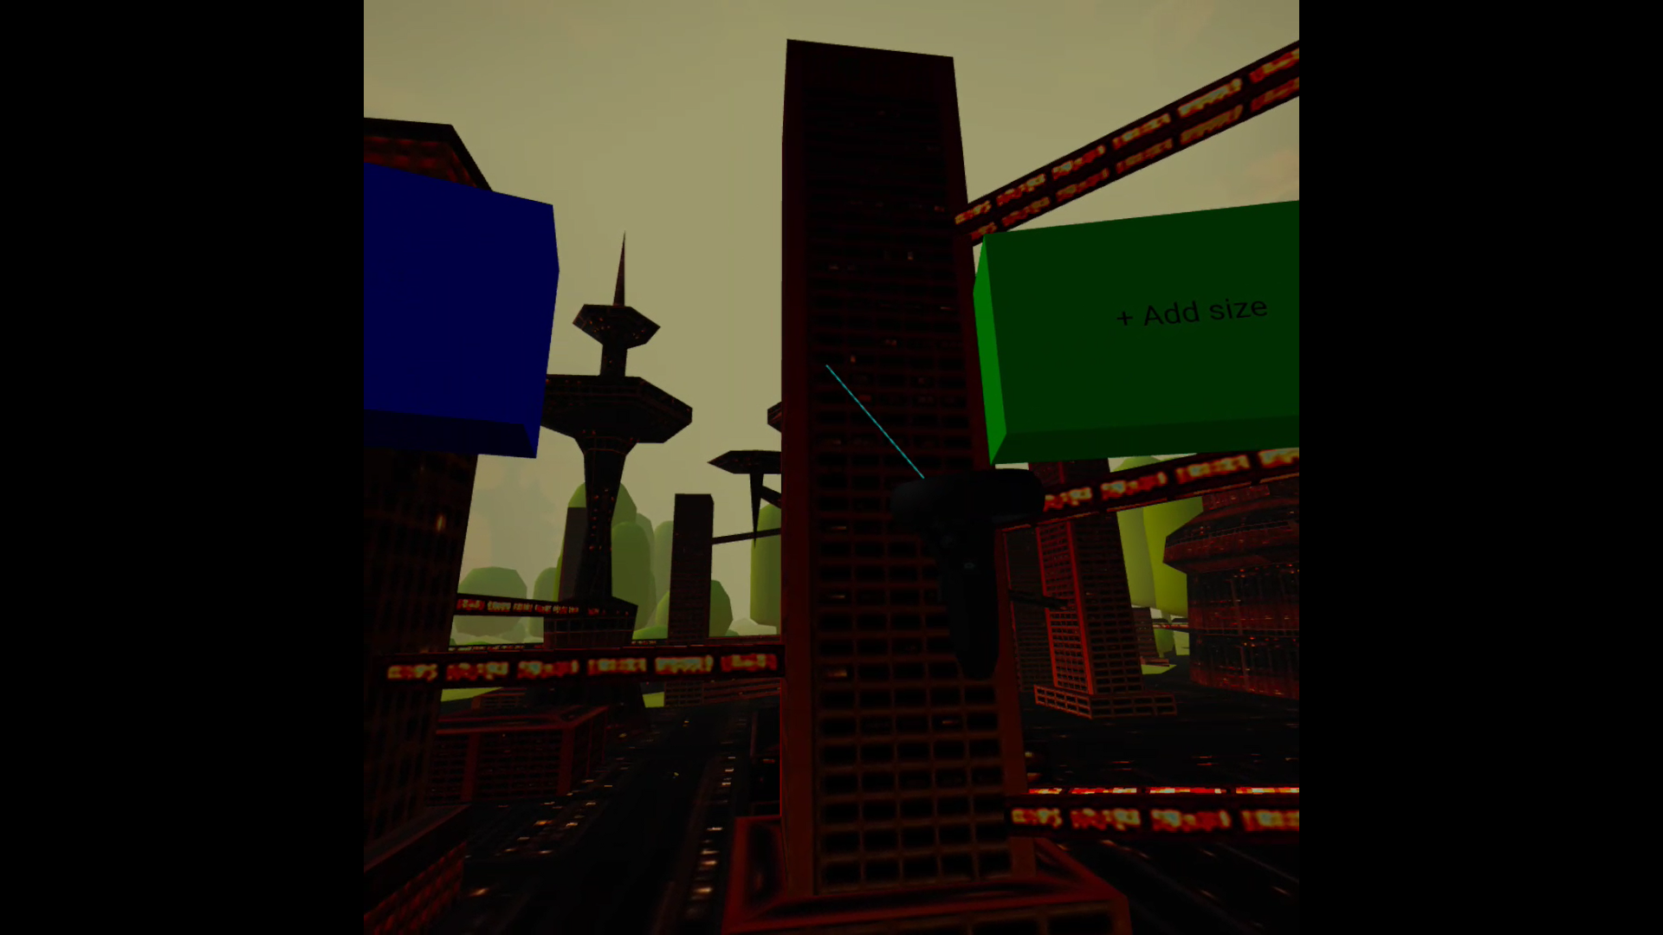

Oculus Touch Controller

# HOW TO SETUP 360-DEGREE VIDEO?

## Introduction

We can use the videosphere primitive to play 360° videos in the background of the scene. Videospheres are a large sphere with the video texture mapped to the inside.

## Stage 1 – Setup 360-degree video

### Create 360-degree video scene using A-Frame

1. First, include the A-Frame in the HTML:

<head>

    <script src="https://aframe.io/releases/1.0.4/aframe.min.js"></script>

</head>

1. Use the asset management system to fetch the 360-degree video to the scene. The videosphere entity is defined as <a-videosphere>:

<body>

    <a-scene>

        <a-assets>

            <video id="video" autoplay loop="true" src="assets/videos/2D_Waterfront.mp4"></video>

        </a-assets>

        <a-videosphere src="#video"></a-videosphere>

    </a-scene>

</body>

1. Play the scene and look around:

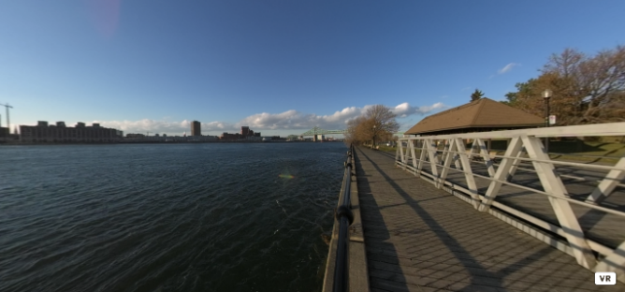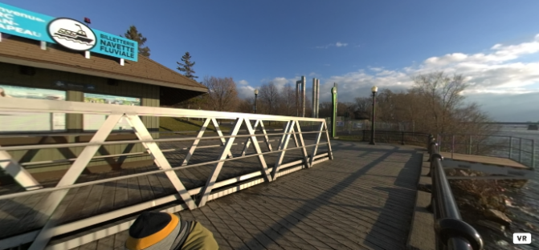

## Stage 2 – Integration with Laravel Project

### Create a new route

1. We can integrate the 360-degree video application with our elearning Laravel project. Create a new folder named “video_360” in your “resources” > “views” folder. Then, copy and paste your “index.html” into “video_360” folder. Rename “index.html” into “index.blade.php”.
2. Create a new route in “web.php” in “routes” folder:

Route::get('/video_360', function() {

        return view('video_360.index');

})->name('video_360');

1. Type in the address bar in your browser: “**https://<your-project-name>.test /video_360**”.

### Create function to display 360-degree video based on the requested video ID

1. Since our elearning project consists of the 360-degree video upload function, we can view the video in VR view in the elearning based on the video ID dynamically.
2. Update the “web.php” to accept the video ID and get the 360-degree video based on the ID:

Route::get('/video_360/{videoId}', function($videoId) {

        $video = App\Models\CourseFile::find($videoId);

        return view('video_360.index', [

            'videoSrc' => $video

        ]);

})->name('video_360');

### View 360-degree video

1. Open the 360-degree video scene as in the View the 3D model section.
2. Search for the 360-degree video you want to view, which has a “**View 360° Video**” button. Click on the “**View 360° Video**” button to open the VR scene.

# HOW TO SETUP AUGMENTED REALITY (AR) SCENE?

## Introduction

### What is AR?

Augmented reality (AR) is the technology that makes possible to add overlayed content on the real world. It can be provided for several type of devices: hand-held (like mobile phones), headsets, desktop displays, and so on.

For hand-held devices (more in general, for video-see-through devices) the 'reality' is captured from one or more cameras and then shown on the device display, adding content on top of it.

### What is AR.js?

AR.js is a lightweight library for AR on the Web, coming with features like Image Tracking, Location based AR and Marker tracking.

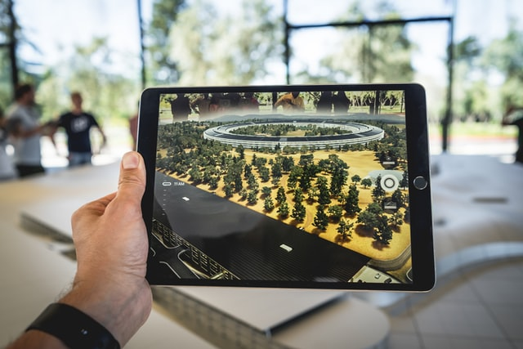

*Source: Photo by* [*Patrick Schneider*](https://unsplash.com/@patrick_schneider?utm_source=unsplash&utm_medium=referral&utm_content=creditCopyText) *on* [*Unsplash*](https://unsplash.com/s/photos/augmented-reality?utm_source=unsplash&utm_medium=referral&utm_content=creditCopyText)

## Stage 1 – Marker tracking

### Installation of AR.js and A-Frame using CDN

To include AR.js in an HTML file in the local server, you can drop a <script> tag pointing to the CDN build:

<script src="https://raw.githack.com/AR-js-org/AR.js/master/aframe/build/aframe-ar-nft.js"></script>

Besides that, we also need to include A-Frame library for the 3D functionality. The A-Frame is working well with the AR.js to create a rich AR experience.

<head>

<script src="https://aframe.io/releases/1.0.4/aframe.min.js"></script>

<script src="https://raw.githack.com/AR-js-org/AR.js/master/aframe/build/aframe-ar-nft.js"></script>

<script src="https://unpkg.com/aframe-extras.animation-mixer@3.4.0/dist/aframe-extras.animation-mixer.js"></script>

</head>

### Adding AR.js entity in A-Frame

1. In this section, we will focus on the **Marker Tracking**. The <a-marker> contains a preset [Hiro marker](https://commons.wikimedia.org/wiki/File:Hiro_marker_ARjs.png) to activate our AR scene.

<body style="margin : 0px; overflow: hidden;">

    <a-scene embedded arjs>

      <a-assets>

            <a-asset-item id="3dmodel" src="https://arjs-cors-proxy.herokuapp.com/https://raw.githack.com/AR-js-org/AR.js/master/aframe/examples/image-tracking/nft/trex/scene.gltf"></a-asset-item>

            </a-assets>

        </a-assets>

        <a-marker preset="hiro">

            <a-entity

            id="gltfModel"

            position="0 0 0"

            scale="0.05 0.05 0.05"

            gltf-model="#3dmodel"

            animation-mixer

            ></a-entity>

        </a-marker>

        <a-entity camera></a-entity>

    </a-scene>

</body>

We place a 3D model entity inside the <a-marker> entity.

1. The Hiro marker.



1. Type in the address bar in your browser: “**https://<your-project-name>.test**”. Place your Hiro marker in front of your laptop/desktop camera. Now we can see the T-rex!

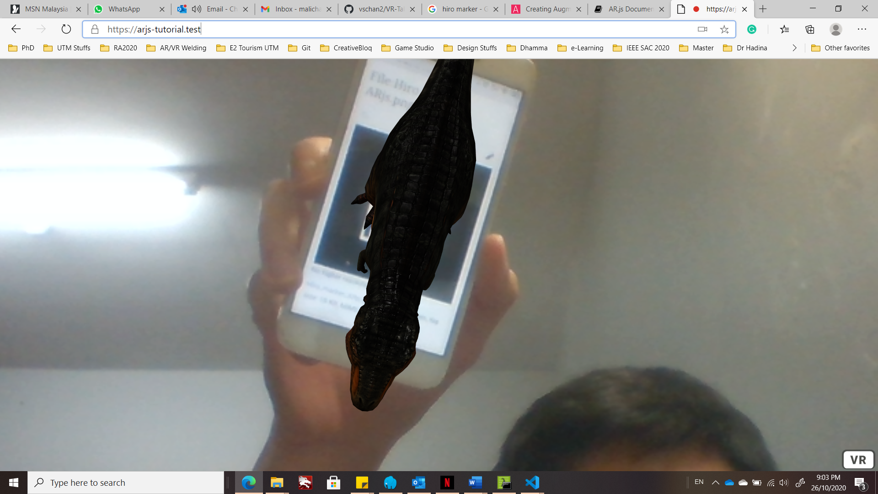

## Stage 2 – Integration with Laravel project

### Create a new route

1. We can integrate the AR application with our elearning Laravel project. Create a new folder named “ar_view” in your “resources” > “views” folder. Then, copy and paste your “index.html” into “ar_view” folder. Rename “index.html” into “index.blade.php”.
2. Create a new route in “web.php” in “routes” folder:

Route::get('/ar_view', function() {

        return view('ar_view.index');

})->name('ar_view');

1. Type in the address bar in your browser: “**https://<your-project-name>.test /ar_view**”.

### Create function to display 3D model based on the requested model ID

1. Since our elearning project consists of the 3D model upload function, we can view the 3D model in AR view in the elearning based on the model ID dynamically.
2. Update the “web.php” to accept the model ID and get the 3D model based on the ID:

Route::get('/ar_view/{modelId}', function($modelId) {

        $model = App\Models\CourseFile::find($modelId);

        return view('ar_view.index', [

            'modelSrc' => $model

        ]);

})->name('ar_view');

1. Update the asset source in the “index.blade.php” to link the 3D model to the chosen 3D model directory.

<a-asset-item id="3dmodel"

src="{{ URL::to(''.$modelSrc->file_path.'') }}"></a-asset-item>

</a-assets>

So, whenever the model ID changed, the scene updates the 3D model according to the ID.

1. Go to the class webpage and open the 3D model scene.

### View the 3D model in AR

1. Open the 360-degree video scene as in the View the 3D model section.
2. Search for the 3D model you want to view. You may notice that only 3D model asset has 2 buttons: “**View in VR**” button and “**View in AR**” button. Click on the “**View in AR**” button to open the AR scene.

## Stage 3 – Create your own marker

### Design and create own marker for elearning

1. Firstly, you need to create a square image by using any image processing program, such as Adobe Photoshop, Adobe Illustrator, GIMP, Inkscape, etc. Example:



1. Then, you need to upload in this AR.js marker generator website: <https://jeromeetienne.github.io/AR.js/three.js/examples/marker-training/examples/generator.html>
2. Click on the “upload” button to select your image marker.

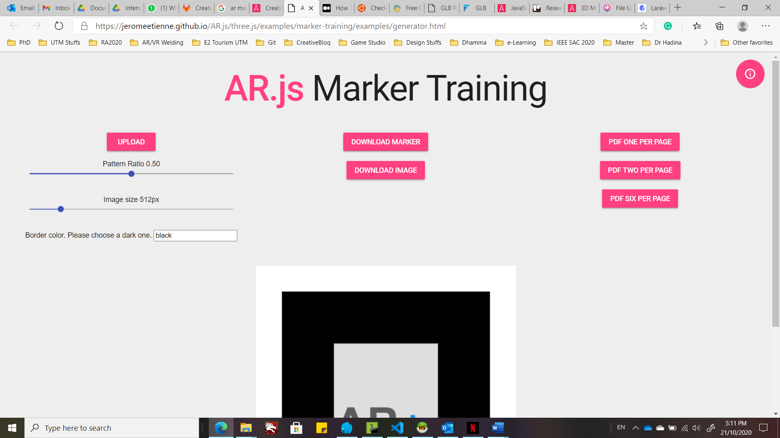

1. Click on the “DOWNLOAD MARKER” button to let the system generate your marker. It will download as a PATT file format.
2. Click on the “DOWNLOAD IMAGE” button to download the image marker.

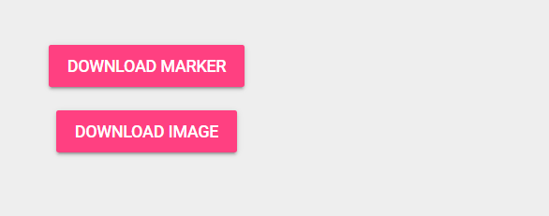

### Import to Laravel project

1. Create a new folder “ar-markers” in “public” folder.
2. Copy the PATT file and paste into your Laravel project in the “ar-markers” folder.

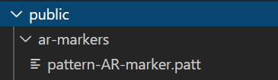

### Using the new marker

Then, change your AR marker URL in “index.blade.php” and add a new type component in the <a-marker> entity which is assigned to pattern.

<a-marker type="pattern" url="{{ asset('ar-markers/pattern-AR-marker.patt') }}">

        <a-entity

            id="gltfModel"

            position="0 0 0"

            scale="0.05 0.05 0.05"

            gltf-model="#3dmodel"

            animation-mixer

            ></a-entity>

</a-marker>

## Stage 3 – User interaction in AR scene

### Create a custom button

1. Same as the topic in VR, we would like to create 2 buttons to change the size of the 3D model. Let’s create 2 buttons in the AR scene:

<a-scene embedded arjs>

<!-- ... -->

        <div>

            <button class="change-size btn-primary" style="left: 0; top: 0" addvalue="-0.05" cursor-listener>- Reduce size</button>

            <button class="change-size btn-primary" style="left: 100px; top: 0" addvalue="0.05" cursor-listener>+ Add size</button>

        </div>

<!-- ... -->

    </a-scene>

1. Then, we use custom CSS to sylize our buttons:

<head>

<!-- ... -->

    <style>

        .btn-primary {

          background-size: 90% 90%;

          border: 0;

          top: 0;

          color: #fff;

          cursor: pointer;

          min-width: 58px;

          min-height: 34px;

          outline: 0;

          position: fixed;

          left: 0;

          transition: background-color .05s ease;

          user-select: none;

          -webkit-transition: background-color .05s ease;

          z-index: 9999;

          border-radius: 8px;

          touch-action: manipulation;

        }

        .btn-primary:active, .btn-primary:hover {

          background-color: #ef2d5e;

        }

    </style>

</head>

1. Add button listener in JavaScript to reduce or increase the 3D model’s size based on the button:

<script>

      var buttons = document.querySelectorAll('.change-size');

      for(var i = 0; i < buttons.length; i++) {

        buttons[i].addEventListener('click', function(evt) {

          var btnEl = evt.target;

          var addValue = parseFloat(btnEl.getAttribute('addvalue'));

          var targetModel = document.querySelector('#gltfModel');

          var scale = targetModel.getAttribute('scale');

          targetModel.setAttribute('scale', {

            x: scale.x + addValue,

            y: scale.y + addValue,

            z: scale.z + addValue

          });

        });

      }

</script>

1. Open the scene and see the result.

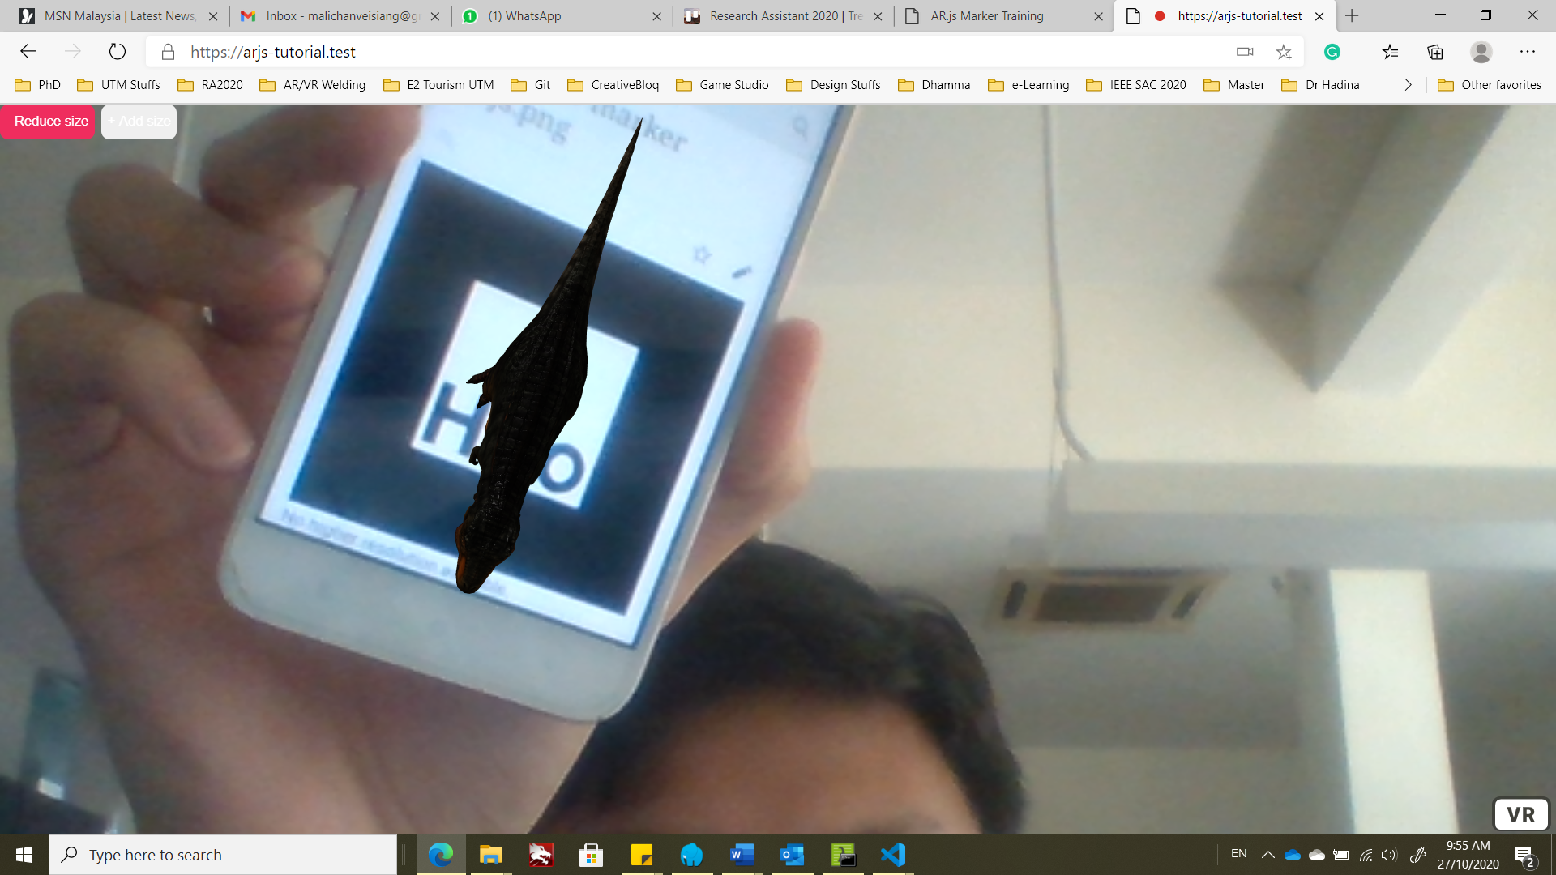

Reduce the size of 3D model.

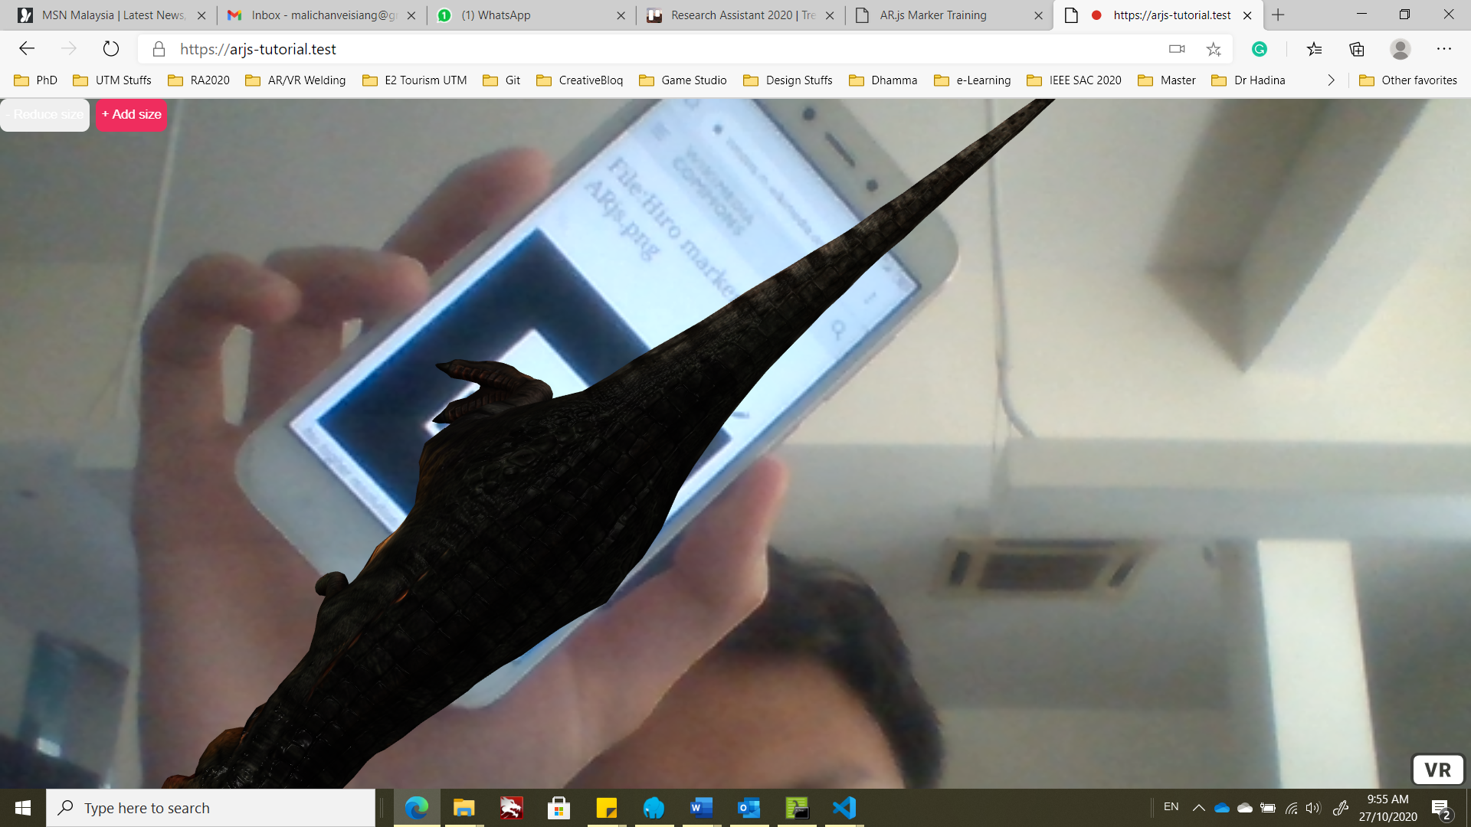

Increase the size of 3D model.